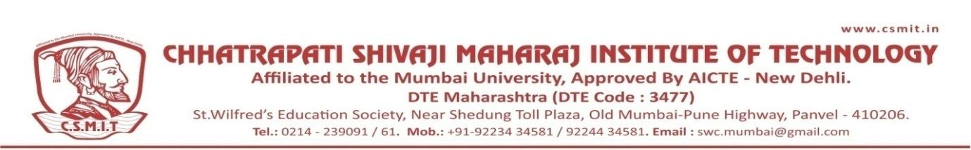

Ref.No:- CSMIT/ Date-08/07/2021

Office Order
Subject: Academic Monitoring Committee for Academic Year: 2021-2022a
Sr. No. | Name of Faculty | Designation | Position
1 | Dr. Dharmendra Dubey | Principal | Chairman
2 | Dr. Savita Agarwal | Assistant Professor | Convener
3 | Dr. Shweta Umale | Assistant Professor | Member
4 | Er. Bhavesh Pasi | Assistant Professor | Member
5 | Er. Shreyas Pande | Assistant Professor | Member
6 | Er. Jyoti Baviskar | Assistant Professor | Member

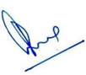

(Principal)
CC:
1) H’ble Secretary- For Kind information Please
2) All Concerned
3) Office Record

