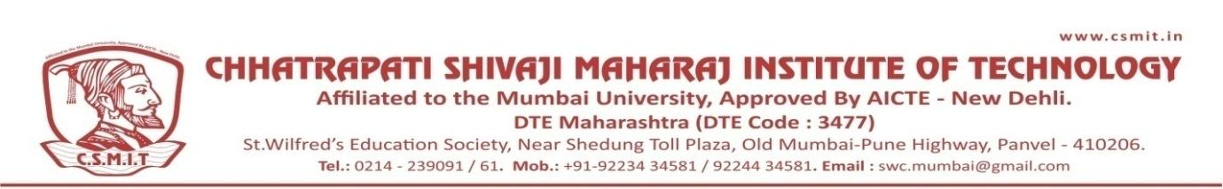

Ref.No:- CSMIT/                                                                                           Date: - 5 Jan 2023

**Notice**

**Subject: National Service Scheme (NSS) Cell Meeting**

We are writing to inform you of an upcoming meeting that has been scheduled to discuss important matters regarding the National Service Scheme (NSS) Cell Meeting. Your presence and input at this meeting are crucial, and we look forward to your participation.

**Date: -** 09/01/2023

**Time: -** 10.00 am – 11.00 am

**Agenda: -**

1. NSS Annual Camp Planning
2. Collaboration with Local NGOs
3. NSS Member Training and Skill Development

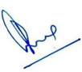

**(Principal)**

CC:

1)                   H’ble Secretary- For Kind information Please

2)                   All Concerned

3)                   Office Record