A REPORT ON MEET BOTTLE GOURD MAN 2023

- NAME OF ACTIVITY: Meet Bottle Gourd Man

- DATE & DURATION: 30th 09, 2023

- TYPE OF ACTIVITY: NSS/ CSMIT Activities

- ORGANIZED BY: Chhatrapati Shivaji Maharaj Institute of Technology, Panvel.

FLYER:

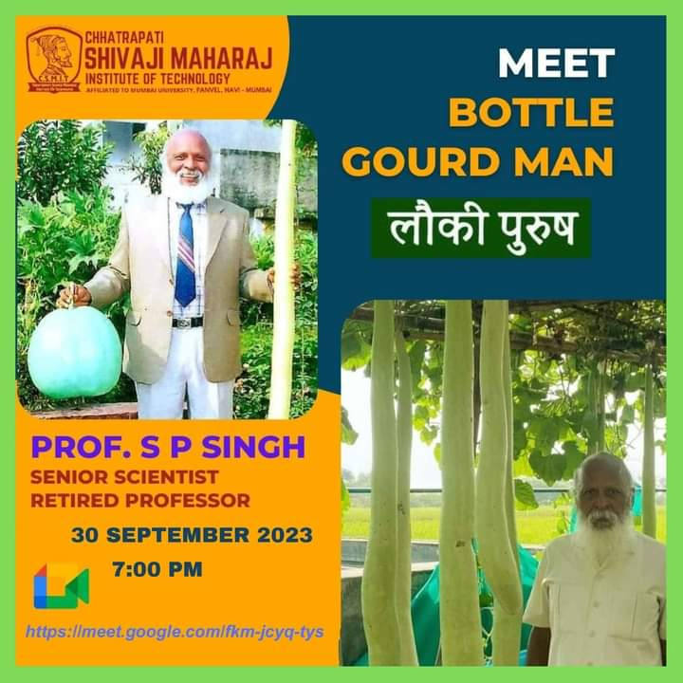

ABOUT THE PROGRAMME
Prof SP Singh who is popularly known as ‘Lauki Purush’ (Bottle gourd man) among farmers and fellow scientists was born in a small village called Gaura Beni in Azamgarh district of Uttar Pradesh on 5th June 1953. In 1982 Prof Singh joined NDUAT as a professor of Vegetable Science. After working here for about three years, he was invited to the University of Nairobi in Kenya as a visiting lecturer.

- GLIMPSES:

