A REPORT ON GANDHI JAYANTI CELEBRATION

- NAME OF ACTIVITY: Gandhi Jayanti

- DATE & DURATION: 02nd 10, 2023

- TYPE OF ACTIVITY: NSS Activity

- ORGANIZED BY: IQAC, Chhatrapati Shivaji Maharaj Institute of Technology, Panvel.

FLYER:

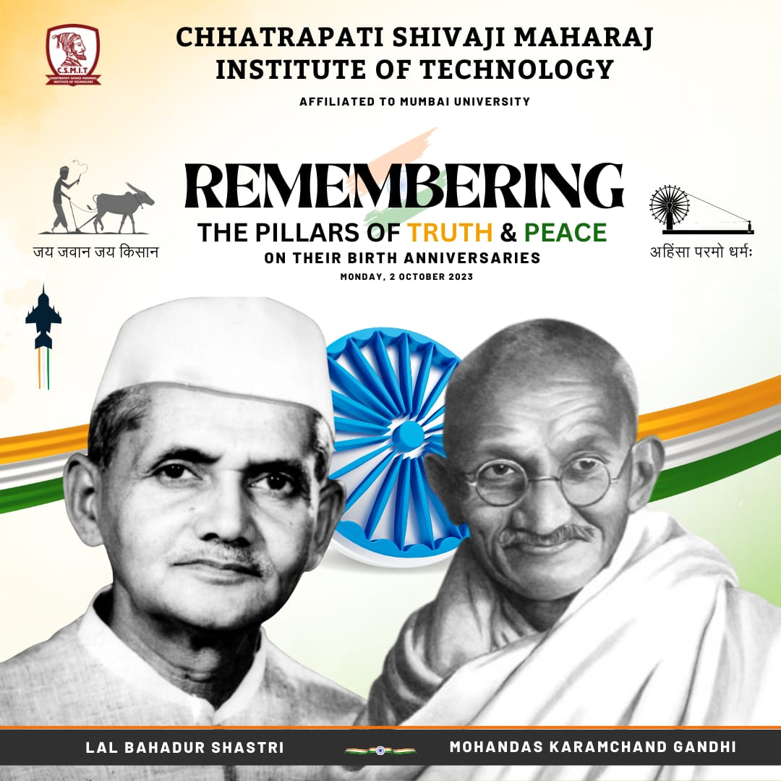

ABOUT THE PROGRAMME
Chhatrapati Shivaji Maharaj Institute of Technology, Panvel celebrated “GANDHI JAYANTI” AND “LAL BAHADUR SHASTRI” Birth anniversary on 2nd October, 2023. On this occasion we organised A Cleanliness Drive in the campus. All faculty taking part in that our principal Dr. Dharmendra Dubey, Dr. Baljit sir, Mr. Nutan Kale, Mr. Harishchandra Mourya, Mr. Abhay sir.etc.

GLIMPSES:

