A REPORT ON YOUTH CAMAIGN ON QUALITY CONNECT BY BIS

- NAME OF ACTIVITY: BIS Youth

- DATE & DURATION: 12th 10, 2023

- TYPE OF ACTIVITY: NSS Activity

- ORGANIZED BY: IQAC, Chhatrapati Shivaji Maharaj Institute of Technology, Panvel.

FLYER:

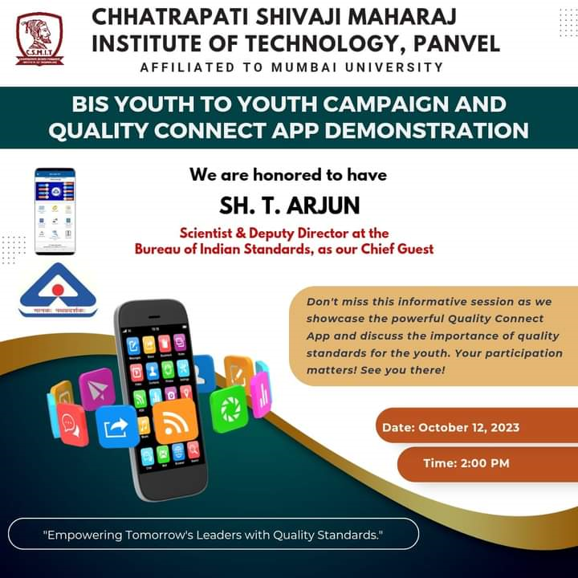
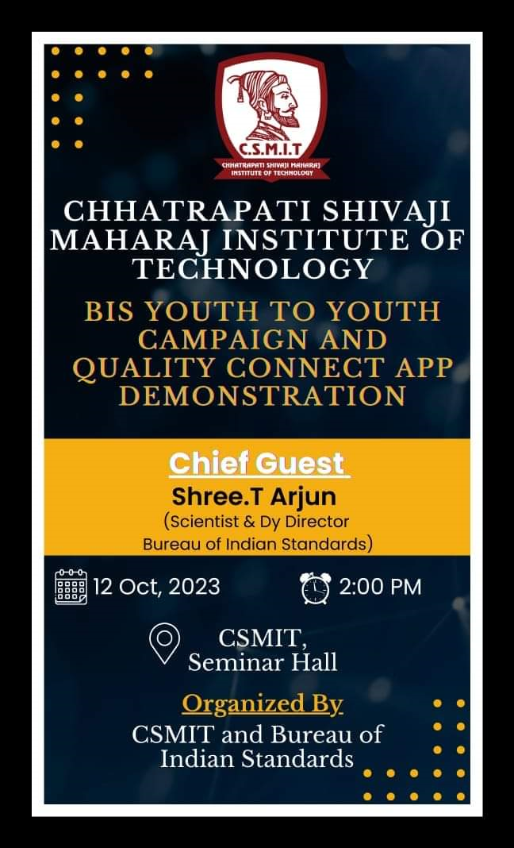

ABOUT THE PROGRAMME
BIS, The National Standards Body of India. We develop & publish Indian Standards, Implement Conformity Assessment Schemes, Recognise & run laboratories for Conformity Assessment, Implement Hallmarking, Work for Consumer empowerment, Conduct capacity building programs on quality assurance and represent the country in ISO & IEC.

GLIMPSES:

