A REPORT ON HEALTH CHECK-UP CAMP

- NAME OF ACTIVITY: Free Health Check-up Camp

- DATE & DURATION: 14th 10, 2023

- TYPE OF ACTIVITY: NSS Activity

- ORGANIZED BY: IQAC, Chhatrapati Shivaji Maharaj Institute of Technology, Panvel.

FLYER:

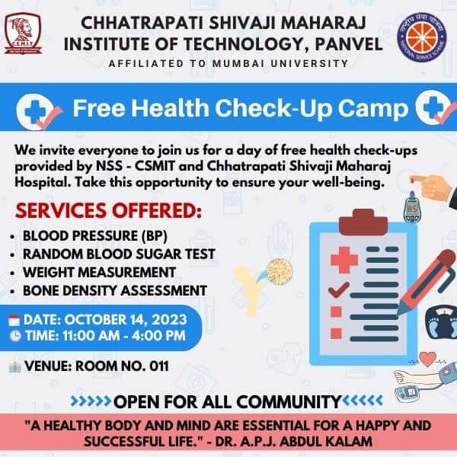

ABOUT THE PROGRAMME

The importance and objectives of the free medical camp are vital, but the main objective is that the free medical camps are set up with the sacred aim to bring awareness amongst the deprived population of the country who have no access to basic healthcare services or knowledge about the diseases they are suffering from. So, Transparent Hands provide the importance and objectives of the medical camp free medical advice, and medicine to unfortunate people, and refer them for specialized treatment or surgery whenever it is required. These camps make sure people are getting the healthcare at the right time, and seeing the doctor early enough before a small health problem turns serious.
A Free Medical Camp can be considered as a life-saving program that aims to provide free medical and surgical services to poor communities living in rural or urban areas by a mobile team with varieties of medical specialized services. Some NGOs, Charitable Medical Trusts, and medical professionals are driven by strong ethics of medicine and believe that it is the moral responsibility and obligation to treat each patient regardless of their income, race, or social status. The main objective of a medical camp is to provide initial care to people in life-threatening conditions which reflects the unique strengths and goals of medical ethics. Other objectives are as stated below:
1. Provide free and high-quality medical services for the poor population.
2. Working as an emergency team in disasters.
3. Raise health awareness among the community and teach them to deal with communicable and non-communicable
4. Register rare and severe cases and refer them to specialized centers.
5. Evaluate the living conditions and determine the obstacles and challenges to work on solving their problems.
6. Refer medical cases towards surgeries if required.

GLIMPSES:

