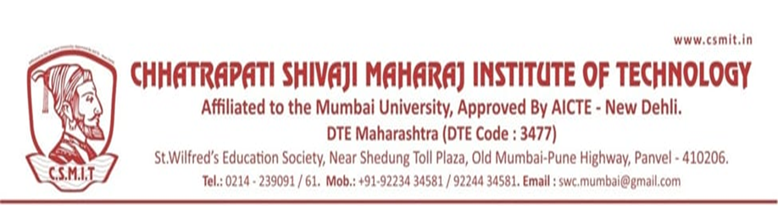

Chhatrapati Shivaji Maharaj Institute of Technology, Navi-Mumbai
Program Organized in Year 2018-19

Sr.N. | Name of Activity | Organization Unit/ Collaboration Agency | Date | Page No.
1 | Swacch Bharat Abhiyan | NSS | 02/10/2018
2 | Ganesh Chaturthi | NSS | 13/09/2018
3 | M. Visvesvarya Jayaanti | NSS | 15/09/2018
4 | Vivekanand Jayanti | NSS | 12/01/2019
5 | Chhatrapati Shivaji Jayanti | NSS | 19/02/2019
6 | Navratri Garba Celebration | NSS | 11/03/2019
7 | Babasaheb Ambedkar Jayanti | NSS | 14/04/2019

