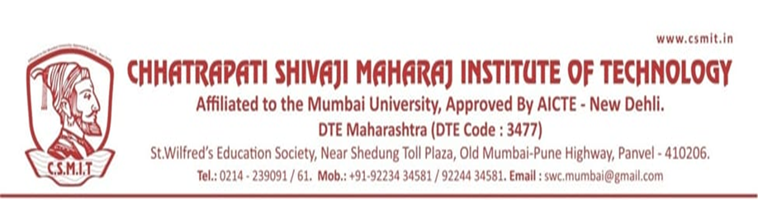

Chhatrapati Shivaji Maharaj Institute of Technology, Navi-Mumbai
Program Organized in Year 2020-21

Sr.N. | Name of Activity | Organization Unit/ Collaboration Agency | Date | Page No.
1 | World Tuberculosis Day | NSS | 24/03/2021
2 | NSS Special Camp 2021 | NSS | 22/03/2021 28/03/2021
3 | World Health Day | NSS | 07/04/2021
4 | Dr. Babasaheb Ambedkar Jayanti | NSS | 14/04/2021
5 | Tree Plantation | NSS | 05/06/2021
6 | International Yoga Day | NSS/CSMIT | 21/06/2021
7

