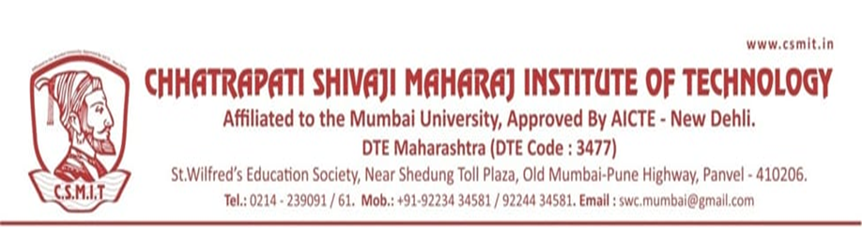

Chhatrapati Shivaji Maharaj Institute of Technology, Navi-Mumbai
Program Organized in Year 2021-22

Sr.N. | Name of Activity | Organization Unit/ Collaboration Agency | Date | Page No.
1 | Tree Plantation | NSS | 20/07/2021
2 | Akhand Bharat Sankalp Diwas | NSS | 14/08/2021
3 | National Unity Day | NSS | 31/10/2021
4 | Rani Laxmi Bai Jayanti | NSS/CSMIT | 20/11/2021
5 | National Constitution Day | NSS | 26/11/2021
6 | Vaccination Drive | NSS/CSMIT | 27/10/2021
7 | Chatrapati Shivaji Maharaj Jayanti | NSS/CSMIT | 19/02/2022
8 | National Science Day | NSS/CSMIT | 28/02/2022
9 | Women’s Day | Women Cell/NSS | 08/03/2022
10 | Holi Celebration | CSMIT | 19/03/2022
11 | Baba Saheb Ambedkar Jayanti | NSS/CSMIT | 14/04/2022
12 | World Environment Day | NSS | 05/06/2022
13 | Rani Laxmi Bai Punyatithi | CSMIT | 18/06/2022
14 | Yoga Day | NSS | 21/06/2022

A REPORT ON TREE PLANTATION DRIVE

- NAME OF ACTIVITY: Tree Plantation

- DATE & DURATION: 20th July, 2021

- TYPE OF ACTIVITY: Extra Curricular

- ORGANIZED BY: Chhatrapati Shivaji Maharaj Institute of Technology

LEARNING OUTCOMES:

MAPPINGS WITH PO AND PSO:

CO | PO1 | PO2 | PO3 | PO4 | PO5 | PO6 | PO7 | PO8 | PO9 | PO10 | PO11 | PO12 | PSO1 | PSO2 | PSO3
Helps reach education goals through free expression, debates, cooperation, coordination, etc. |  |  |  |  |  | 3 | 2 | 2 | 3 | 3 |  | 1 | 2 |  | 3
Develops habits of constructive competition, improves skills and competence |  |  |  |  |  | 3 | 2 | 2 | 3 | 3 |  | 1
Develops a sense of responsibility and belongingness |  |  |  |  |  | 3 | 2 | 2 | 3 | 3 |  | 1 | 2 |  | 3
Develops decision- making skills  self-assessment, and cultural awareness |  |  |  |  |  | 3 | 2 | 2 | 3 | 3 |  | 1 | 2 |  | 3
Develops leadership, managerial, and organizing skills |  |  |  |  |  | 3 | 2 | 2 | 3 | 3 |  | 1 | 2 |  | 3
Creates opportunities to meet with other like- minded students for socialization, |  |  |  |  |  | 3 | 2 | 2 | 3 | 3 |  | 1 | 2 |  | 3

- ASSESSMENT TOOLS: NIL

FLYER:

Tree Plantation drives combat many environmental issues like deforestation, erosion of soil, desertification in semi-arid areas, global warming and hence enhancing the beauty and balance of the environment.
On 05th June 2022, Chhatrapati Shivaji Maharaj Institute of Technology, Panvel, arranged tree plantation drive. All the faculties and students were involved in this event.
In order to sensitize students towards the need to preserve our environment and ecology, Tree plantation drive was organised by CSMIT. The main purpose of this event was to teach students, how we can save our climate from pollution.

GLIMPSES:

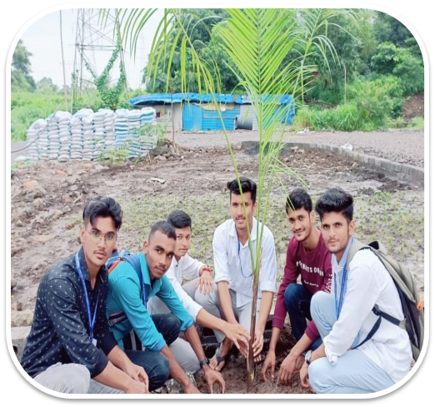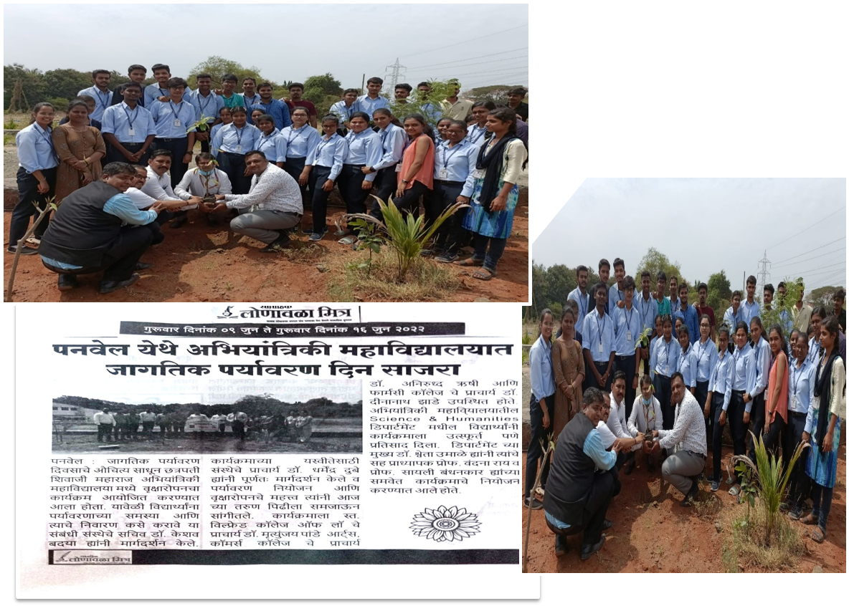

Student Coordinators / Volunteers: Core Committee

Faculty In-charge:
S.No. | Name of Student | Branch | Semester | Contact Number
1
2
3
4
5
6
7
8
9
10
Photography Team
S.No. | Name of Student | Branch | Semester | Contact Number
1
2
3
4

Technical Team
S.No. | Name of Student | Branch | Semester | Contact Number
1
2
3
4

Refreshment Team
S.No. | Name of Student | Branch | Semester | Contact Number
1
2
3
4

Room Management & Personal Care of Blood Donors Committee
S.No. | Name of Student | Branch | Semester | Contact Number
1
2
3
4

Registration Committee
S.No. | Name of Student | Branch | Semester | Contact Number
1
2
3
4

A REPORT ON NATIONAL UNITY DAY

- NAME OF ACTIVITY: Unity Day

- DATE & DURATION: 31st Oct, 2021

- TYPE OF ACTIVITY: Extra Curricular

- ORGANIZED BY: NSS/Chhatrapati Shivaji Maharaj Institute of Technology

LEARNING OUTCOMES:

FLYER:

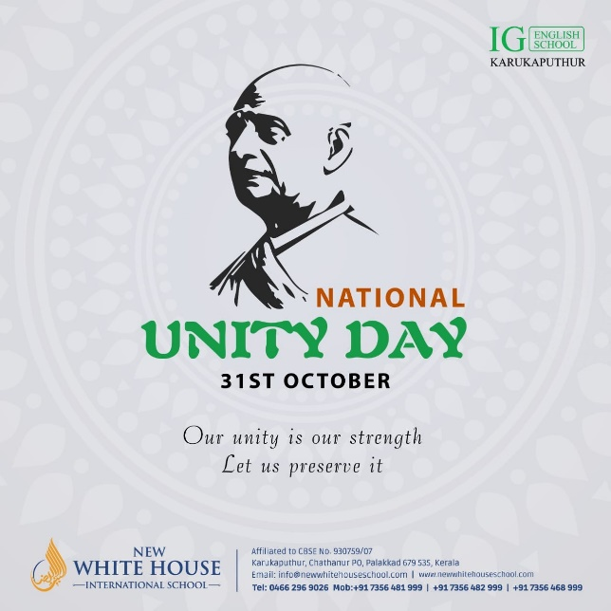

National Unity Day is a commemoration of solidarity, harmony, and diversity. It brings together people from all walks of life, transcending boundaries and fostering a sense of oneness. Through celebration and reflection, it reminds us of the strength and importance of unity in building a prosperous and inclusive nation.
On National Unity Day, we honor the sacrifices of our ancestors who fought for freedom and unity. It is a day to embrace our shared values, bridge differences, and work towards a common goal. Through dialogue, understanding, and respect, we strive to create a society where diversity is celebrated and every voice is heard. Together, we build a stronger, more cohesive nation for future generations.

A REPORT ON TREE PLANTATION DRIVE

- NAME OF ACTIVITY: Tree Plantation

- DATE & DURATION: 5th June, 2022 Time: 10.00am -4.00 pm

- TYPE OF ACTIVITY: Extra Curricular

- ORGANIZED BY: Chhatrapati Shivaji Maharaj Institute of Technology

LEARNING OUTCOMES:

MAPPINGS WITH PO AND PSO:

CO | PO1 | PO2 | PO3 | PO4 | PO5 | PO6 | PO7 | PO8 | PO9 | PO10 | PO11 | PO12 | PSO1 | PSO2 | PSO3
Helps reach education goals through free expression, debates, cooperation, coordination, etc. |  |  |  |  |  | 3 | 2 | 2 | 3 | 3 |  | 1 | 2 |  | 3
Develops habits of constructive competition, improves skills and competence |  |  |  |  |  | 3 | 2 | 2 | 3 | 3 |  | 1
Develops a sense of responsibility and belongingness |  |  |  |  |  | 3 | 2 | 2 | 3 | 3 |  | 1 | 2 |  | 3
Develops decision- making skills  self-assessment, and cultural awareness |  |  |  |  |  | 3 | 2 | 2 | 3 | 3 |  | 1 | 2 |  | 3
Develops leadership, managerial, and organizing skills |  |  |  |  |  | 3 | 2 | 2 | 3 | 3 |  | 1 | 2 |  | 3
Creates opportunities to meet with other like- minded students for socialization, |  |  |  |  |  | 3 | 2 | 2 | 3 | 3 |  | 1 | 2 |  | 3

- ASSESSMENT TOOLS: NIL

FLYER:

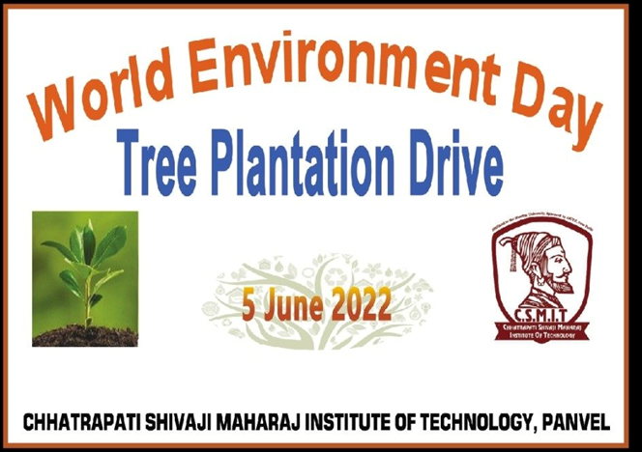

Tree Plantation drives combat many environmental issues like deforestation, erosion of soil, desertification in semi-arid areas, global warming and hence enhancing the beauty and balance of the environment.
On 05th June 2022, Chhatrapati Shivaji Maharaj Institute of Technology, Panvel, arranged tree plantation drive. All the faculties and students were involved in this event.
In order to sensitize students towards the need to preserve our environment and ecology, Tree plantation drive was organised by CSMIT. The main purpose of this event was to teach students, how we can save our climate from pollution.

GLIMPSES:

Refreshment Team
S.No. | Name of Student | Branch | Semester | Contact Number
1
2
3
4

Room Management & Personal Care of Blood Donors Committee
S.No. | Name of Student | Branch | Semester | Contact Number
1
2
3
4

Registration Committee
S.No. | Name of Student | Branch | Semester | Contact Number
1
2
3
4

