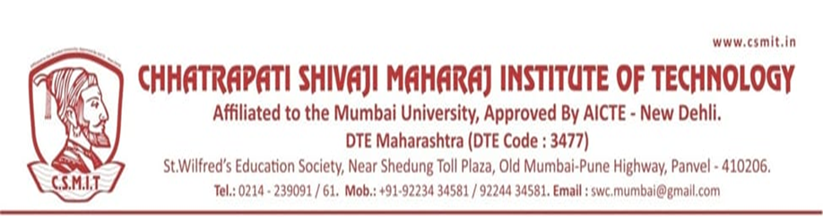

Chhatrapati Shivaji Maharaj Institute of Technology, Navi-Mumbai
Program Organized in Year 2022-23

Sr.N. | Name of Activity | Organization Unit/ Collaboration Agency | Date | Page No.
1 | Har Ghar Tiranga- An Awareness Rally | NSS | 12 & 13/08/2022
2 | Ganpati Celebration | CSMIT | 01/09/2022
3 | Tree Plantation | NSS | 21/09/2022
4 | Film Promotion | CSMIT | 23/09/2023
5 | Blood Donation Camp | NSS | 28/09/2022
6 | Gandhi Jayanti | NSS | 02/10/2022
7 | Diwali Celebration | NSS | 23/10/2022
8 | Rashtriya Ekta Divas | NSS | 31/10/2023
9 | Birsa Munda Day | NSS | 15/11/2022
10 | Constitution Day | NSS | 28/11/2023
11 | Swami Vivekanand Jayanti | NSS | 12/01/2023
12 | Netaji Subash Chandra Bose Jayanti | CSMIT | 23/01/2023
13 | Blood Donation Camp | NSS | 25/01/2023
14 | Chhatrapati Shivaji Maharaj Jayanti | NSS | 19/02/2023
15 | Blood Donation Camp | NSS | 17/03/2023
16 | Gudi Padwas Traditional Day | CSMIT | 23/03/2023
17 | NSS Camp | NSS | 26/03/2023
18 | Career Counseling | NSS/Infinity edu classes | 03/03/2023
19 | Women’s Day | CSMIT/Women Cell | 08/03/2023
20 | NSS Special Camp | NSS | 26/03/2023 to 02/04/2023
21 | Seminar on Women’s Empowerment | NSS/Women Cell/Zilla Parishad school, chavane, Rasayani | 07/04/2023
22 | Ambedkar Jayanti | NSS | 14/04/2023
23 | Seminar on Career Counseling | NSS/SS Academy | 24/04/2023
24 | Mother’s Day | Women Cell | 14/05/2023
25 | Tree Plantation | NSS | 05/06/2023
26 | Shiva ji Maharaj Rajabshike | NSS | 06/06/2023
27 | Tree Plantation | NSS | 06/06/2023
28 | World Food Safety Day | NSS | 05/06/2023
29 | International Yoga Day | NSS | 21/06/2023
30 | Musical Concert | CSMIT | 21/06/2023
31 | Ekadashi Celebration | NSS | 29/06/2023

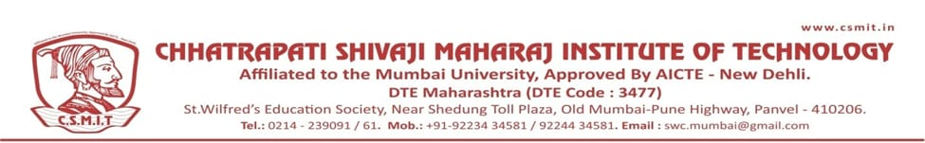

A REPORT ON HAR GHAR TIRANGA DRIVE

- NAME OF ACTIVITY: Har Ghar Tiranga

- DATE & DURATION: 12th to 13 Aug, 2022

- TYPE OF ACTIVITY: Extra Curricular

- ORGANIZED BY: Chhatrapati Shivaji Maharaj Institute of Technology

LEARNING OUTCOMES:

FLYER:

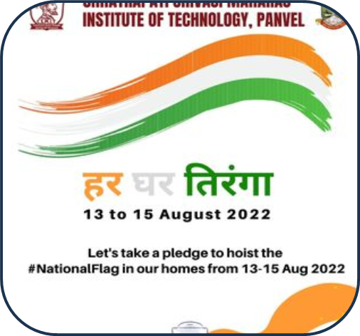

An awareness rally for HAR GHAR TIRANGA was conducted by Chhatrapati Shivaji Maharaj Institute of Technology, Panvel on 12th August 2022, Friday. The students, teachers and general public joined the foot March taken out for public awareness. Rally was held between Orion mall to Karnala Sports Academy.

♦
GLIMPSES:

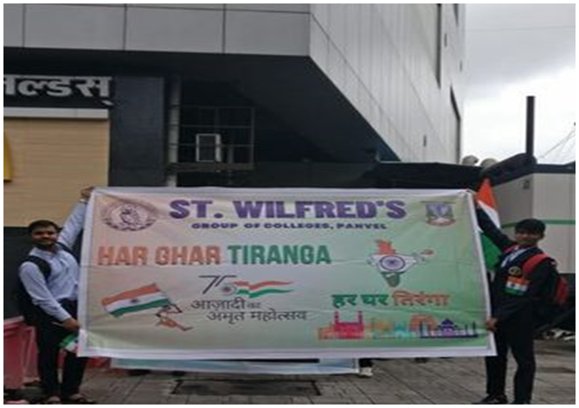

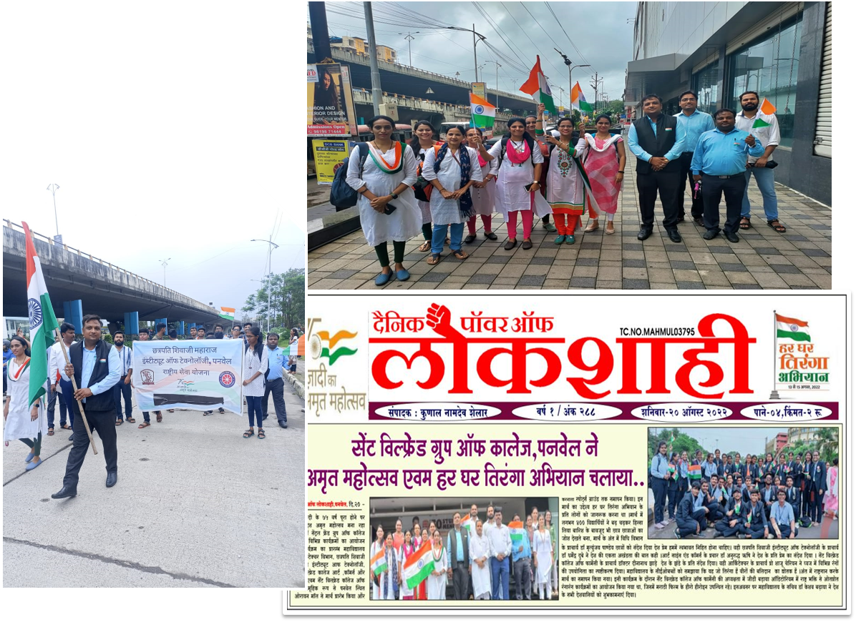

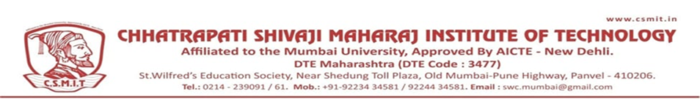

A REPORT ON TREE PLANTATION DRIVE

- NAME OF ACTIVITY: Tree Plantation

- DATE & DURATION: 21st Sept, 2022

- TYPE OF ACTIVITY: Extra Curricular

- ORGANIZED BY: Chhatrapati Shivaji Maharaj Institute of Technology

LEARNING OUTCOMES:

MAPPINGS WITH PO AND PSO:

CO | PO1 | PO2 | PO3 | PO4 | PO5 | PO6 | PO7 | PO8 | PO9 | PO10 | PO11 | PO12 | PSO1 | PSO2 | PSO3
Helps reach education goals through free expression, debates, cooperation, coordination, etc. |  |  |  |  |  | 3 | 2 | 2 | 3 | 3 |  | 1 | 2 |  | 3
Develops habits of constructive competition, improves skills and competence |  |  |  |  |  | 3 | 2 | 2 | 3 | 3 |  | 1
Develops a sense of responsibility and belongingness |  |  |  |  |  | 3 | 2 | 2 | 3 | 3 |  | 1 | 2 |  | 3
Develops decision- making skills  self-assessment, and cultural awareness |  |  |  |  |  | 3 | 2 | 2 | 3 | 3 |  | 1 | 2 |  | 3
Develops leadership, managerial, and organizing skills |  |  |  |  |  | 3 | 2 | 2 | 3 | 3 |  | 1 | 2 |  | 3
Creates opportunities to meet with other like- minded students for socialization, |  |  |  |  |  | 3 | 2 | 2 | 3 | 3 |  | 1 | 2 |  | 3

- ASSESSMENT TOOLS: NIL

FLYER:

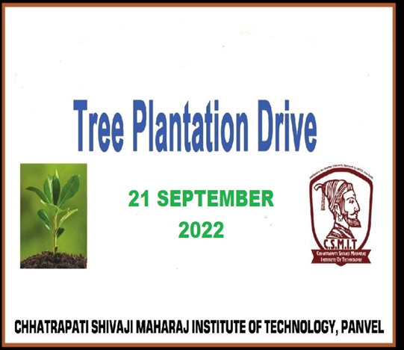

Tree Plantation drives combat many environmental issues like deforestation, erosion of soil, desertification in semi-arid areas, global warming and hence enhancing the beauty and balance of the environment. Trees absorb harmful gases and emit oxygen resulting in an increase in oxygen supply
On 21ST SEPTEMBER 2022, NSS, Chhatrapati Shivaji Maharaj Institute of Technology, Panvel, arranged tree plantation drive. All the faculties and students were involved in this event.

GLIMPSES:

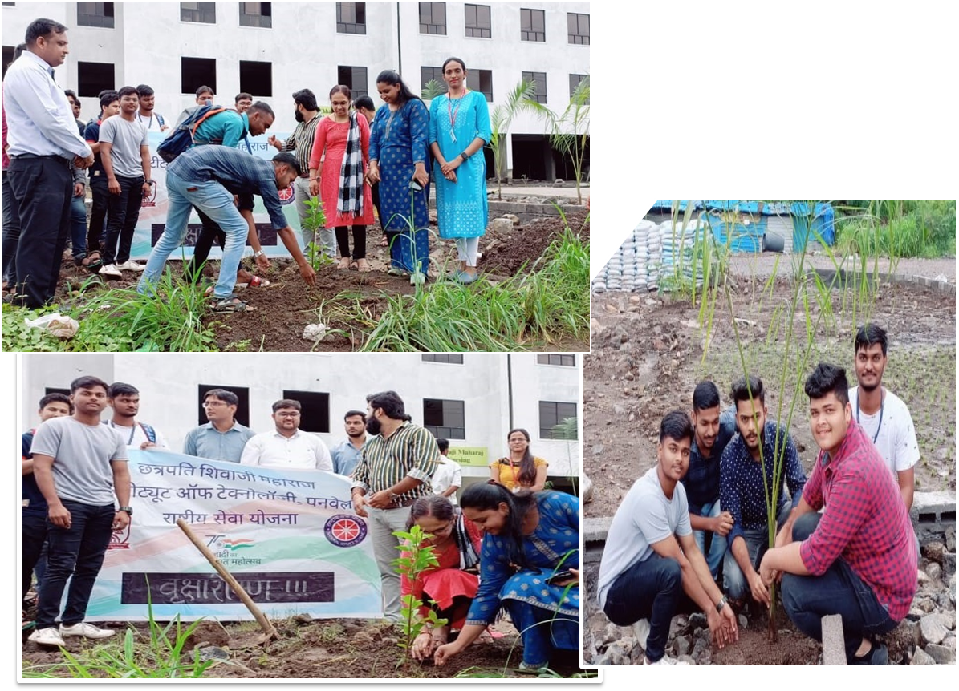

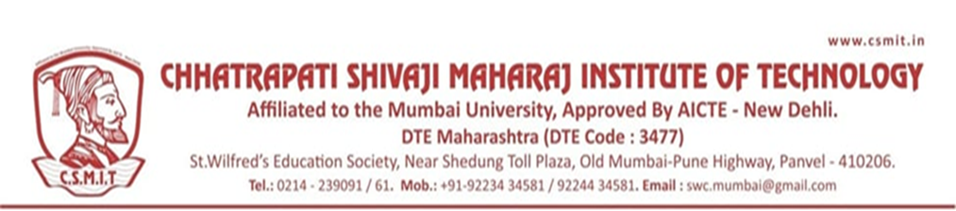

REPORT ON BLOOD DONATION CAMP

- NAME OF ACTIVITY: Blood Donation Camp

- DATE & DURATION: 28th Sept, 2022 Time: 1:00 PM to 4:00 PM

- TYPE OF ACTIVITY: Extra Curricular

- ORGANIZED BY: Chhatrapati Shivaji Maharaj Institute of Technology and Navi Mumbai Blood Bank

LEARNING OUTCOMES:

- Rise global awareness of the need for safe blood and blood product for blood
- transfusion and critical contribution voluntarily.
- Promote unpaid blood donors make to national health.
- Celebrate & thanks individual, who donate blood.
- Encourage those who have not yet donated blood to start donating.
- Focus attention on donor health quality of donor care as a critical factors in building
- donor commitment & willingness to donate regularly
- Motivate all students to take a pledge to donate blood at least once in a year

Instil the feeling of helping others to breathe life with their precious donation

FLYER:

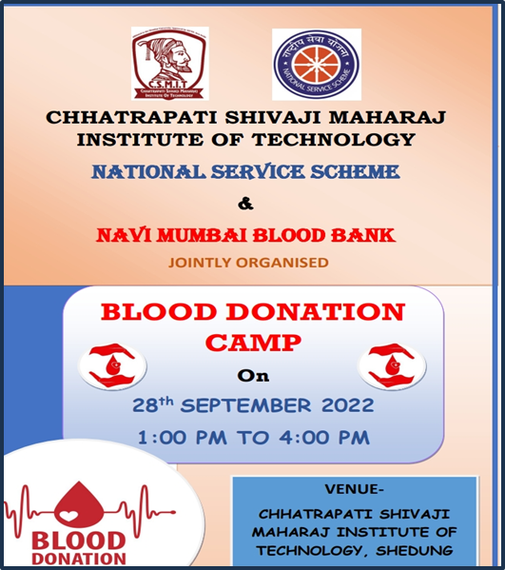

On 28TH September 2022, NSS, Chhatrapati Shivaji Maharaj Institute of Technology, Panvel, arranged BLOOD DONATION CAMP. All the faculties and students were involved in this event.

♦ GLIMPSES:

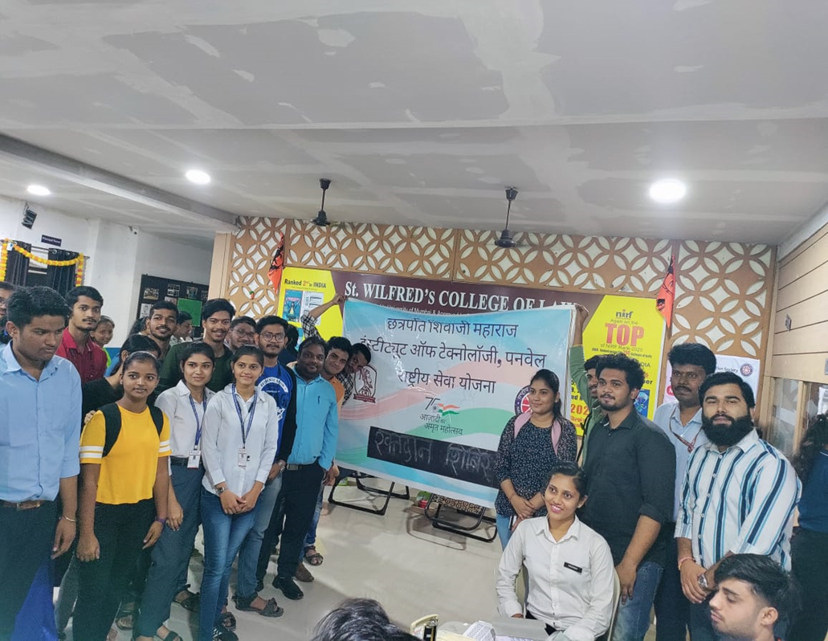

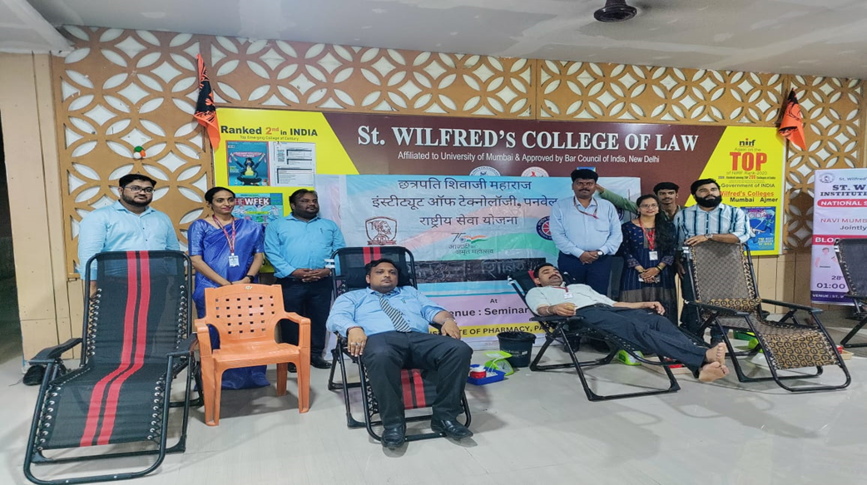

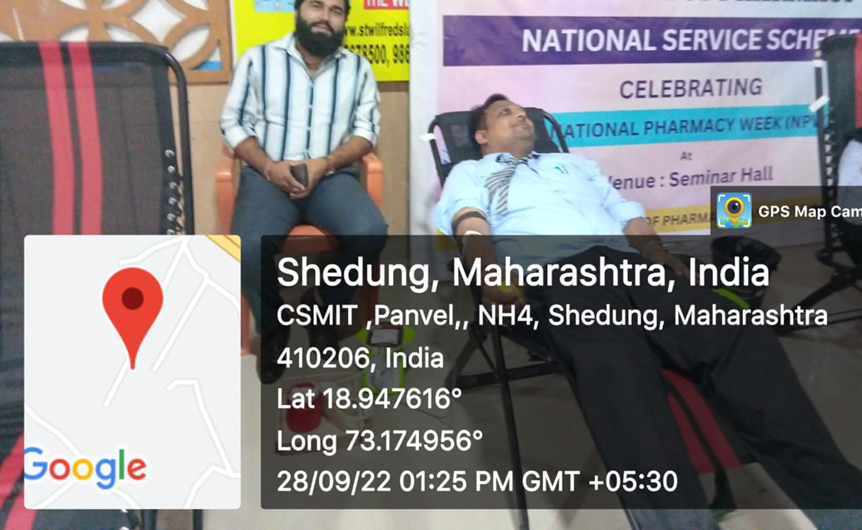

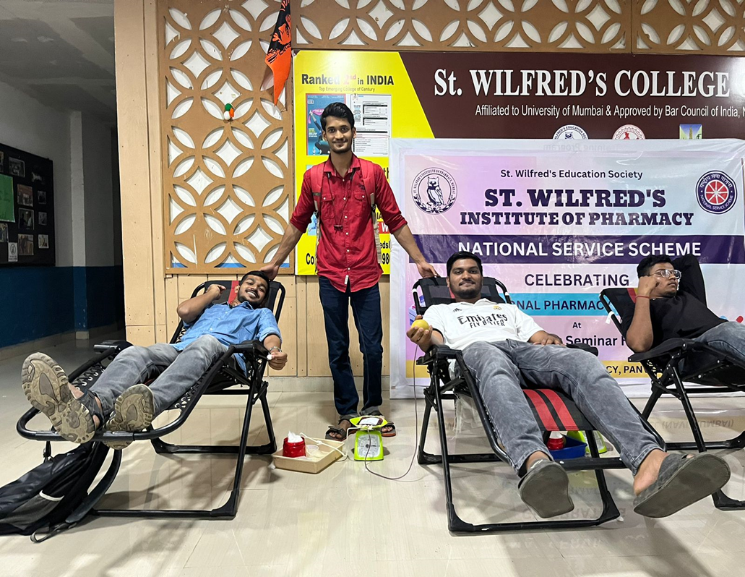

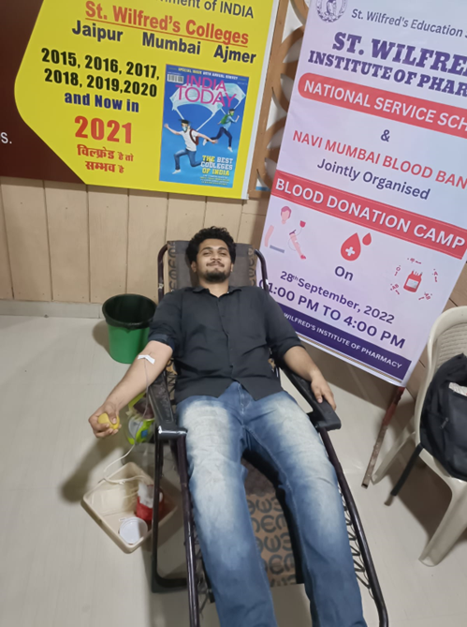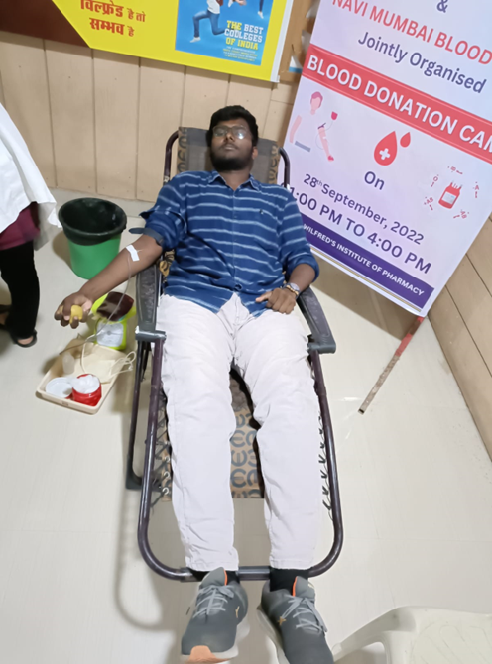
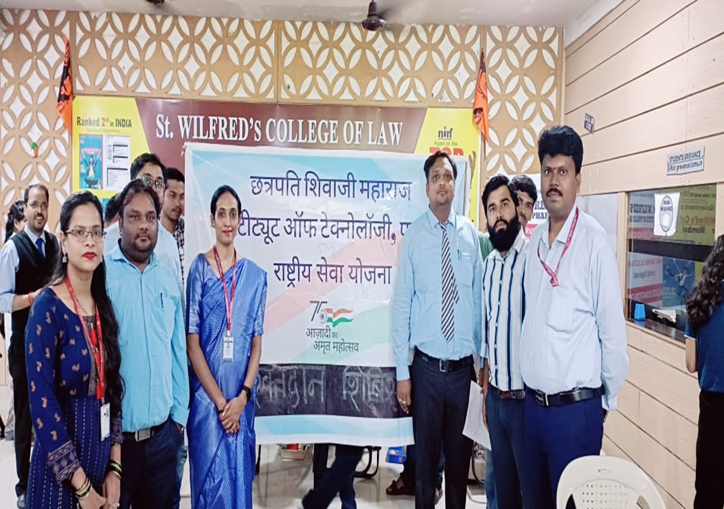
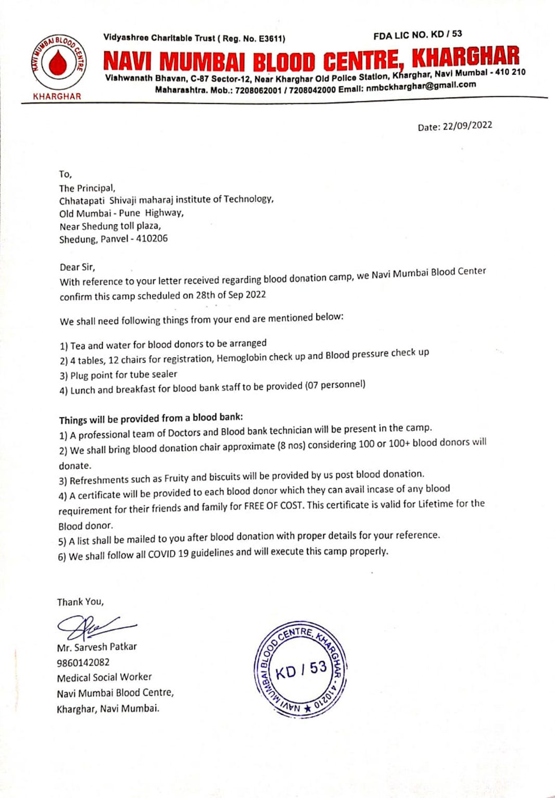

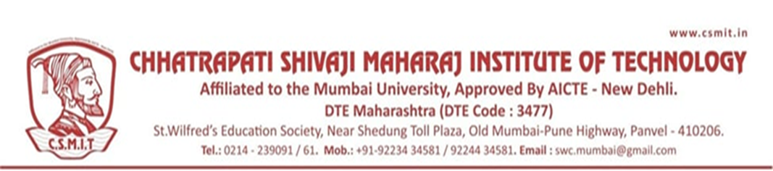

REPORT ON GANDHI JAYANTI

- NAME OF ACTIVITY: Gandhi Jayanti

- DATE & DURATION: 2nd Oct, 2022

- TYPE OF ACTIVITY: Extra Curricular

- ORGANIZED BY: Chhatrapati Shivaji Maharaj Institute of Technology

ABOUT THE PROGRAMME

Gandhi Jayanti is celebrated to mark the birth anniversary of the Father of the Nation. This day is celebrated all over the country even outside the country by the followers of Mahatma Gandhi. Gandhi Ji was the practitioner of Ahinsa (Non-Violence) so this day is also celebrated as the International Day of Non-Violence by the United Nations. Gandhi Jayanti is being observed today, on October 2, 2022. Mahatma Gandhi was born on October 2, 1869 in Porbandar city of Gujrat. Mahatma Gandhi's full name was Mohandas Karamchand Gandhi later known as Mahatma Gandhi. He completed his education and got a law degree from London and then he went to South Africa to practice further.
In South Africa, the situation of Indians was not so good as they were treated badly due to their dark skin. He contributed his efforts and tried to improve the situation of Indians.

GLIMPSES:

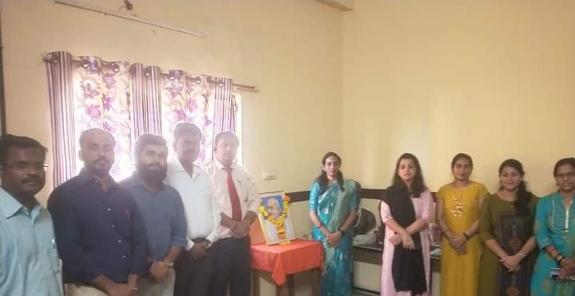

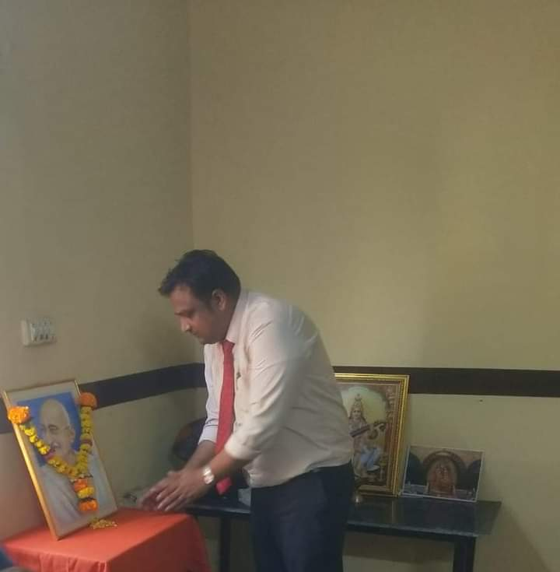

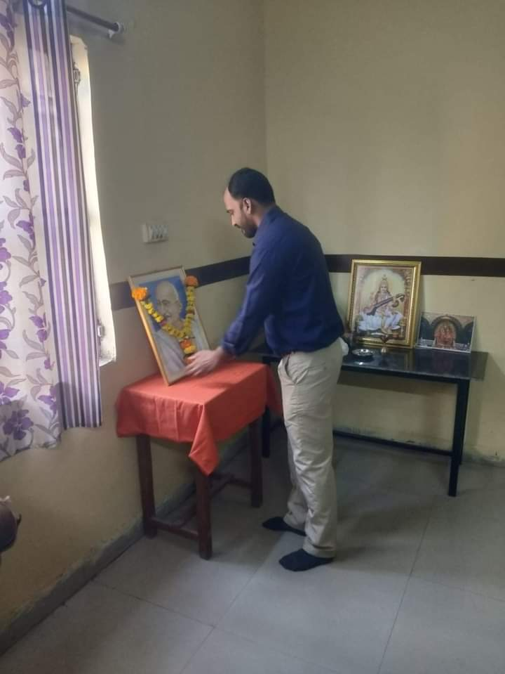

REPORT ON RASHTRIYA EKTA DIVAS

- NAME OF ACTIVITY: National Unity Day

- DATE & DURATION: 31st Oct, 2022

- TYPE OF ACTIVITY: Extra Curricular

- ORGANIZED BY: Chhatrapati Shivaji Maharaj Institute of Technology

October 31st is celebrated as Unity Day in India to commemorate the birth anniversary of Sardar Vallabhbhai Patel. Know about the date, theme, significance, and history of the day here.
Every year October 31st is celebrated as the National Unity Day or Rashtriya Ekta Diwas in India to commemorate the birth anniversary of Sardar Vallabhbhai Patel.
Sardar Vallabhbhai Patel, also known as the Indian Iron Man, was India’s first deputy Prime Minister and Home Minister. He was a vital figure in the Indian independence movement and played a key role in the partition of British India into two independent nations - India and Pakistan.

REPORT ON BIRSA MUNDA DAY

- NAME OF ACTIVITY: Birsa Munda Day

- DATE & DURATION: 15st Nov, 2022

- TYPE OF ACTIVITY: Extra Curricular

- ORGANIZED BY: Chhatrapati Shivaji Maharaj Institute of Technology

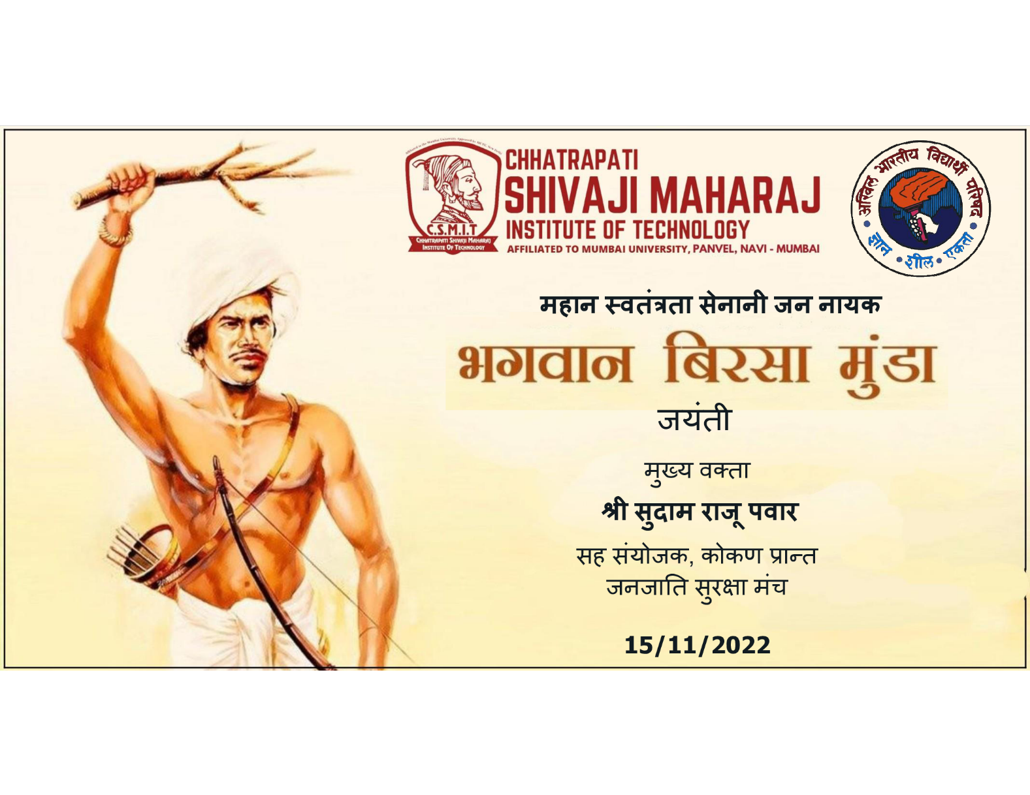

REPORT ON CONSTITUTION DAY

- NAME OF ACTIVITY: Constitution Day

- DATE & DURATION: 28th Nov 2023

- TYPE OF ACTIVITY: Extra Curricular

- ORGANIZED BY: Chhatrapati Shivaji Maharaj Institute of Technology

ABOUT THE PROGRAMME
Constitution Day also known as 'Samvidhan Divas', is celebrated in our country on 26th November every year to commemorate the adoption of the Constitution of India. On 26 November 1949, the Constituent Assembly of India adopted the Constitution of India, which came into effect on 26th January 1950.
The Ministry of Social Justice and Empowerment on 19th November 2015 notified the decision of the Government of India to celebrate the 26th day of November every year as 'Constitution Day' to promote Constitution values among citizens.

FLYER

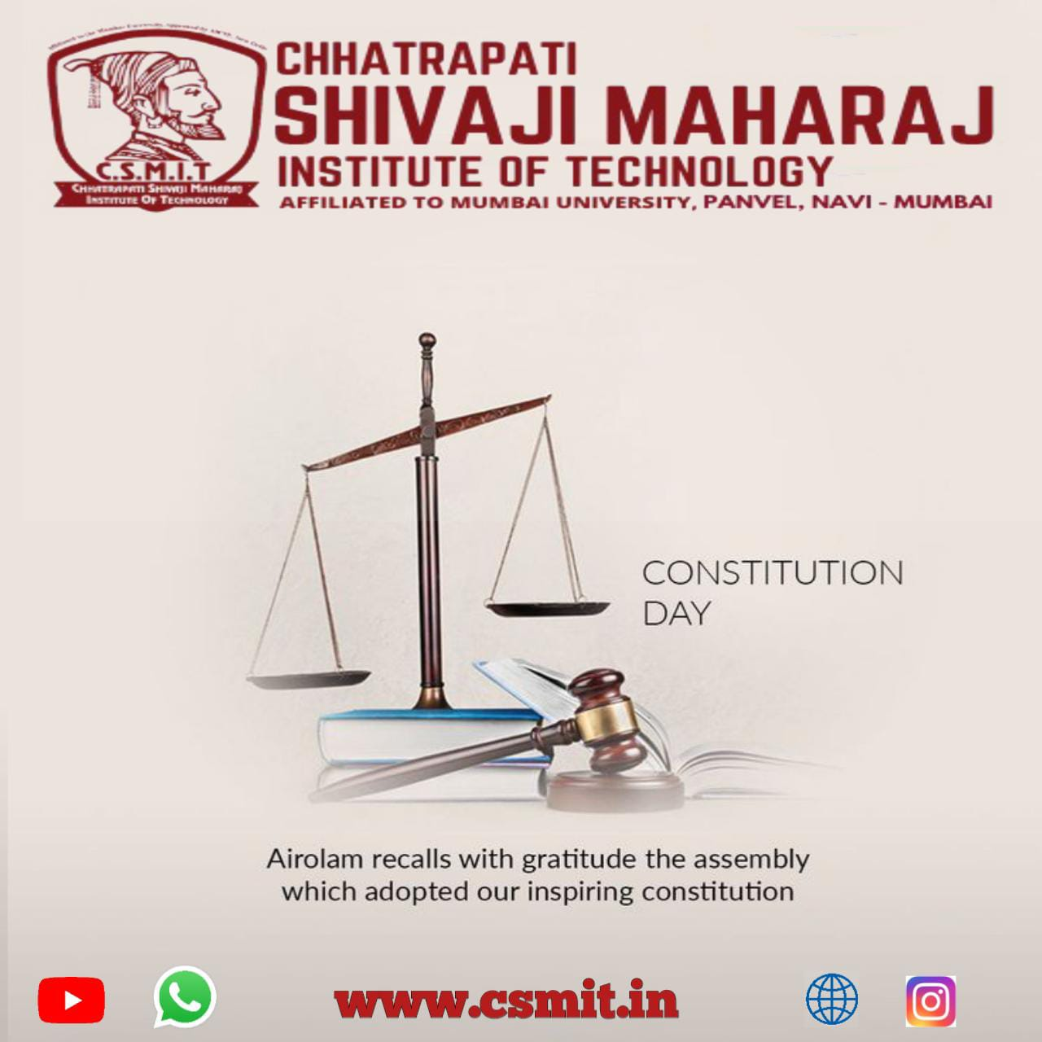

GLIMPSES:

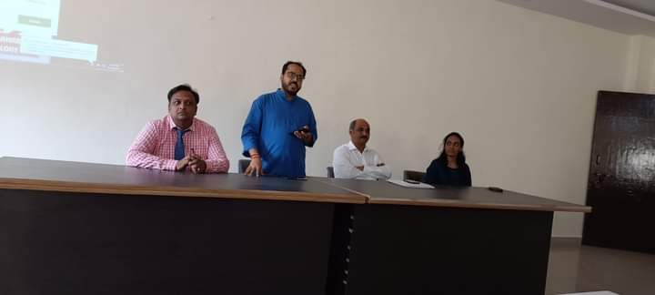

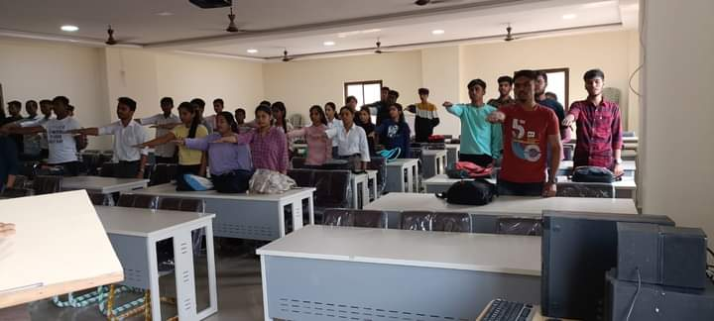

REPORT ON BLOOD DONATION CAMP

- NAME OF ACTIVITY: Blood Donation Camp

- DATE & DURATION: 25th Jan, 2023 Time: 1:00 PM to 4:00 PM

- TYPE OF ACTIVITY: Extra Curricular

- ORGANIZED BY: Chhatrapati Shivaji Maharaj Institute of Technology and Navi Mumbai Blood Bank

LEARNING OUTCOMES:

- Rise global awareness of the need for safe blood products for blood
- transfusion& and critical contribution voluntarily.
- Promote unpaid blood donors to national health.
- Celebrate & thanks individual, who donate blood.
- Encourage those who have not yet donated blood to start donating.
- Focus attention on donor health and quality of donor care as critical factors in building
- donor commitment & and willingness to donate regularly
- Motivate all students to take a pledge to donate blood at least once in a year

Instil the feeling of helping others to breathe life with their precious donation

♦ FLYER:
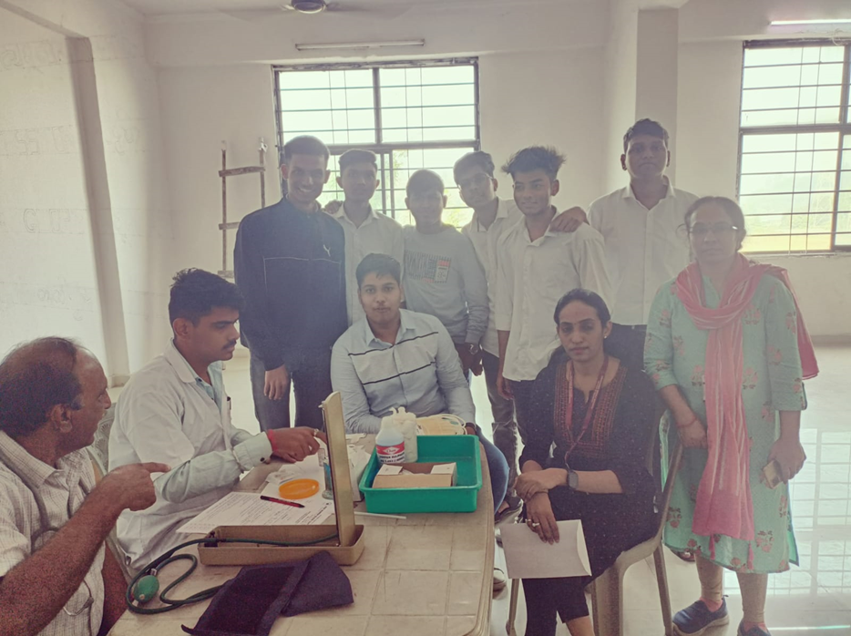

On 25th Jan 2023, NSS, Chhatrapati Shivaji Maharaj Institute of Technology, Panvel, arranged BLOOD DONATION CAMP. All the faculties and students were involved in this event.

GLIMPSES:
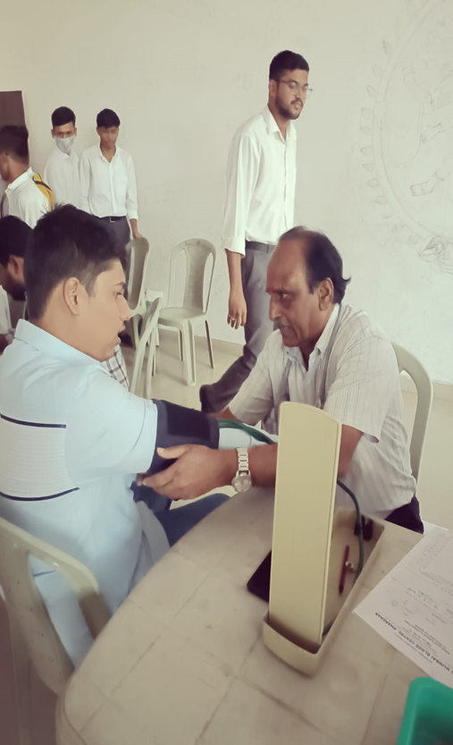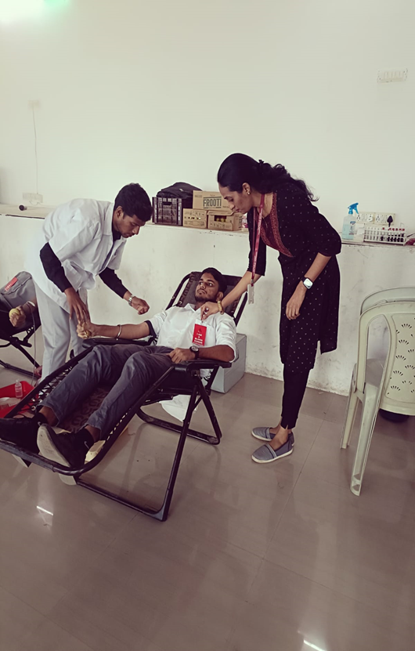
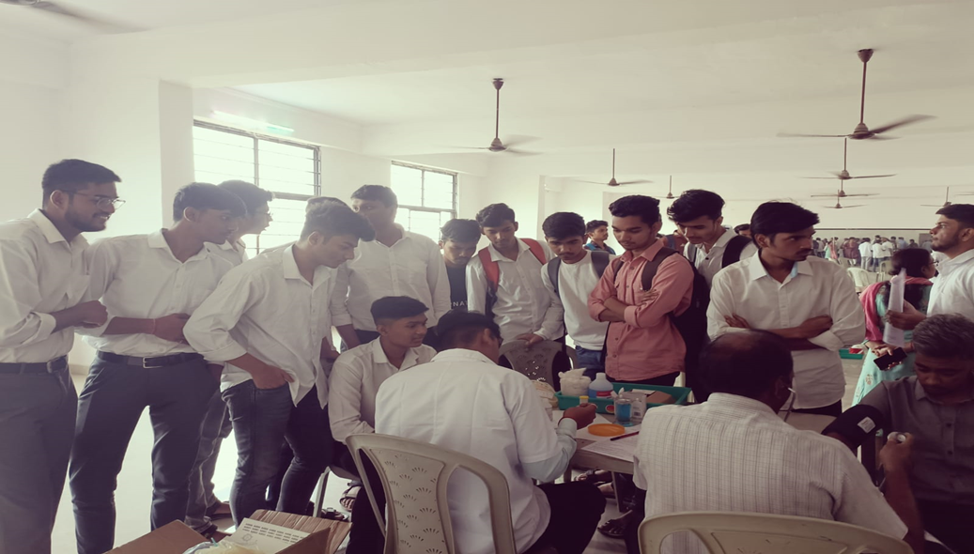

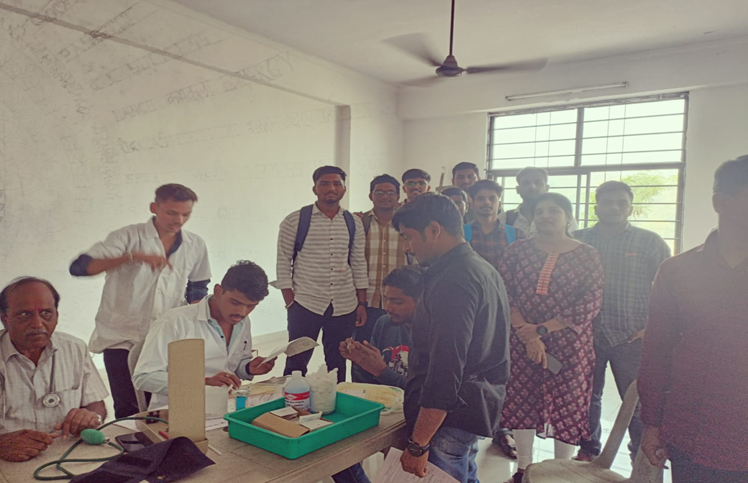

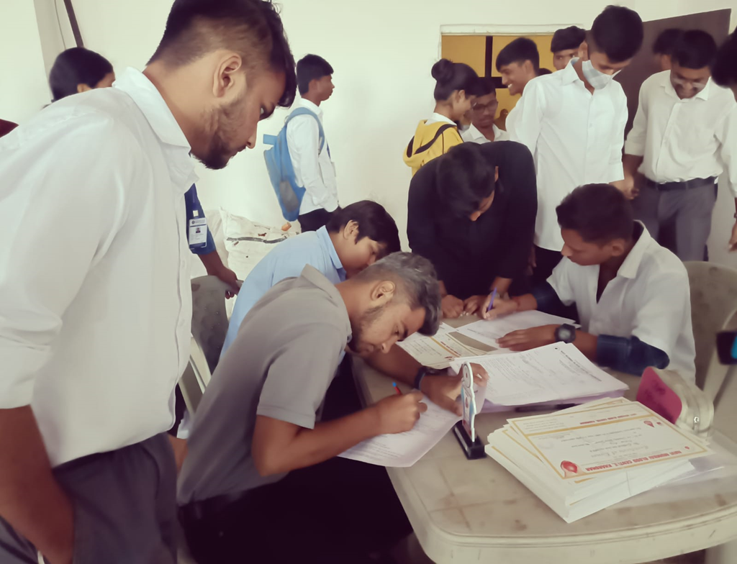
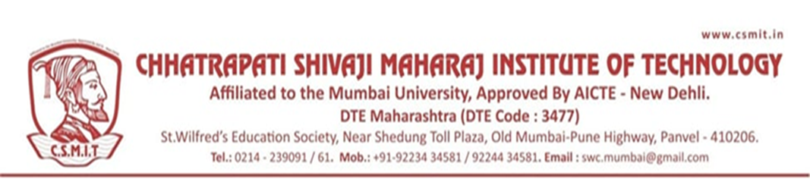

REPORT ON BLOOD DONATION CAMP

- NAME OF ACTIVITY: Blood Donation Camp

- DATE & DURATION: 17th March, 2023 Time: 1:00 PM to 4:00 PM

- TYPE OF ACTIVITY: Extra Curricular

- ORGANIZED BY: Chhatrapati Shivaji Maharaj Institute of Technology and Navi Mumbai Blood Bank

LEARNING OUTCOMES:

- Rise global awareness of the need for safe blood and blood product for blood
- transfusion and critical contribution voluntarily.
- Promote unpaid blood donors make to national health.
- Celebrate & thanks individual, who donate blood.
- Encourage those who have not yet donated blood to start donating.
- Focus attention on donor health quality of donor care as critical factors in building
- donor commitment & willingness to donate regularly
- Motivate all students to take a pledge to donate blood at least once in a year

Instil the feeling of helping others to breathe life with their precious donation

FLYER:

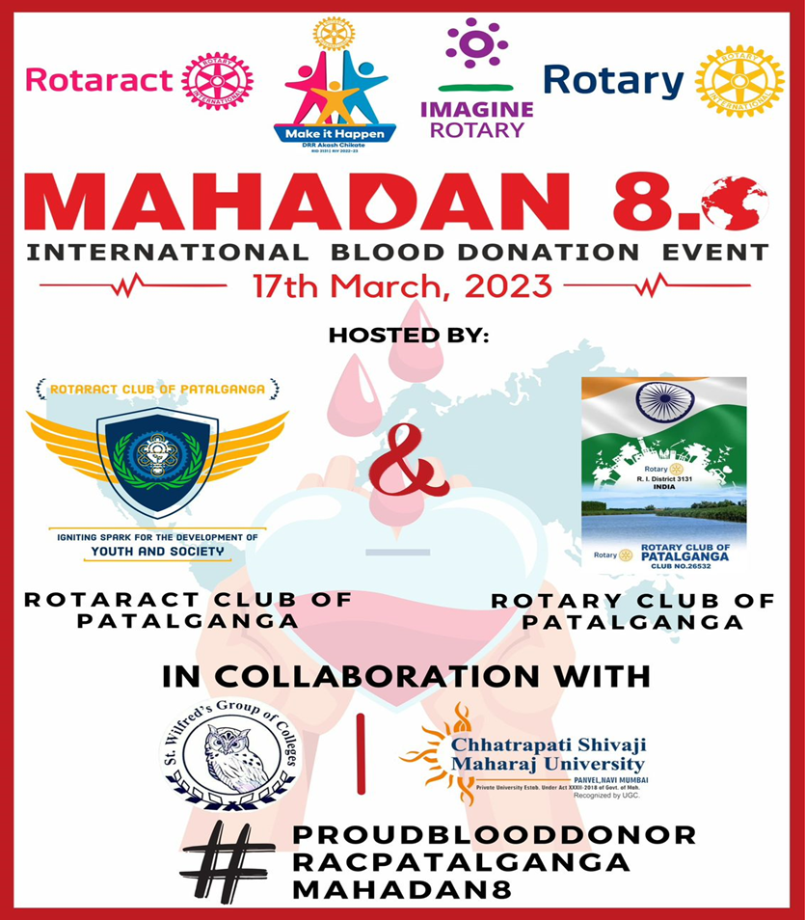

GLIMPSES:
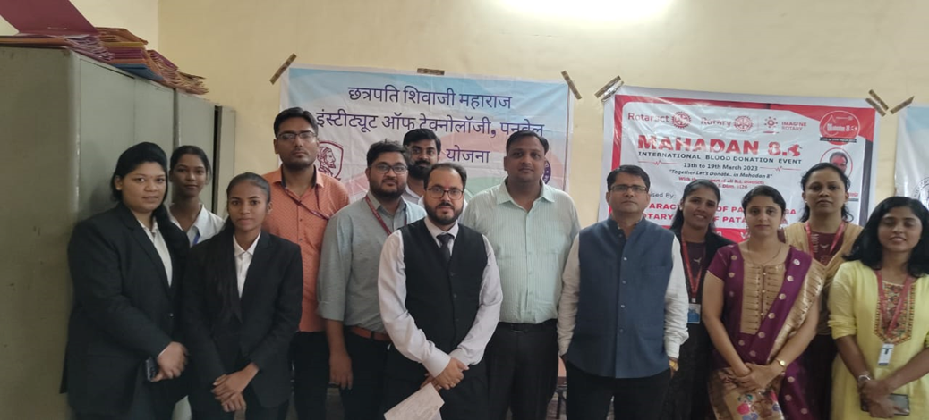

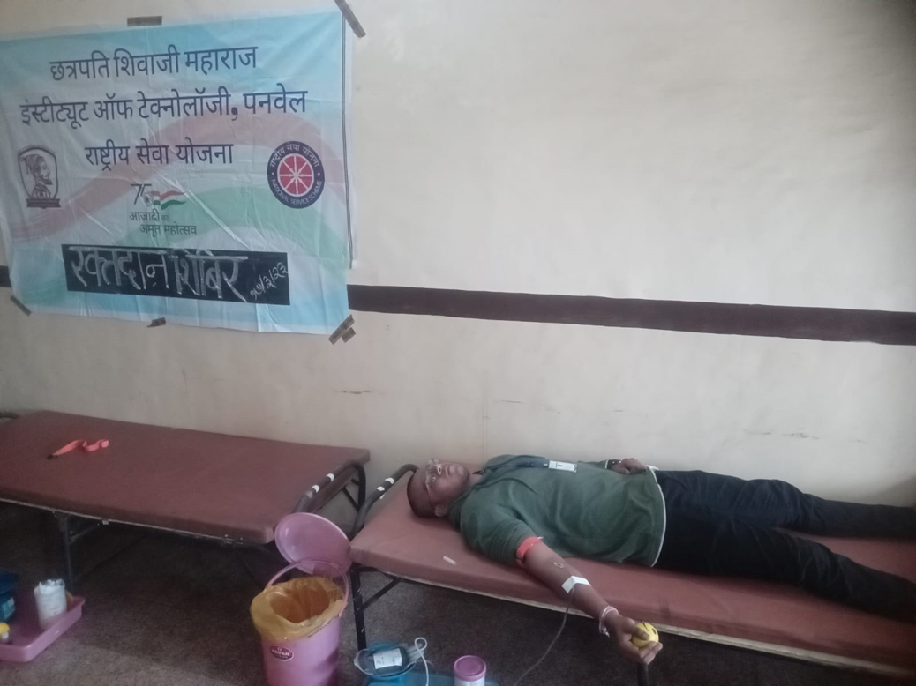

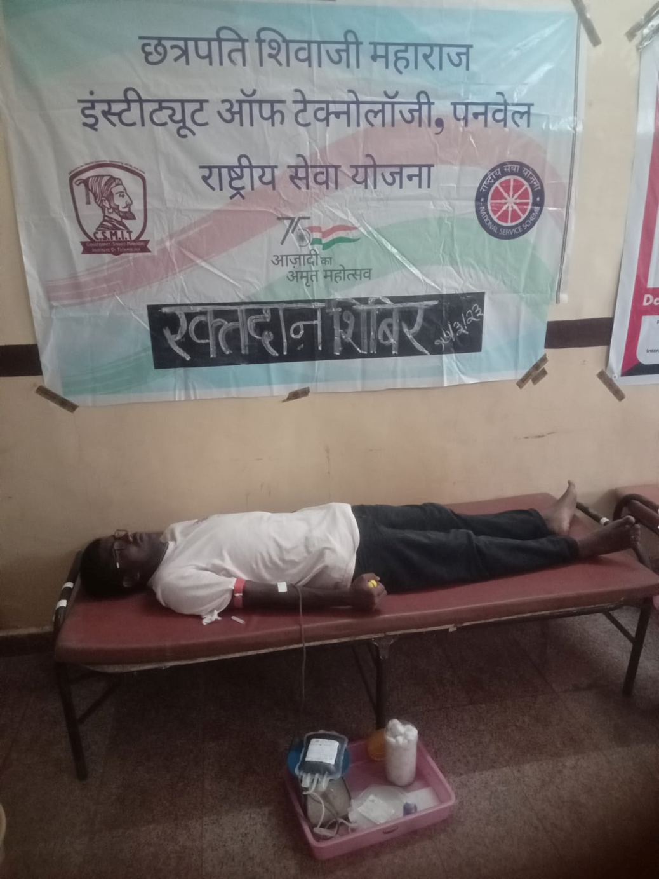

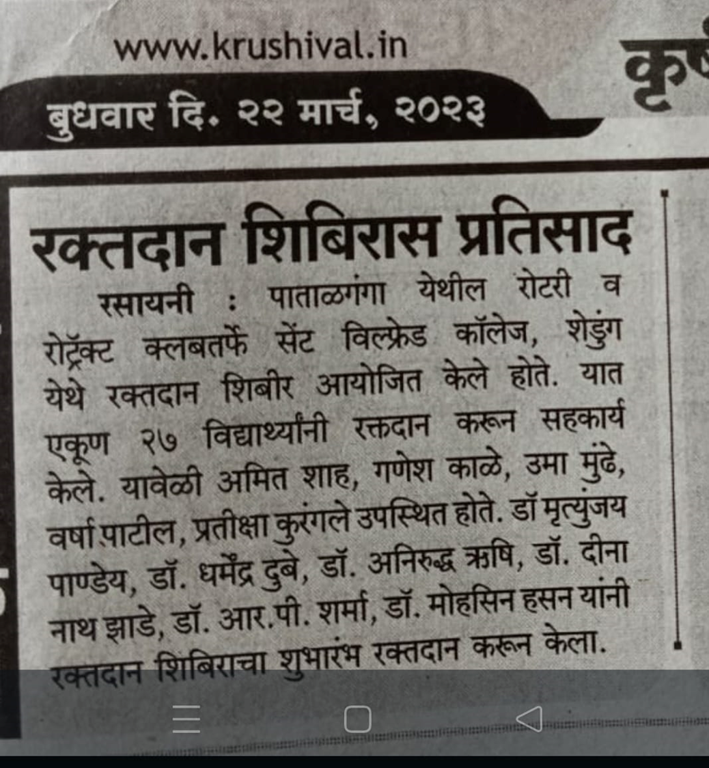

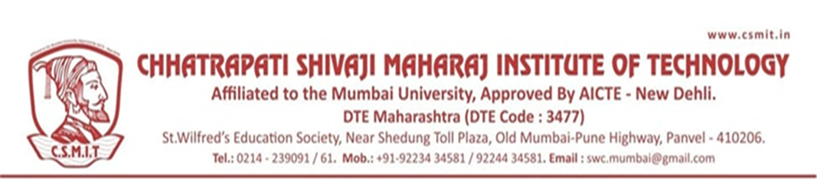

A REPORT ON NSS SPECIAL CAMP

- NAME OF ACTIVITY: NSS Camp

- DATE & DURATION: 26th March to 2nd April, 2023

- TYPE OF ACTIVITY: Extra Curricular

- ORGANIZED BY: Chhatrapati Shivaji Maharaj Institute of Technology

LEARNING OUTCOMES:

FLYER:

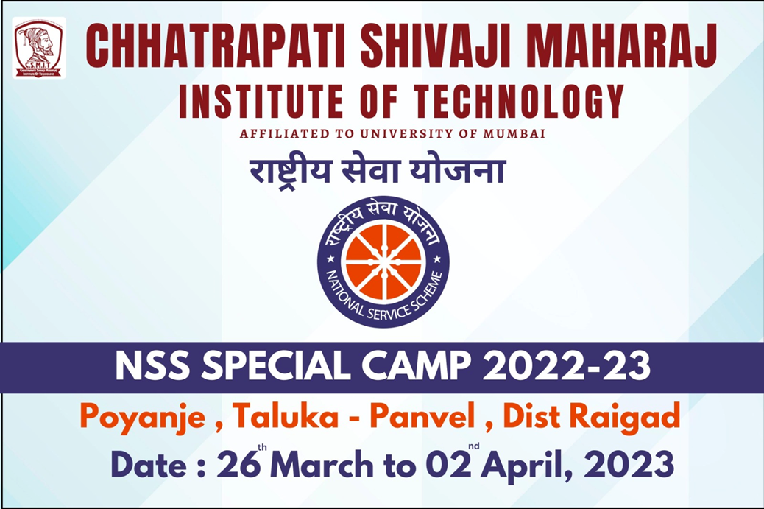

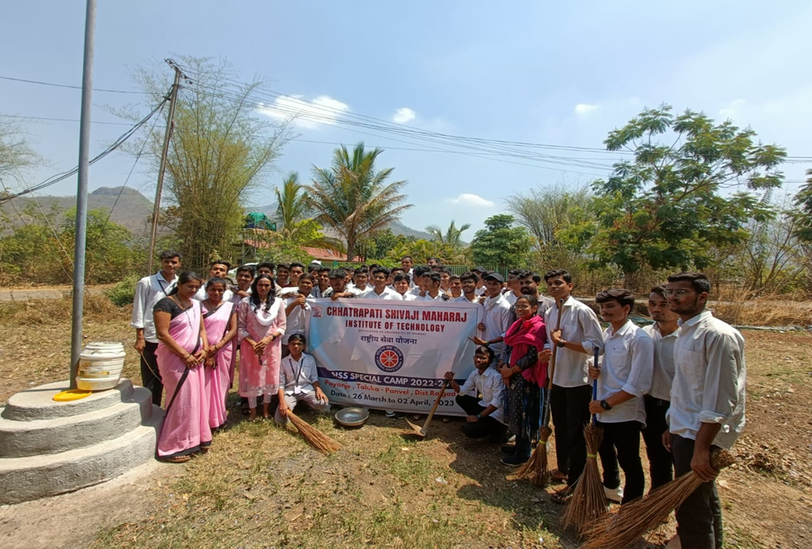

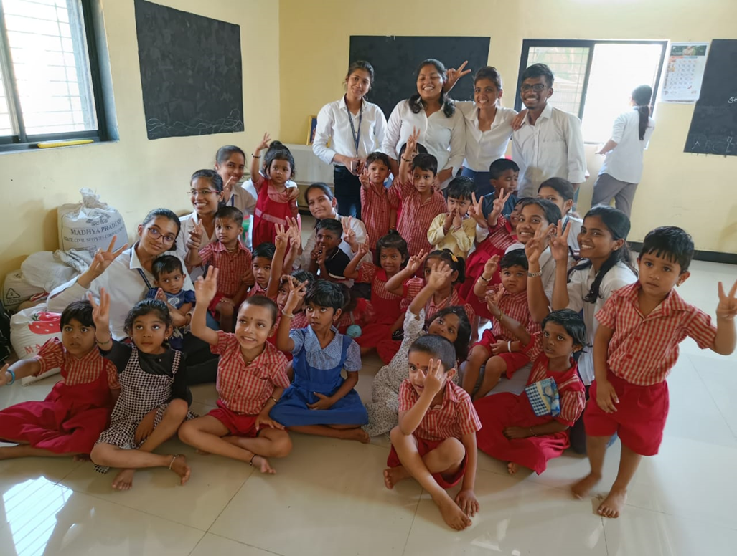

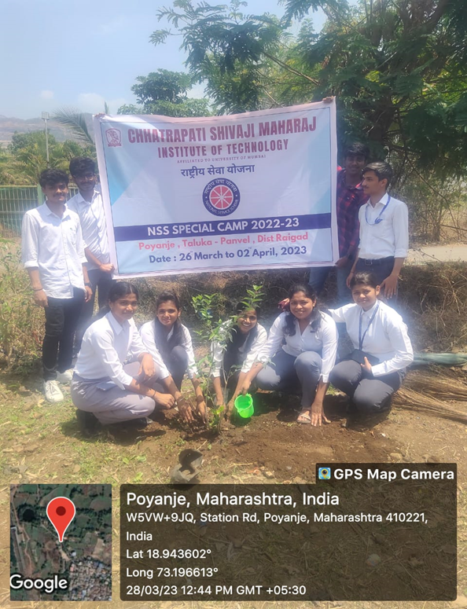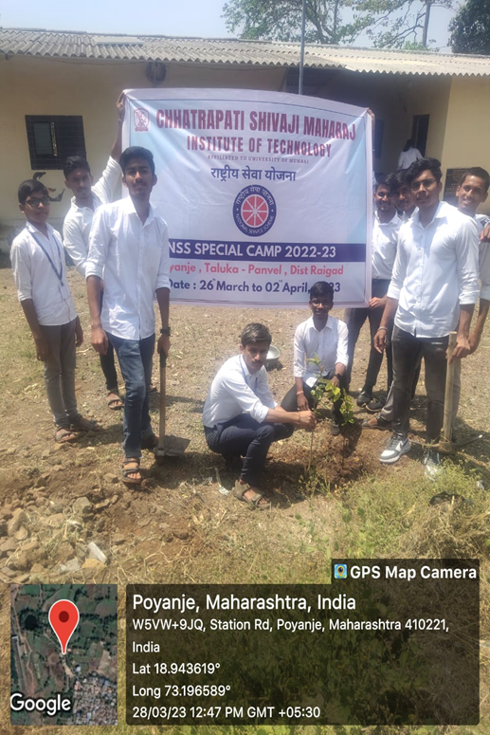

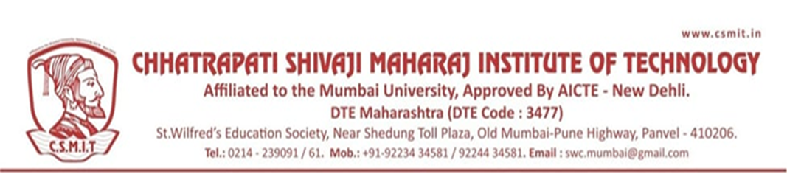

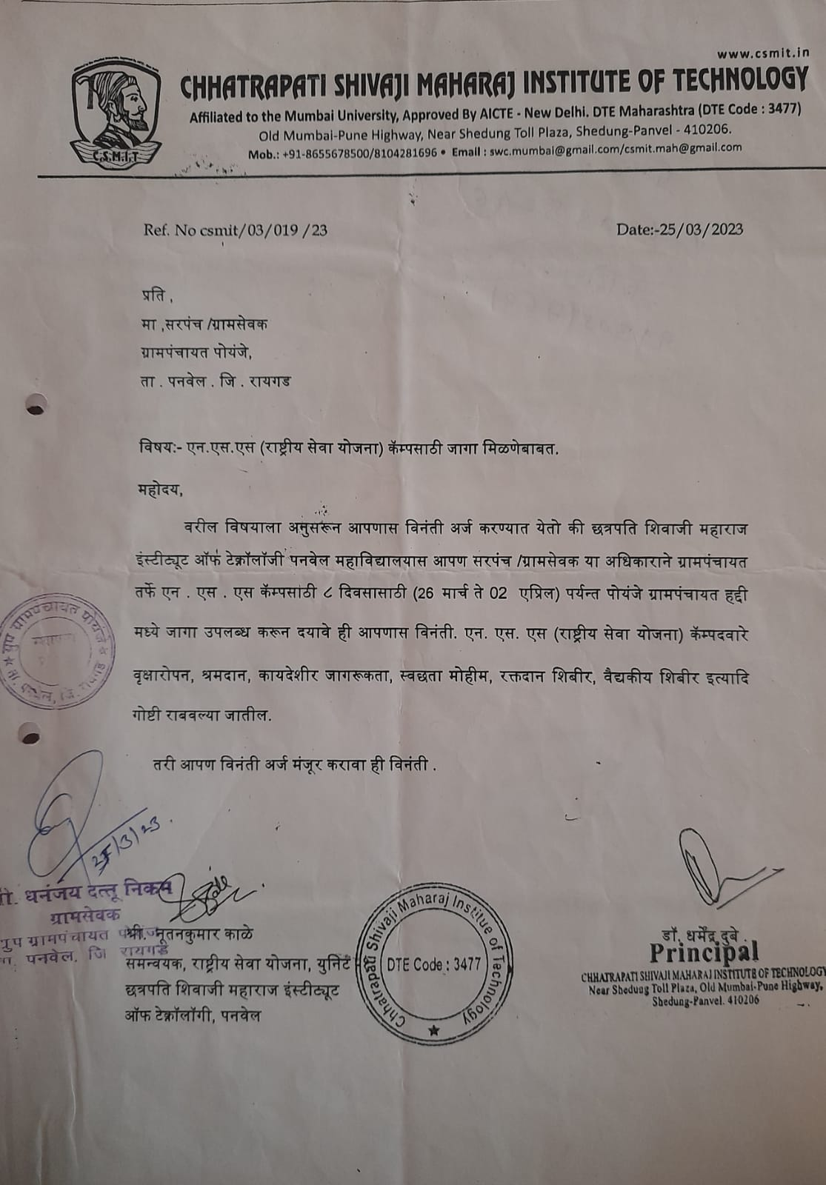

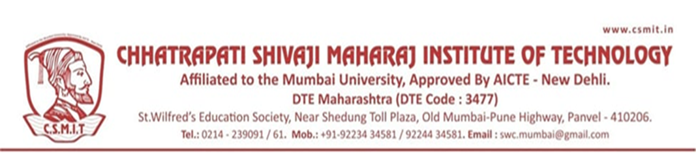

A REPORT ON INTERNATIONAL YOGA DAY

- NAME OF ACTIVITY: International Yoga Day

- DATE & DURATION: 21st June 2023

- TYPE OF ACTIVITY: Extra Curricular

- ORGANIZED BY: Chhatrapati Shivaji Maharaj Institute of Technology

LEARNING OUTCOMES:

FLYER

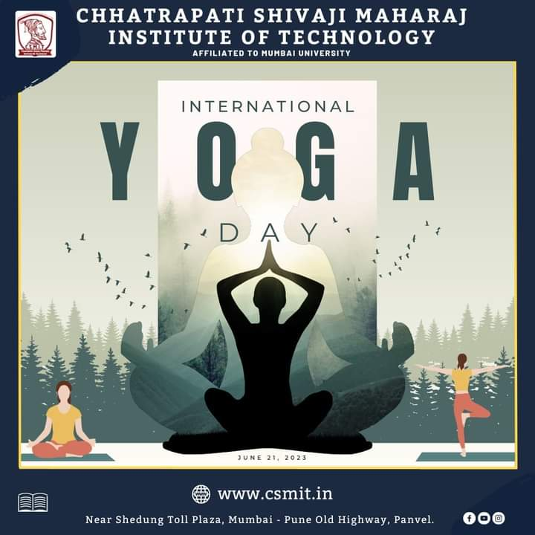

ABOUT THE PROGRAMME
International Yoga Day is celebrated every year on June 21. It serves as a global platform to raise awareness about the various benefits of practicing yoga.
It is an ancient practice that originated in India and has gained popularity globally for its mental, physical, and spiritual benefits. It incorporates various postures (asanas), meditation techniques, and breathing exercises (pranayama) to promote overall well-being and harmony.

