Chhatrapati Shivaji Maharaj Institute of Technology, Navi-Mumbai
Program Organized in Year 2023-24

Sr.N. | Name of Activity | Organization Unit/ Collaboration Agency | Date | Page No.
1 | Swami Vivekananda Punyatithi | NSS | 04/07/2023
2 | Tree Plantation Drive | NSS | 15/07/2023
3 | Pledge for Meri Mati Mera Desh | NSS | 09/08/2023
4 | Tree Plantation | NSS | 23/08/2023
5 | Teacher’s Day Celebration | NSS | 05/09/2023
6 | Janmashtami Celebration | NSS | 06/09/2023
7 | Swachh Bharat Abhiyan | NSS | 16/09/2023
8 | Ganesh Chaturthi Celebration | NSS | 19/09/2023 to 25/09/2023
9 | NSS Foundation Day | NSS | 24/09/2023
10 | World Environment Health Day | NSS | 26/09/2023
11 | Meet Bottle Gourd Man | NSS | 30/09/2023
12 | Cleaning Drive | NSS | 02/10/2023
13 | Gandhi Jayanti | NSS | 02/10/2023
14 | Investor Awareness Program | CASI Global & CSMIT | 04/10/2023
15 | World’s Investor week Quiz Competition | CASI Global & CSMIT | 10/10/2023
16 | Youth Campaign on Quality Connect | CSMIT & BIS | 12/10/2023
17 | Free Health Check-up Camp | NSS | 14/10/2023
18 | Dussehra Celebration | CSMIT | 21/10/2023
19 | Meri Maati Mera Desh Selfi & Kalash Program | CSMIT | 30/10/2023
20 | Gramin Computer Literacy Program | NSS | 31/10/2023
21 | National Unity Day | NSS | 31/10/2023 to  02/11/2023

A REPORT ON SWAMI VIVEKANAND JAYANTI

- NAME OF ACTIVITY: Swami Vivekanand Jayanti

- DATE & DURATION: 04th 07, 2023

- TYPE OF ACTIVITY: NSS Activity

- ORGANIZED BY: Chhatrapati Shivaji Maharaj Institute of Technology, Panvel.

FLYER:

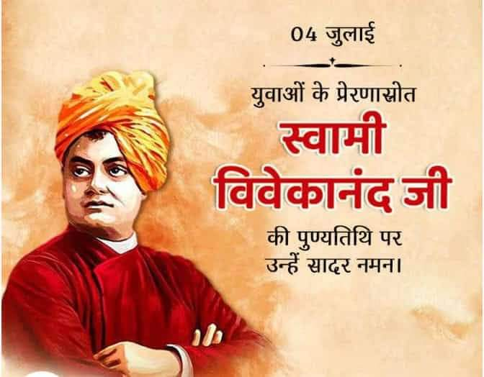

ABOUT THE PROGRAMME
National Youth Day 2023: National Youth Day in India is celebrated to mark the birthday of Swami Vivekananda, who was a Hindu monk, philosopher, and one of the most influential spiritual leaders in India. He was born on January 12, 1863 and his teachings and philosophy have had a significant impact on the development of modern India.Swami Vivekananda was a key figure in the introduction of the Hindu philosophy of Vedanta and Yoga to the Western world, and he is created with bringing Hinduism to the status of a major world religion during the late 19th century. He was also a strong advocate for social justice and worked to uplift the status of women and lower castes in Indian society.

A REPORT ON TREE PLANTATION DRIVE

- NAME OF ACTIVITY: Tree Plantation

- DATE & DURATION: 15th 07, 2023

- TYPE OF ACTIVITY: NSS Activity

- ORGANIZED BY: Chhatrapati Shivaji Maharaj Institute of Technology, Panvel.

- DETAILS OF ACTIVITY:

Trees represent life, growth, peace and nature. They produce oxygen, clean soil, prevent drought, control flood related disasters, prevent soil erosion, improve physiological, mental and spiritual health, and also reduce carbon footprints. Keeping this in mind the campaign for the One-Student One-Tree programme was initiated by the Chhatrapati Shivaji Maharaj Institute of Technology on 15th August 2023. Tree Plantation drives combat many environmental issues like deforestation, erosion of soil, desertification in semi-arid areas, global warming and hence enhancing the beauty and balance of the environment. Trees absorb harmful gases and emit oxygen resulting in an increase in oxygen supply. On average, a single tree emits 260 pounds of oxygen annually. Similarly, a fully-grown tree is sufficient for 18 human beings in one acre of land in one year stressing the importance of tree plantation for mankind.
All the faculties and students were involved in this event. In order to sensitise students towards the need to preserve our environment and ecology, Tree plantation drive was organised by CSMIT. The main purpose of this event was to teach students how we can save our climate from pollution.

Sr. No. | Name of college | Total Tree Planted | By support of  social group
1. | Chhatrapati Shivaji Maharaj Institute of Technology | 250

GLIMPSES:

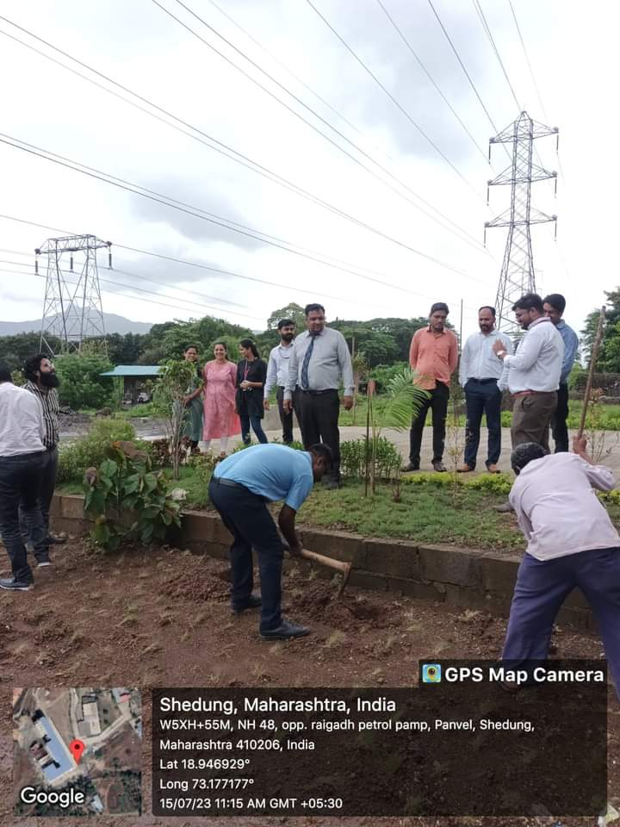

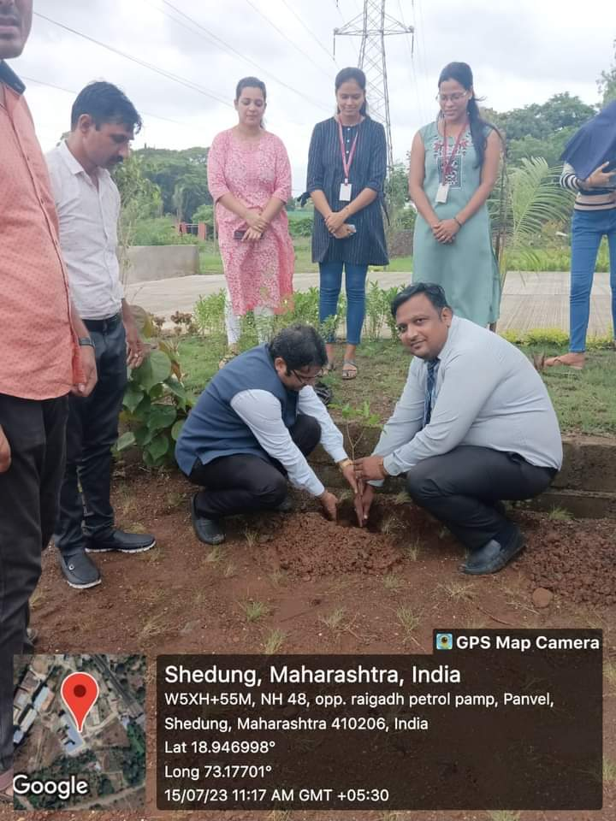

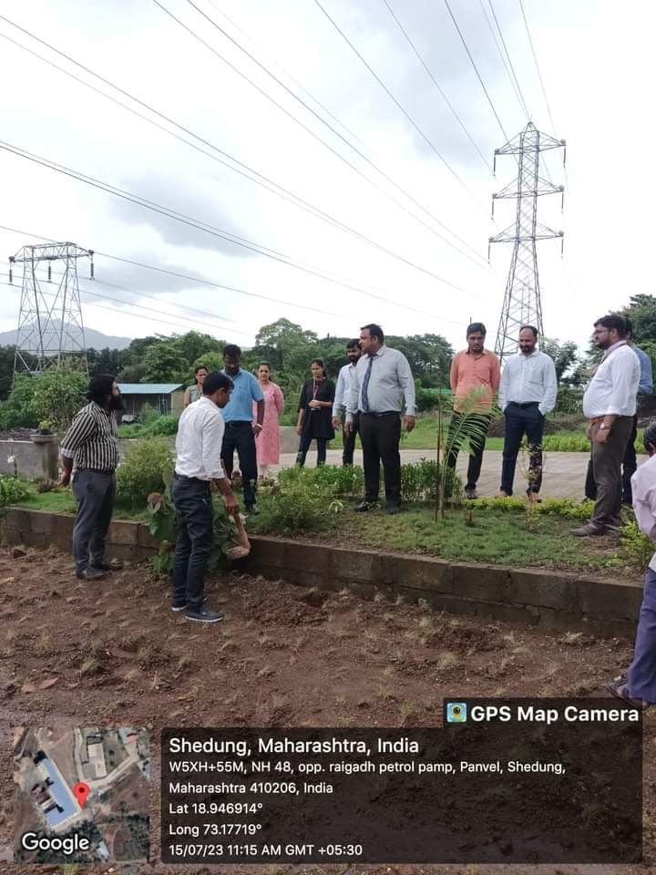

A REPORT ON PLEDGE FOR MERI MATI MERA DESH

- NAME OF ACTIVITY: MERI MATI MERA DESH

- DATE & DURATION: 09th 08, 2023

- TYPE OF ACTIVITY: NSS Activity

- ORGANIZED BY: Chhatrapati Shivaji Maharaj Institute of Technology, Panvel.

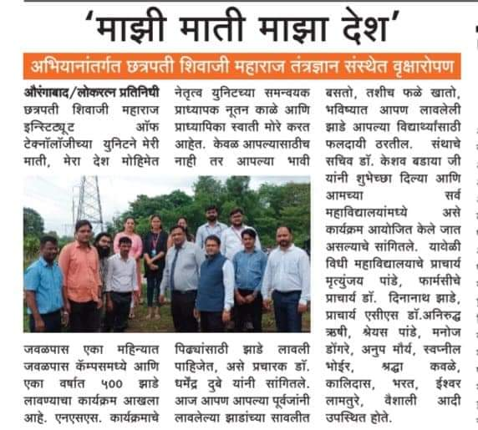

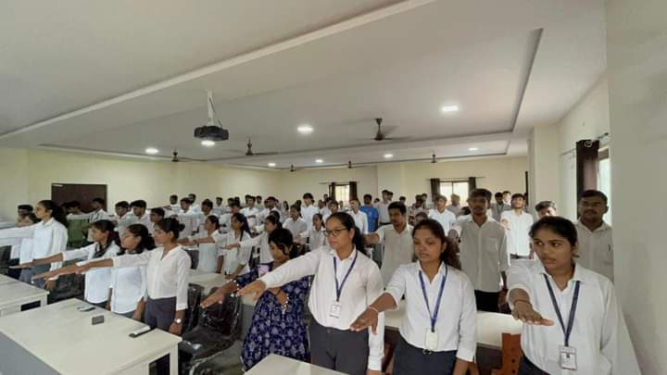

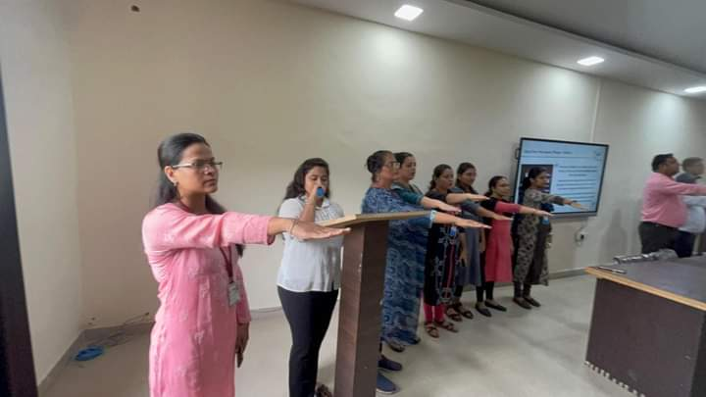

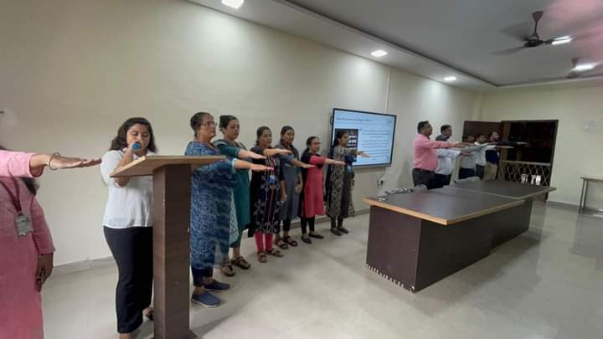

A REPORT ON TREE PLANTATION DRIVE

- NAME OF ACTIVITY: Tree Plantation

- DATE & DURATION: 23th 08, 2023 Time: 1.00 pm -4.00 pm

- TYPE OF ACTIVITY: 1st Year Induction Program - NSS Activity

- ORGANIZED BY: Department of Science and Humanity, Chhatrapati Shivaji Maharaj Institute of Technology, Panvel.

LEARNING OUTCOMES:

MAPPINGS WITH PO AND PSO:

CO | PO1 | PO2 | PO3 | PO4 | PO5 | PO6 | PO7 | PO8 | PO9 | PO10 | PO11 | PO12 | PSO1 | PSO2 | PSO3
Helps reach education goals through free expression, debates, cooperation, coordination, etc. |  |  |  |  |  | 3 | 2 | 2 | 3 | 3 |  | 1 | 2 |  | 3
Develops habits of constructive competition, improves skills and competence |  |  |  |  |  | 3 | 2 | 2 | 3 | 3 |  | 1
Develops a sense of responsibility and belongingness |  |  |  |  |  | 3 | 2 | 2 | 3 | 3 |  | 1 | 2 |  | 3
Develops decision- making skills  self-assessment, and cultural awareness |  |  |  |  |  | 3 | 2 | 2 | 3 | 3 |  | 1 | 2 |  | 3
Develops leadership, managerial, and organizing skills |  |  |  |  |  | 3 | 2 | 2 | 3 | 3 |  | 1 | 2 |  | 3
Creates opportunities to meet with other like- minded students for socialization, |  |  |  |  |  | 3 | 2 | 2 | 3 | 3 |  | 1 | 2 |  | 3

- ASSESSMENT TOOLS: NIL

FLYER:
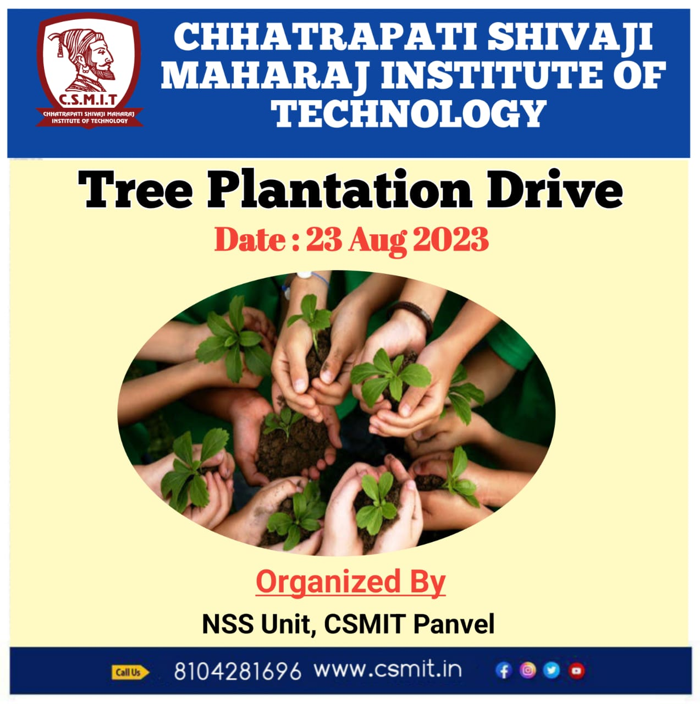

- DETAILS OF ACTIVITY:

Trees represent life, growth, peace and nature. They produce oxygen, clean soil, prevent drought, control flood related disasters, prevent soil erosion, improve physiological, mental and spiritual health, and also reduce carbon footprints. Keeping this in mind the campaign for the One-Student One-Tree programme was initiated by the Chhatrapati Shivaji Maharaj Institute of Technology on 23rd August 2023. Tree Plantation drives combat many environmental issues like deforestation, erosion of soil, desertification in semi-arid areas, global warming and hence enhancing the beauty and balance of the environment. Trees absorb harmful gases and emit oxygen resulting in an increase in oxygen supply. On average, a single tree emits 260 pounds of oxygen annually. Similarly, a fully-grown tree is sufficient for 18 human beings in one acre of land in one year stressing the importance of tree plantation for mankind.
All the faculties and students were involved in this event. In order to sensitise students towards the need to preserve our environment and ecology, Tree plantation drive was organised by CSMIT. The main purpose of this event was to teach students how we can save our climate from pollution.

Sr. No. | Name of college | Total Tree Planted | By support of  social group
1. | Chhatrapati Shivaji Maharaj Institute of Technology | 500

ATTENDANCE RECORD:

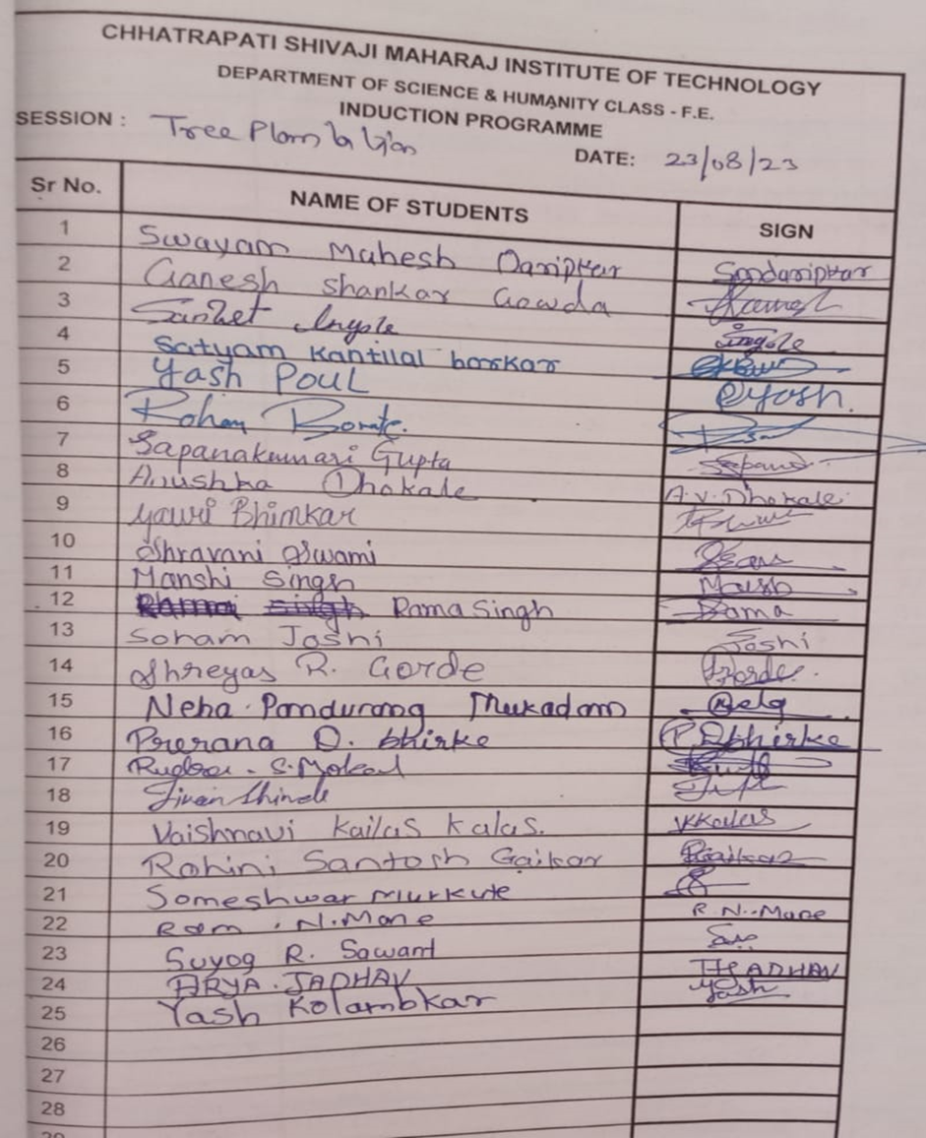

GLIMPSES:

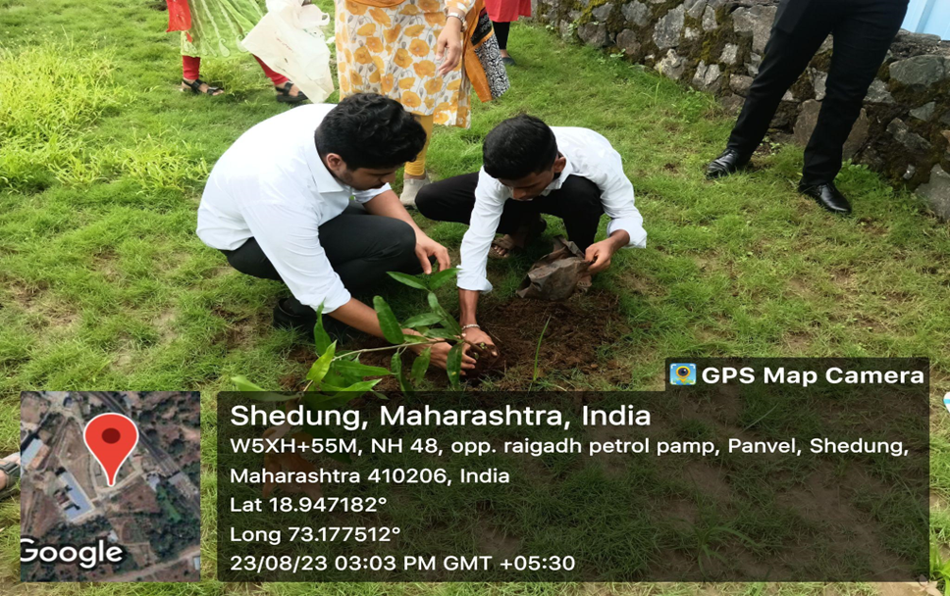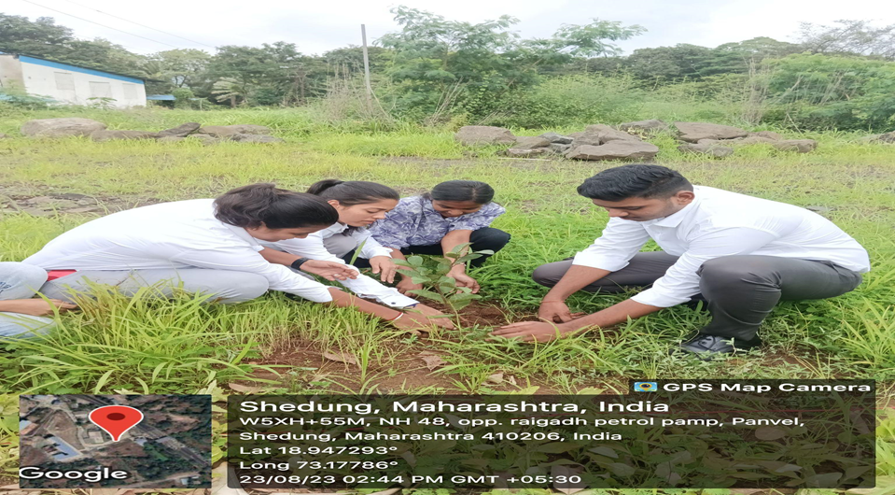

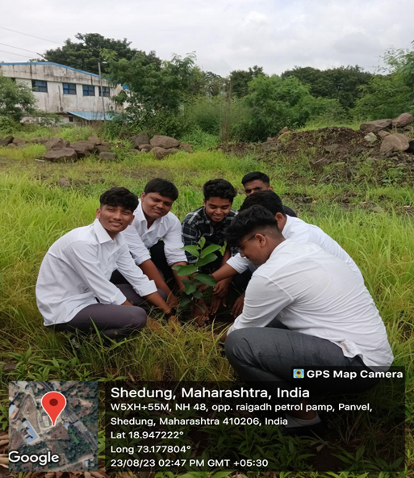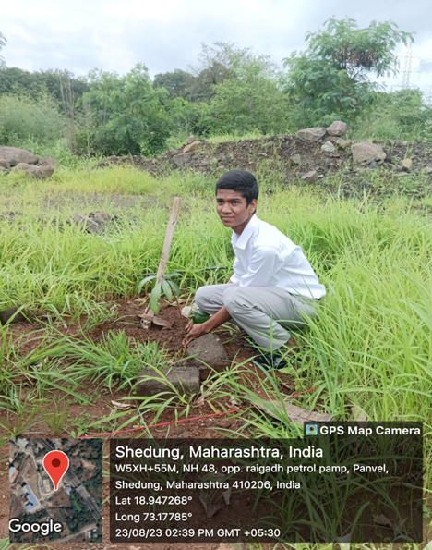

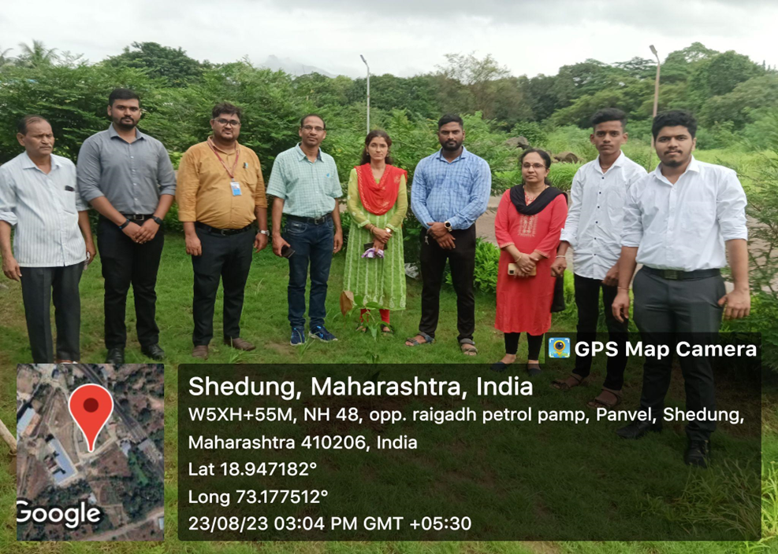

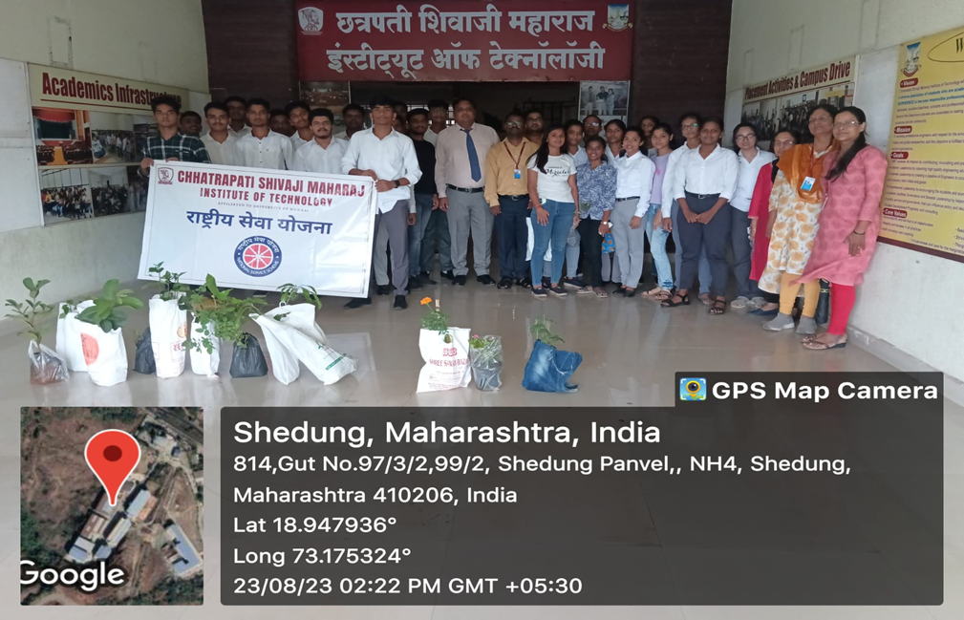

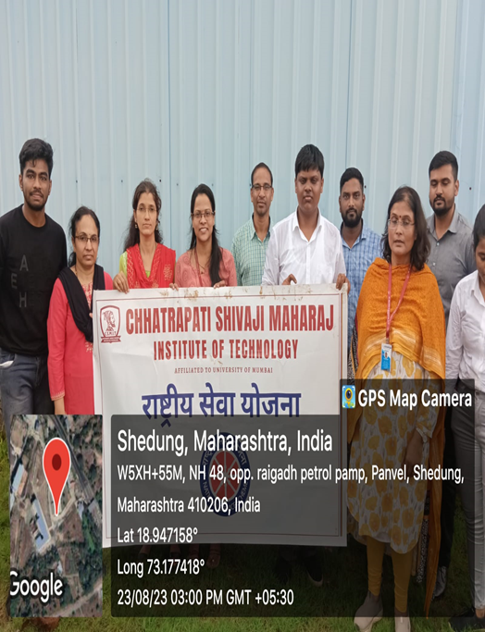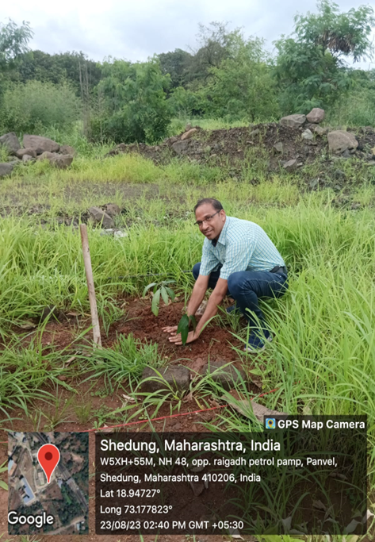

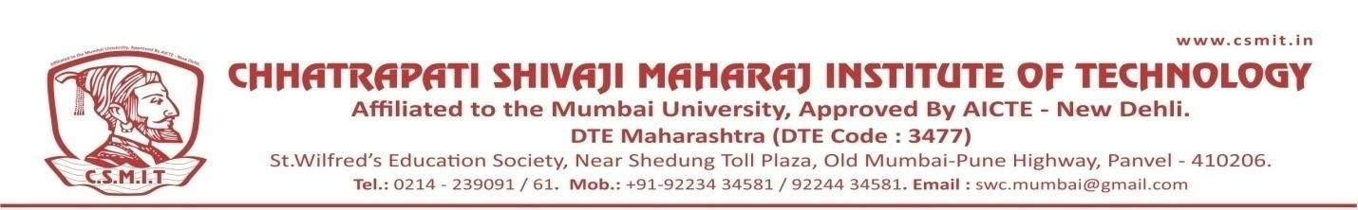

A REPORT ON TEACHER DAY CELEBRATION

- NAME OF ACTIVITY: Teacher’s Day Celebration

- DATE & DURATION: 05th 09, 2023

- TYPE OF ACTIVITY: National Day celebration

- ORGANIZED BY: Chhatrapati Shivaji Maharaj Institute of Technology, Panvel.

FLYER:

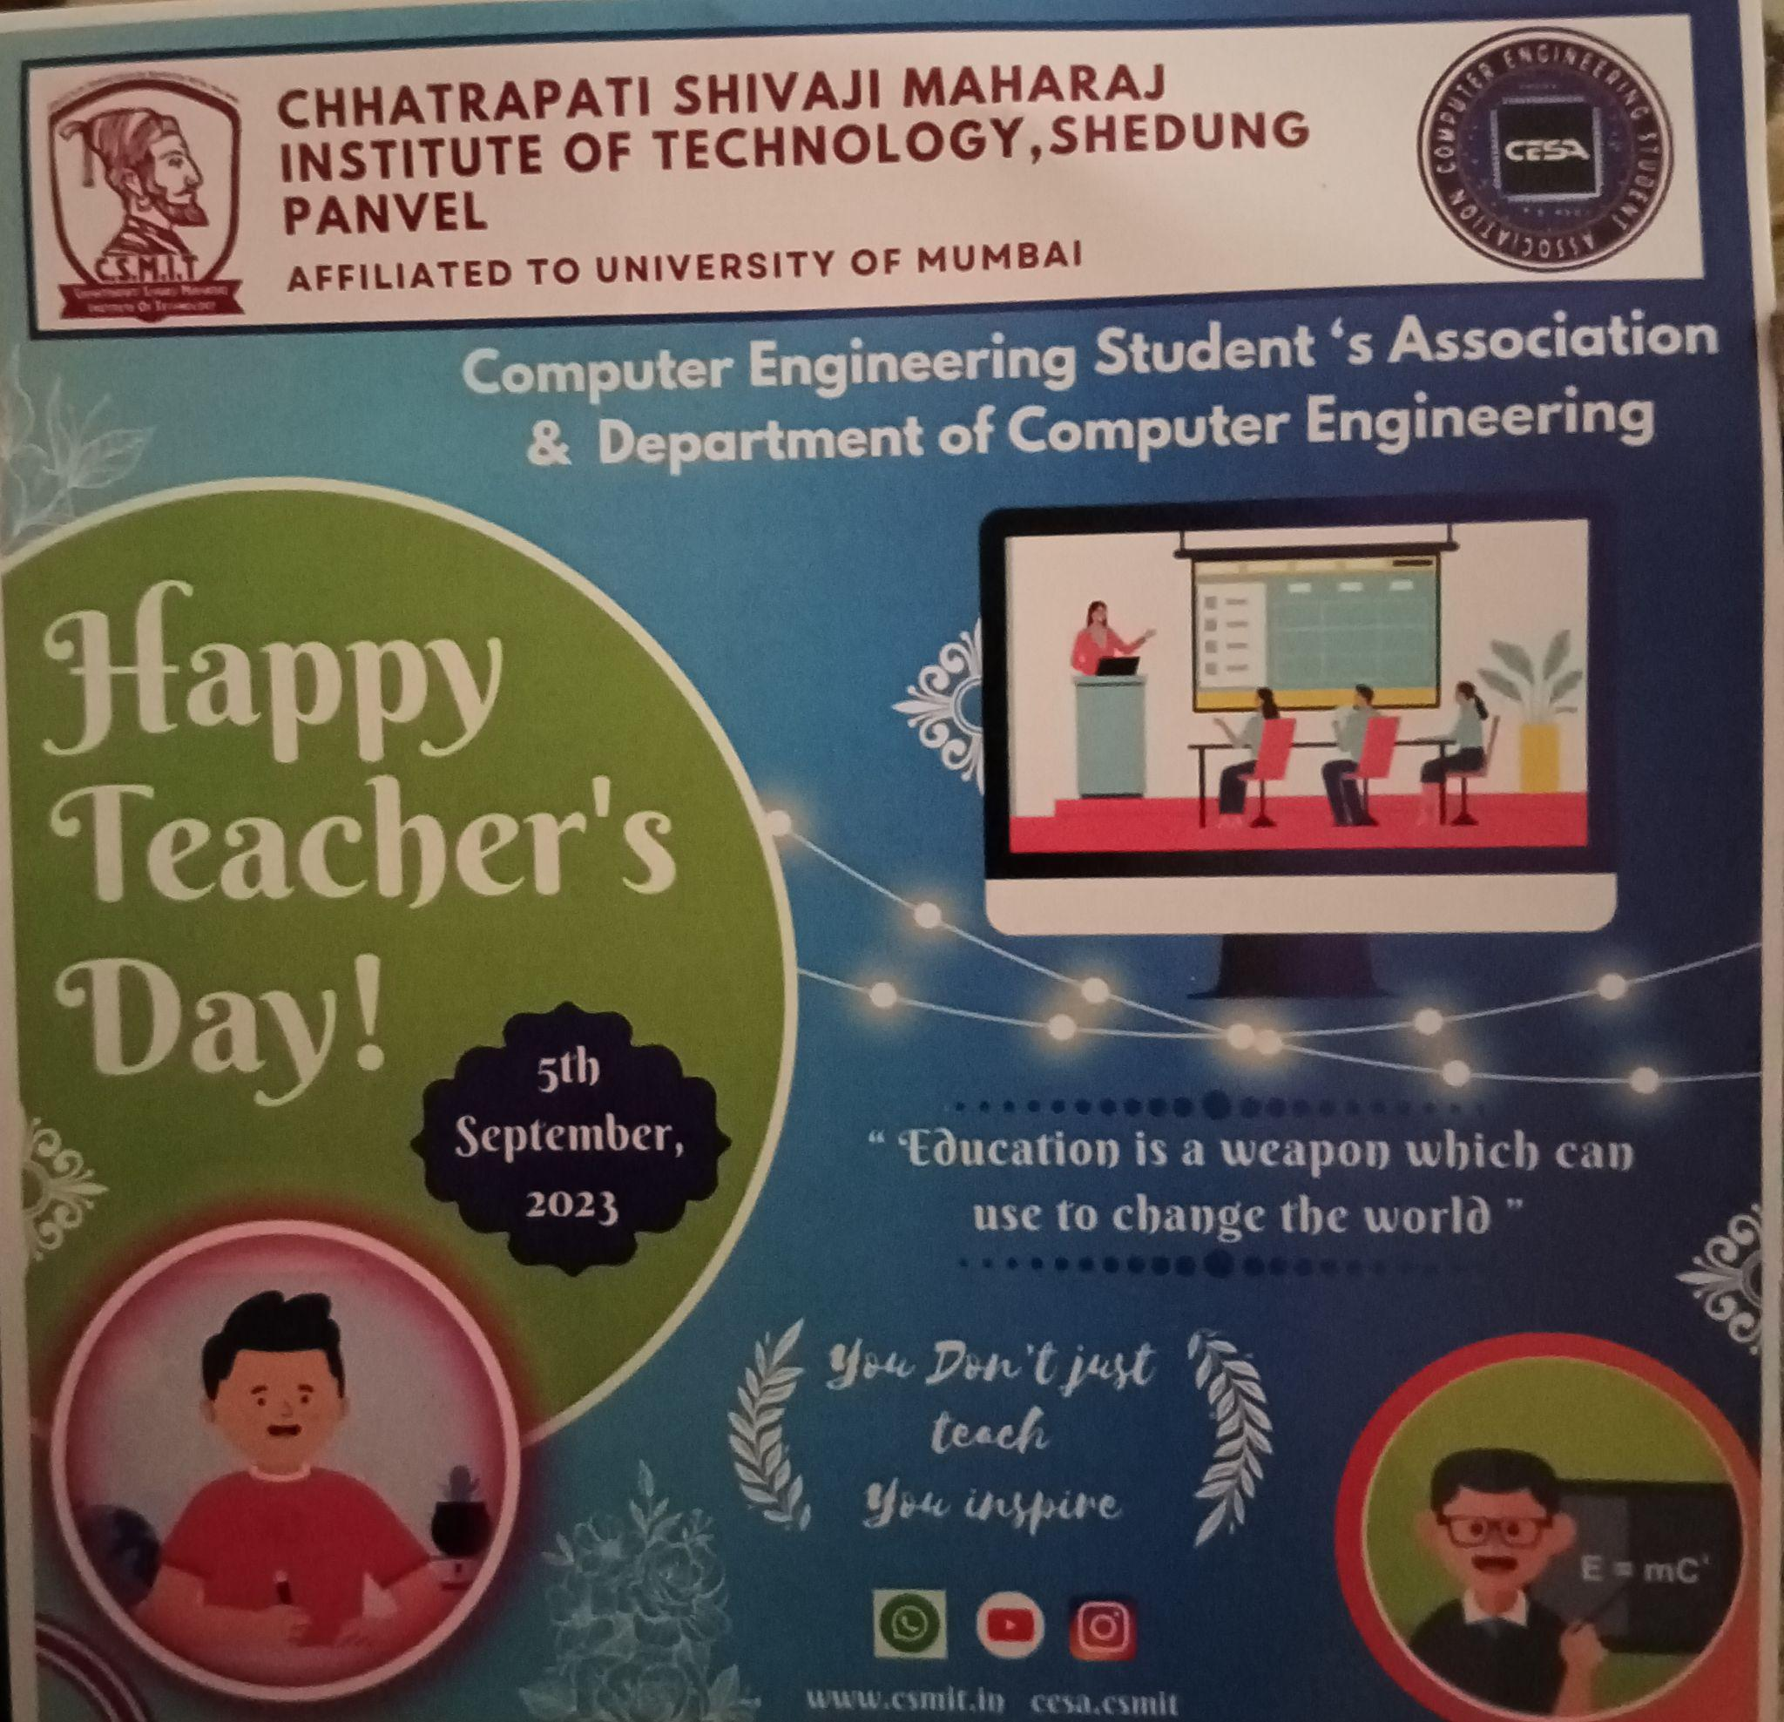

ABOUT THE PROGRAMME
Teachers' Day 2023: Teacher's Day in India was first observed in the year 1962. The day commemorated the birth anniversary of Dr. Sarvepalli Radhakrishnan. He was the first Vice-President and second President of independent India. Teachers' Day in India is celebrated every year on September 5 to mark the birth anniversary of Dr. Sarvepalli Radhakrishnan. He was a former President of India, scholar, philosopher and Bharat Ratna recipient. On Teachers' Day 2023, students all over the country pay respect and tribute to their teachers. In some schools, special programs are also organised to celebrate Teachers' Day on September 5. It is a reminder of the role that teachers play in nation-building by guiding and educating the brightest minds of our country. As the common adage goes, the future of a country lies in the hands of its children, and teachers, as mentors, can mould students into future leaders who shape the destiny of India. They play an important role in our lives in helping us become successful in our careers and businesses. They help us to become good human beings, a better member of society, and an ideal citizen of the country. Teacher’s Day is celebrated to acknowledge the challenges, hardships, and special roles that teachers play in our lives.

GLIMPSES:

A REPORT ON JANMASHTAMI CELEBRATION 2023

- NAME OF ACTIVITY: Janmashtami Celebration

- DATE & DURATION: 06th 09, 2023

- TYPE OF ACTIVITY: Festival

- ORGANIZED BY: Chhatrapati Shivaji Maharaj Institute of Technology, Panvel.

FLYER:

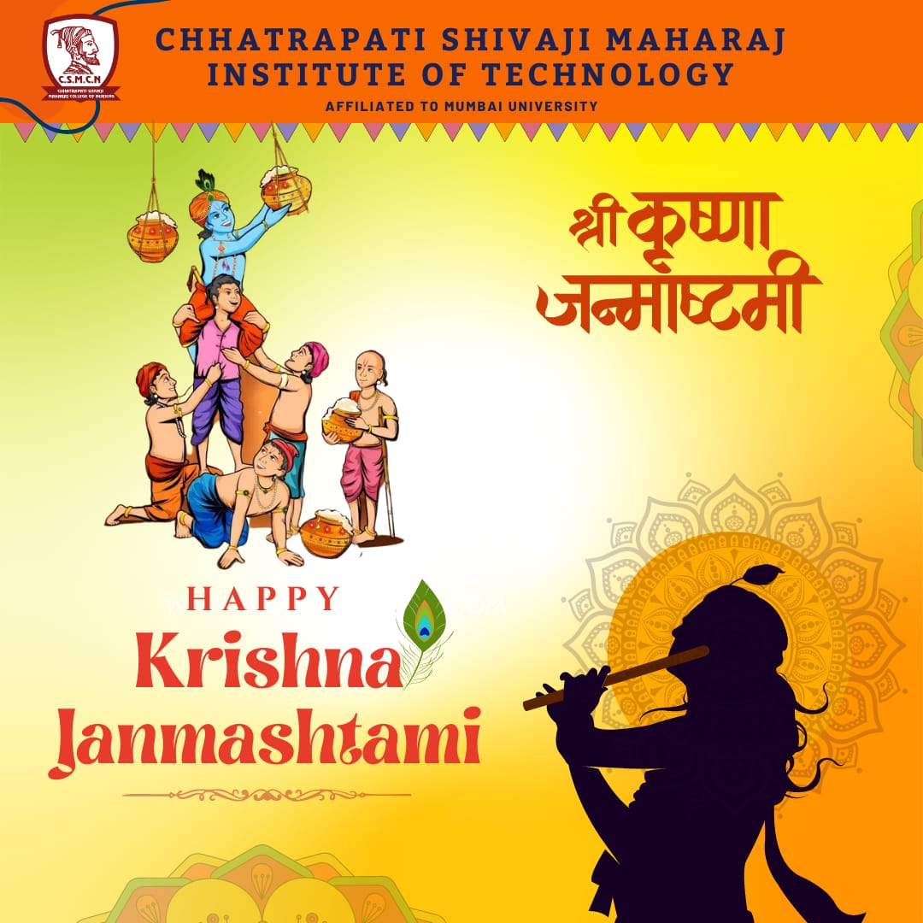

ABOUT THE PROGRAMME
The Krishna Janmashtami festival, popularly known as Janmashtami, is celebrated across India and marks the birth of revered Hindu deity Krishna, the eighth incarnation of Lord Vishnu.
This day is celebrated to commemorated the birth anniversary of the beloved God Krishna. He was born on Ashtami Tithi of Krishna Paksha especially under Rohini Nakshatra in Bharapada month. In the year 2023, Krishna Janmashtami was celebrated on September 6, 2023 and Dahi Handi is going to be celebrated on September 7, 2023.

GLIMPSES:

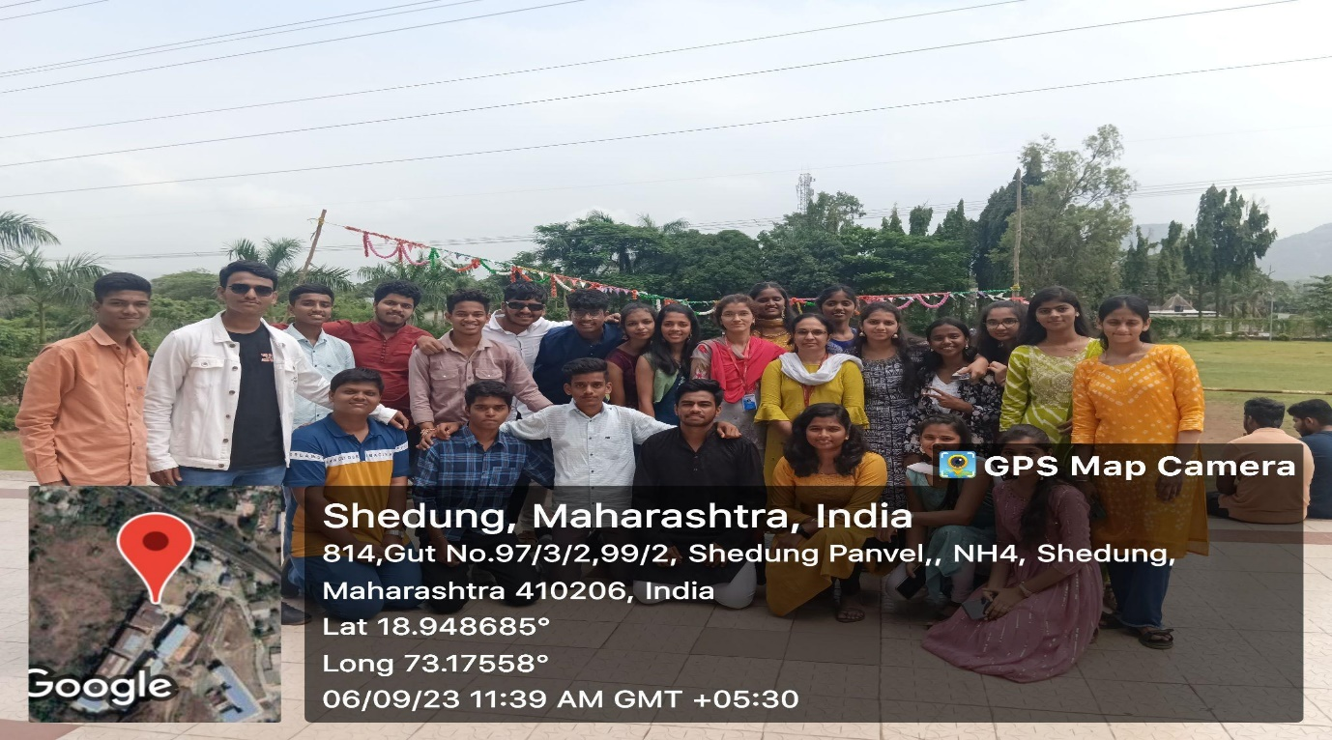
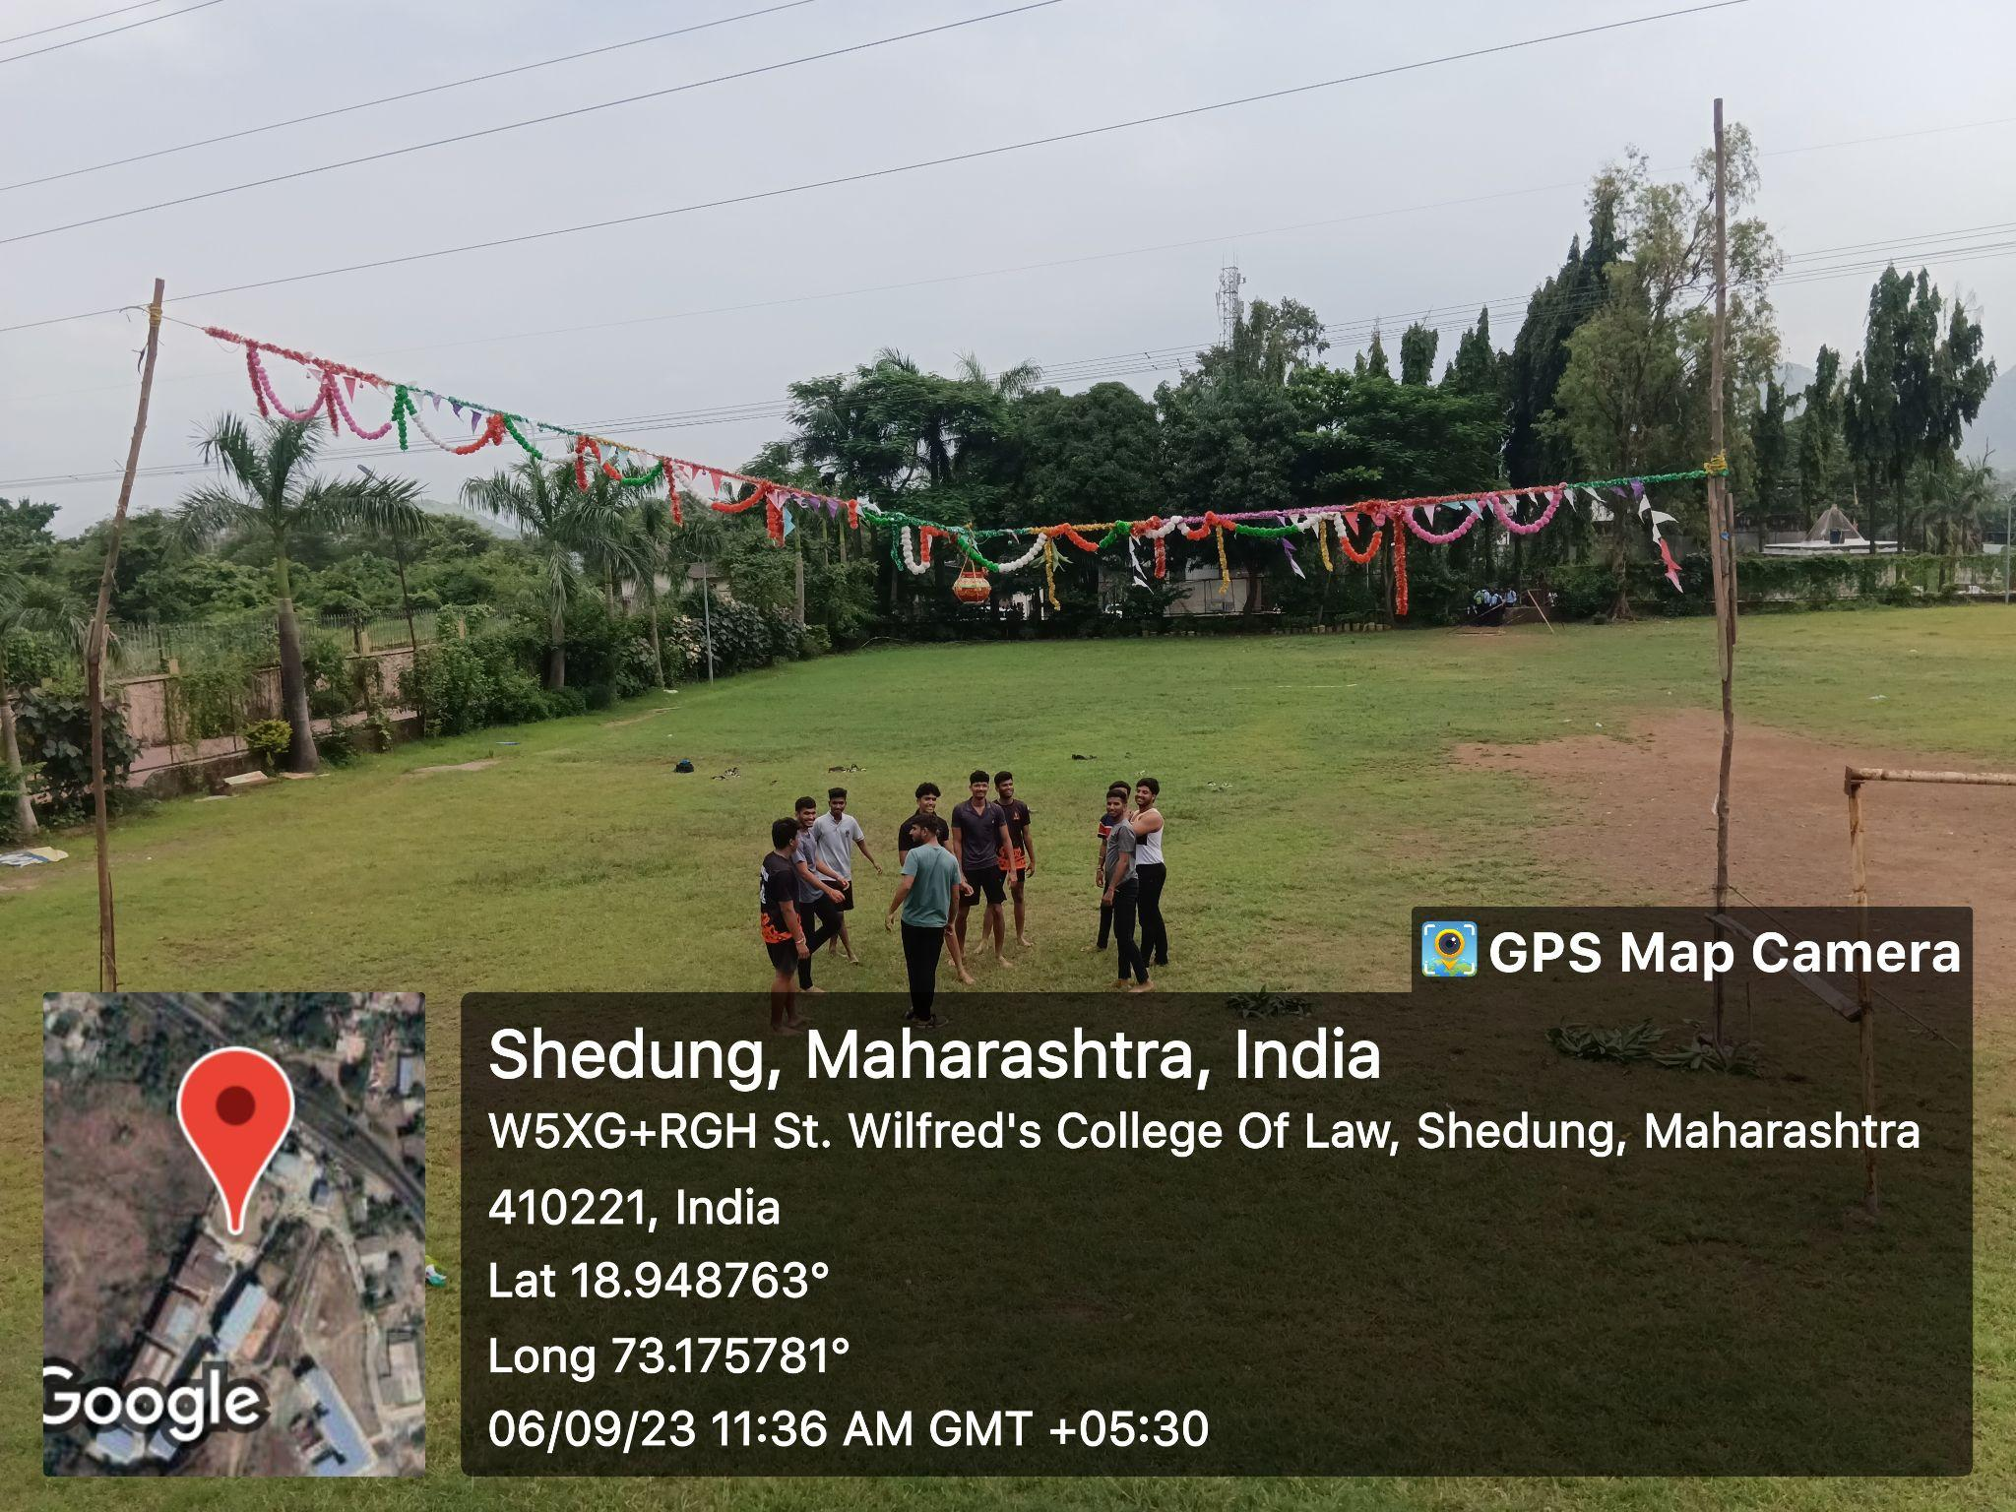

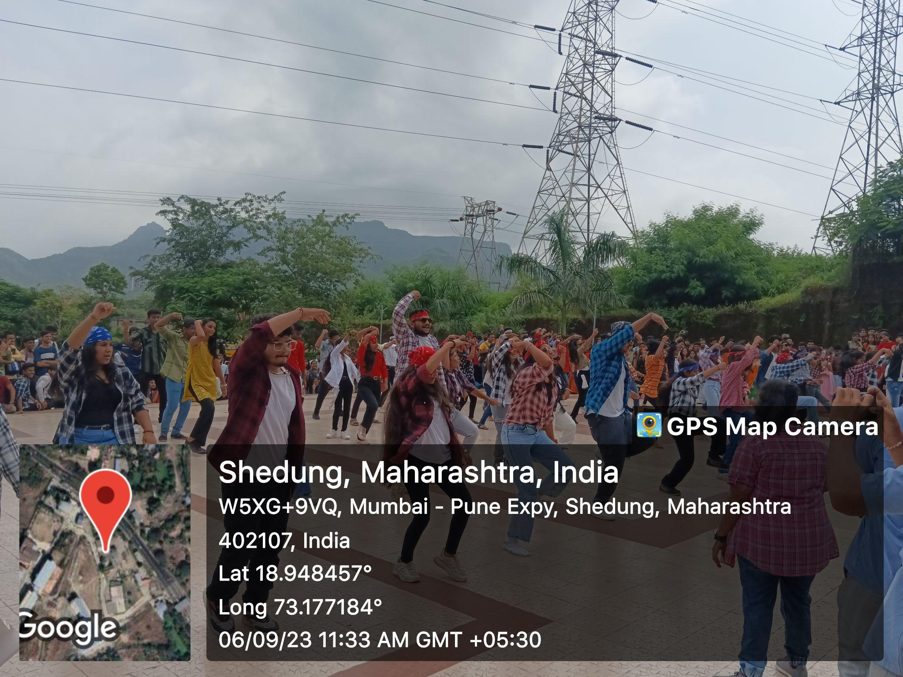

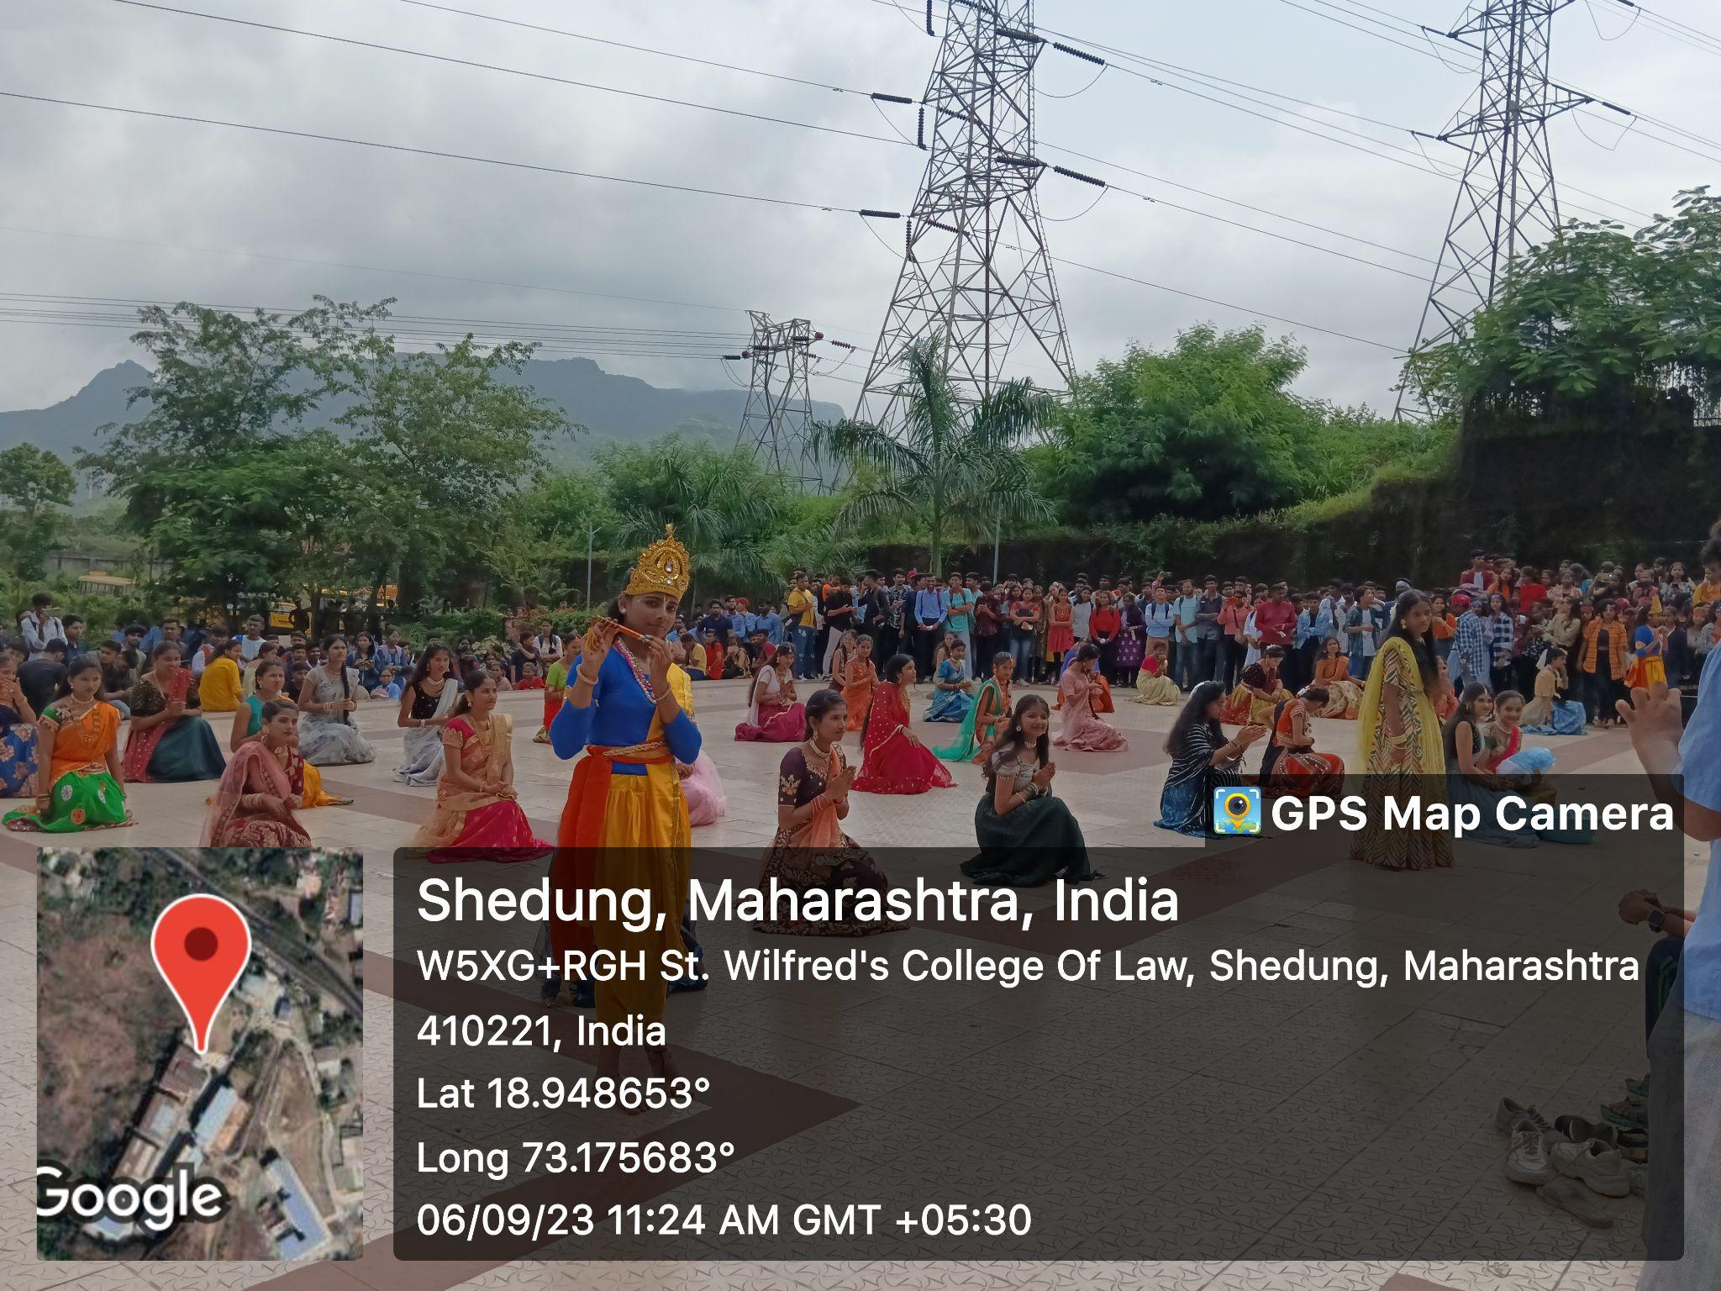

A REPORT ON SWACHH BHARAT ABHIYAN AT POYANJE LAKE

- NAME OF ACTIVITY: Swachh Bharat Abhiyan

- DATE & DURATION: 16th 09, 2023

- TYPE OF ACTIVITY: NSS Cell

- ORGANIZED BY: NSS Cell, Chhatrapati Shivaji Maharaj Institute of Technology, Panvel.

FLYER:

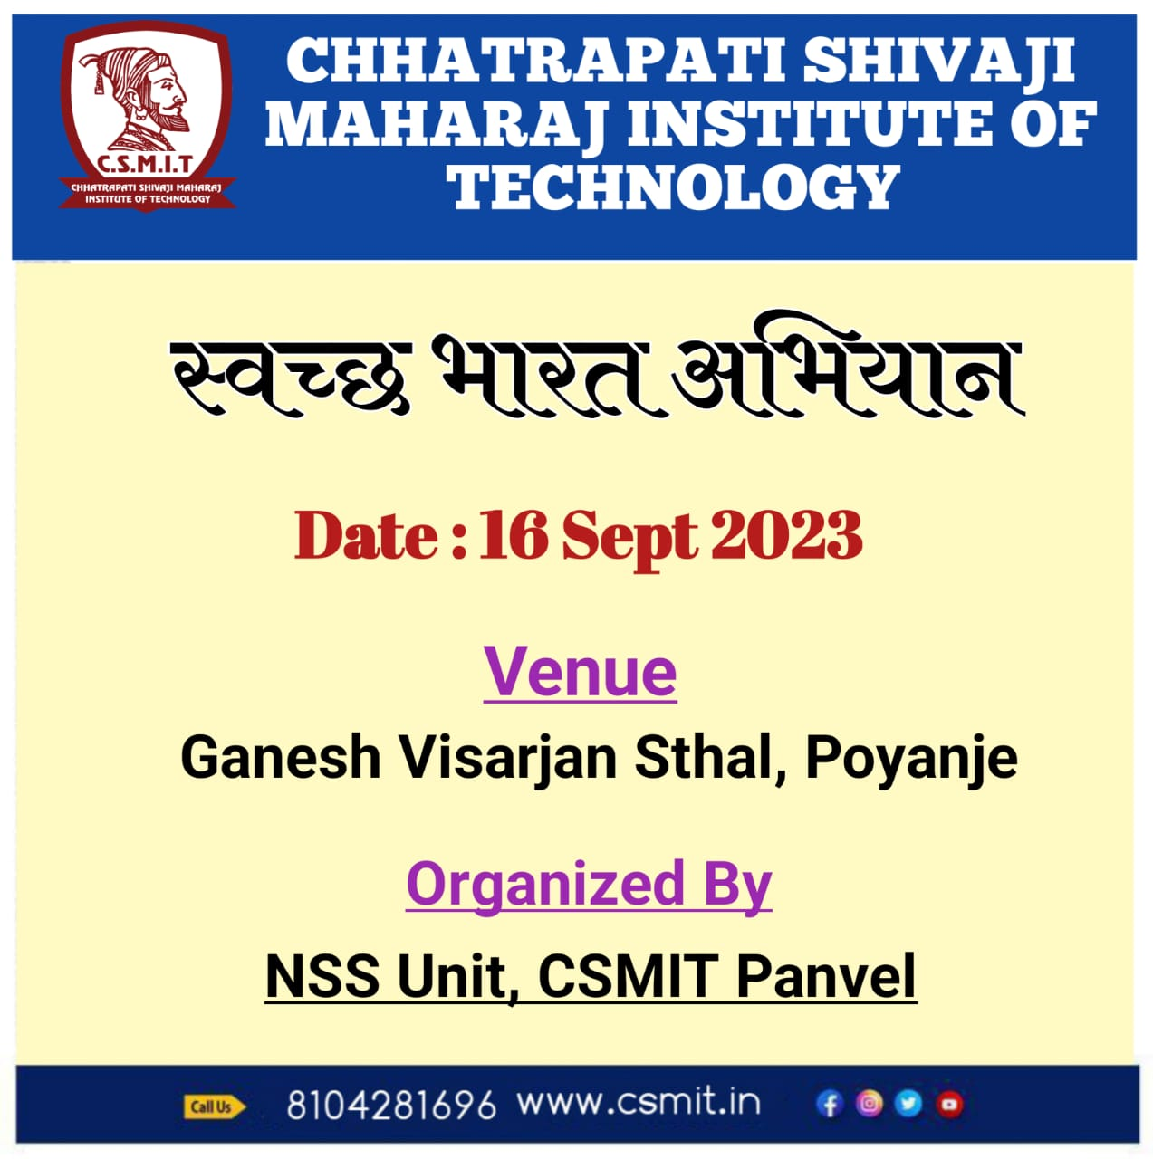
ABOUT THE PROGRAMME
Chhatrapati Shivaji Maharaj Institute of Technology organised a Cleanliness Drive under Swachh Bharat Abhiyan Programme on the occasion of Ganesh Chaturti festival on 16th september, 2023 at 12.00pm. For that we have to visit a lake which is in Poyanje village. The main purpose of this programme was to create awareness among the students regarding Cleanliness and its benefits. Under this programme, all the students from first year engineering had to participate. Even teachers were the essential part of this drive. As a part of this Cleanliness Drive, we had to clean the nearby area of the lake. Some of us picked brooms and started our jobs. Some of the students did the dusting of the area. After collecting them they threw them into the dustbins. After doing this job for two to three hours, we all assembled in the hall. There we were given refreshment in the form of vada pav and tea. Also students enjoy the lake side.

GLIMPSES:

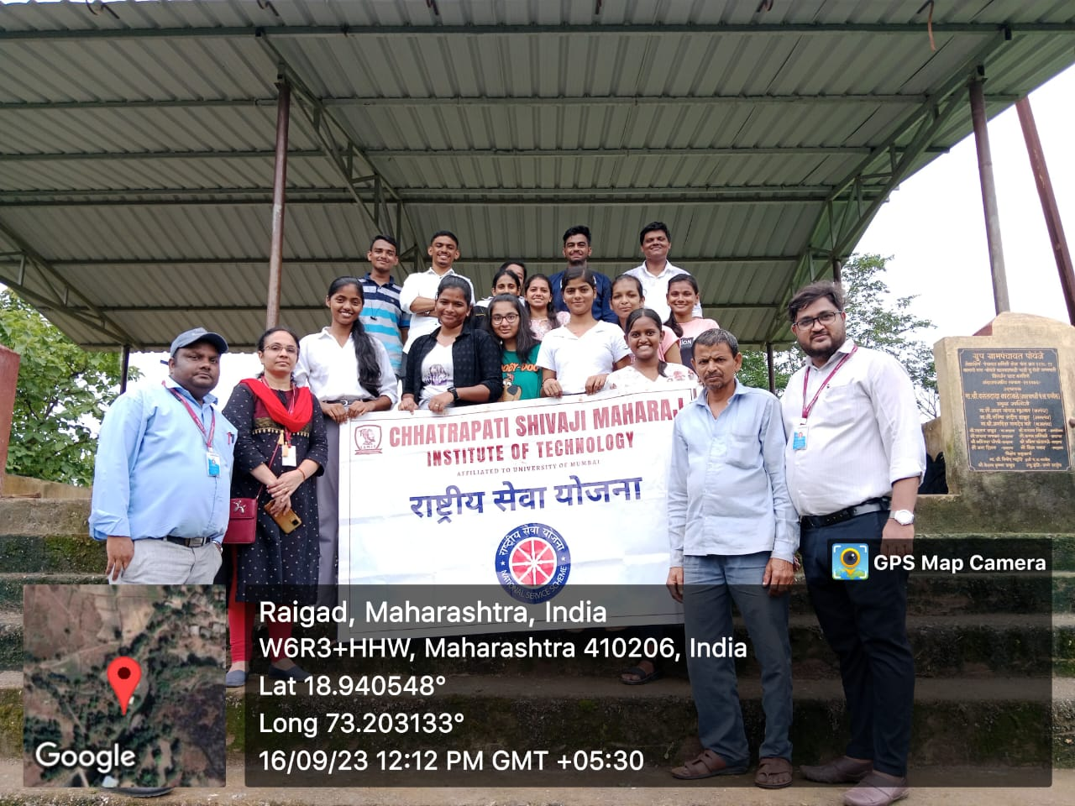

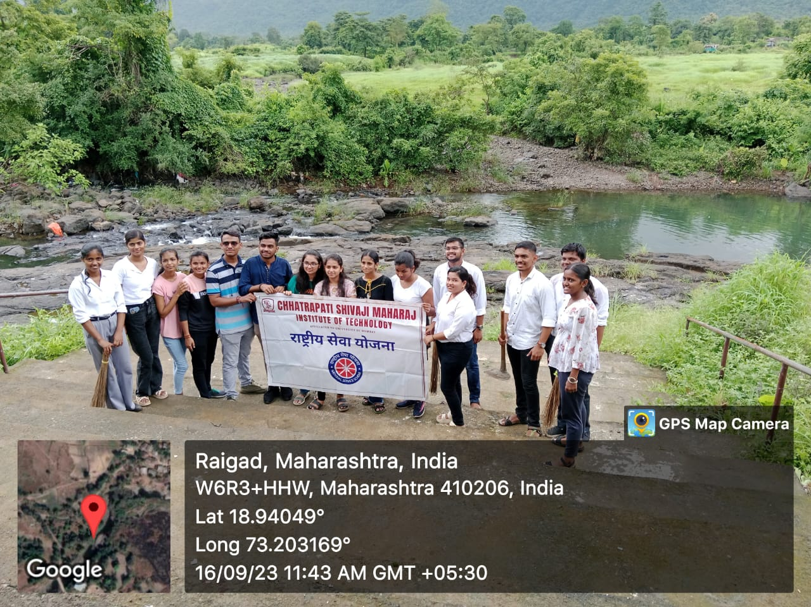

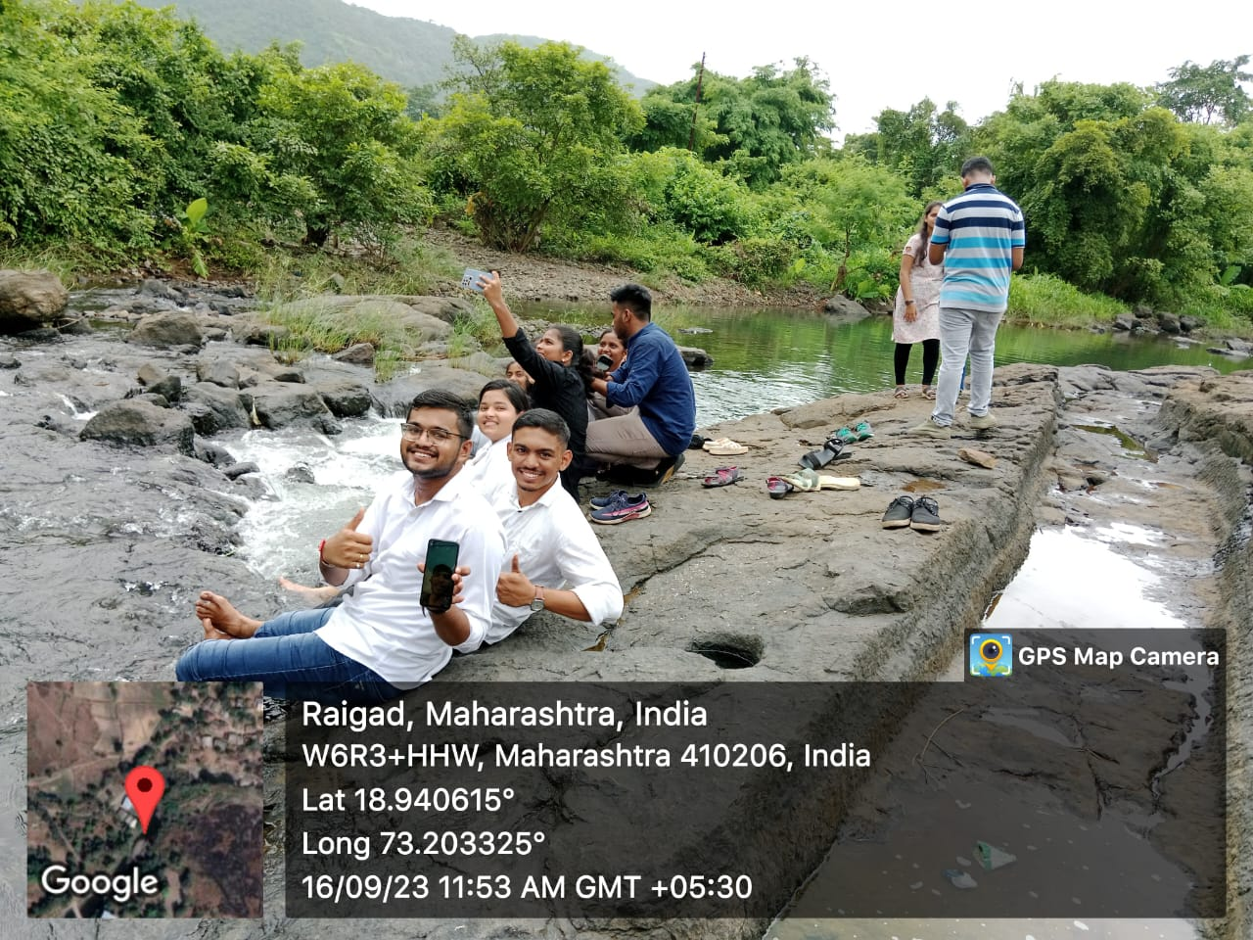

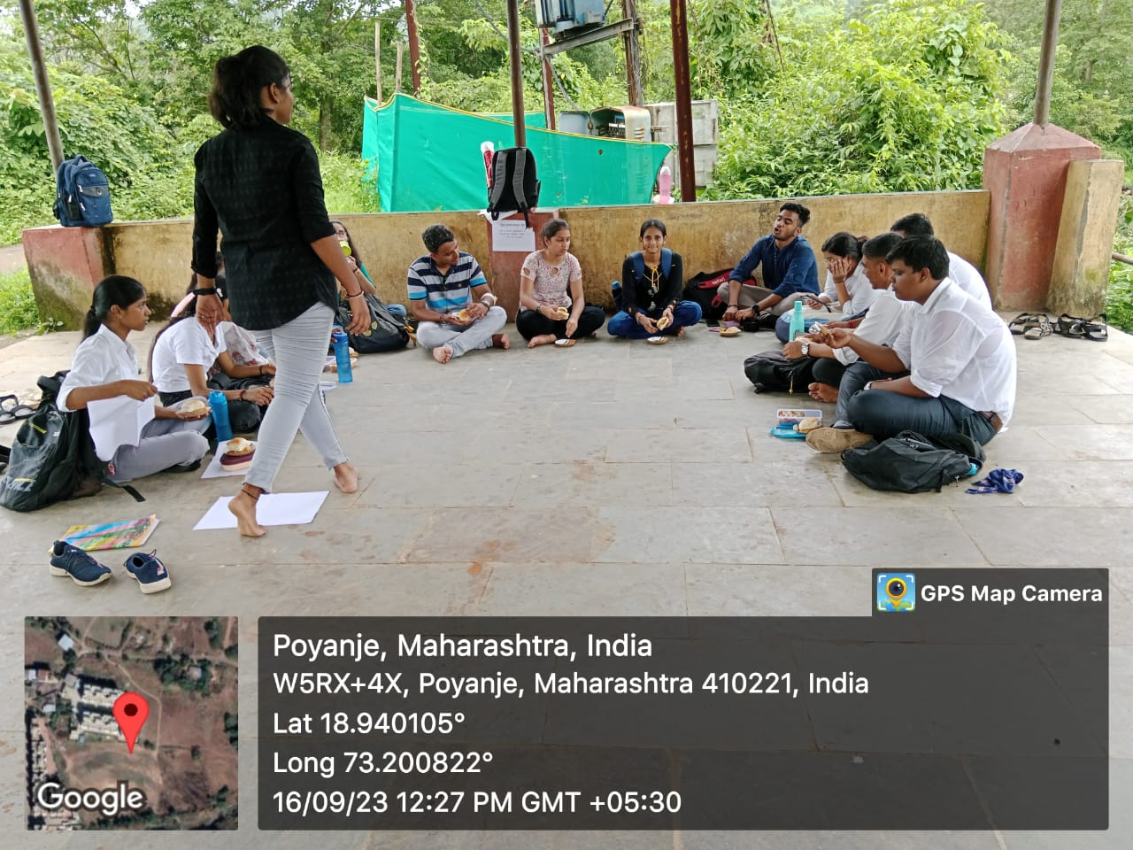

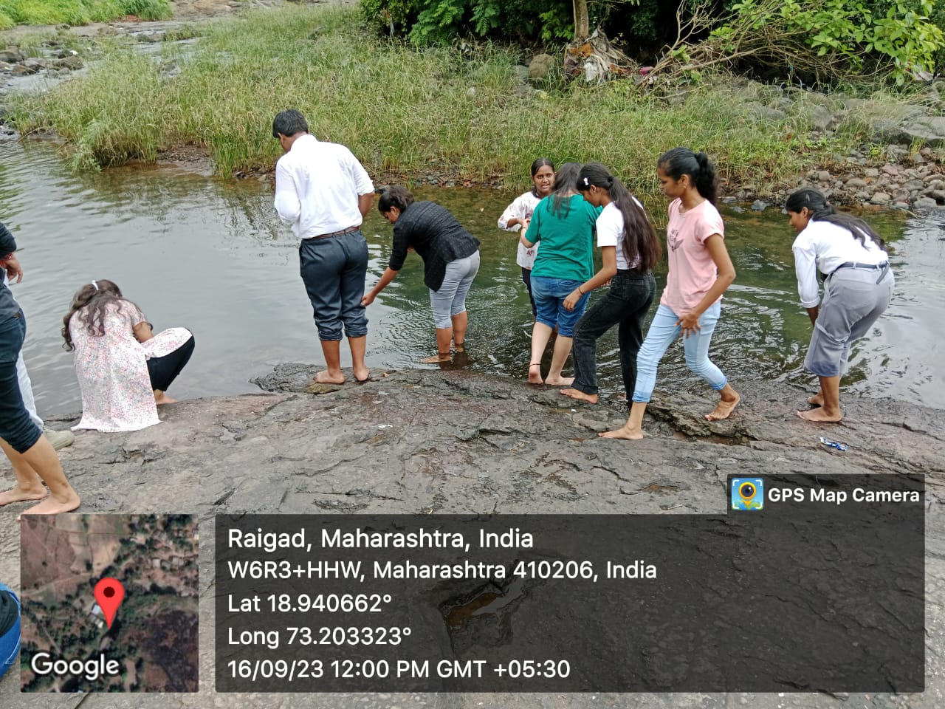

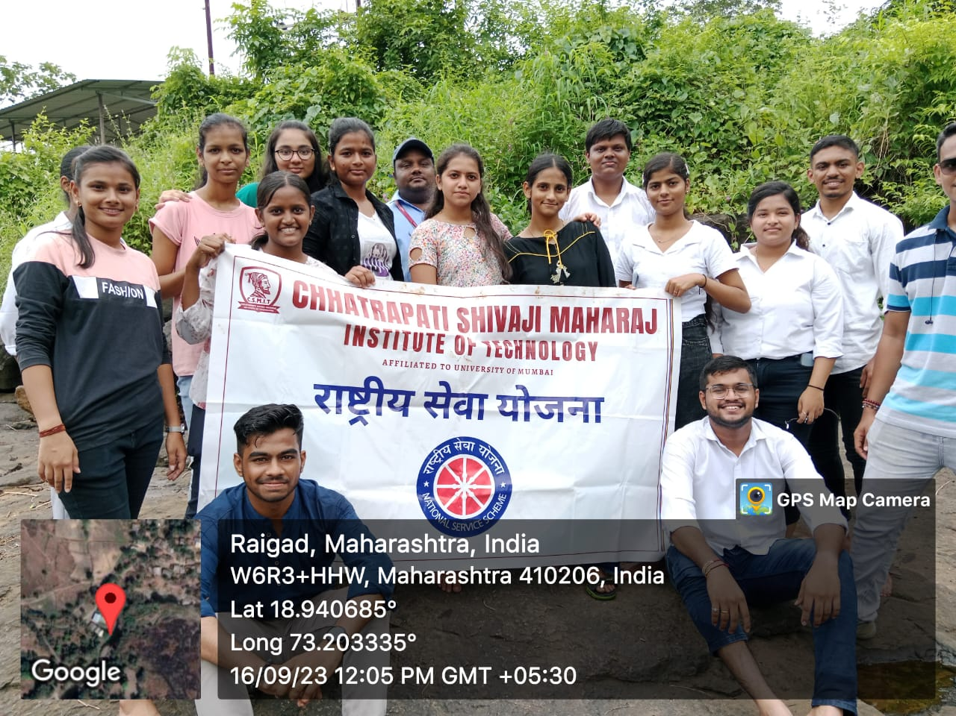

A REPORT ON GANESH CHATURATI CELEBRATION 2023

- NAME OF ACTIVITY: Ganesh Chaturthi Celebration

- DATE & DURATION: 19th to 25th 09, 2023

- TYPE OF ACTIVITY: NSS Activity, Cultural Committee

- ORGANIZED BY: ST. WILFRED EDUCATION SOCIETY, PANVEL

FLYER:

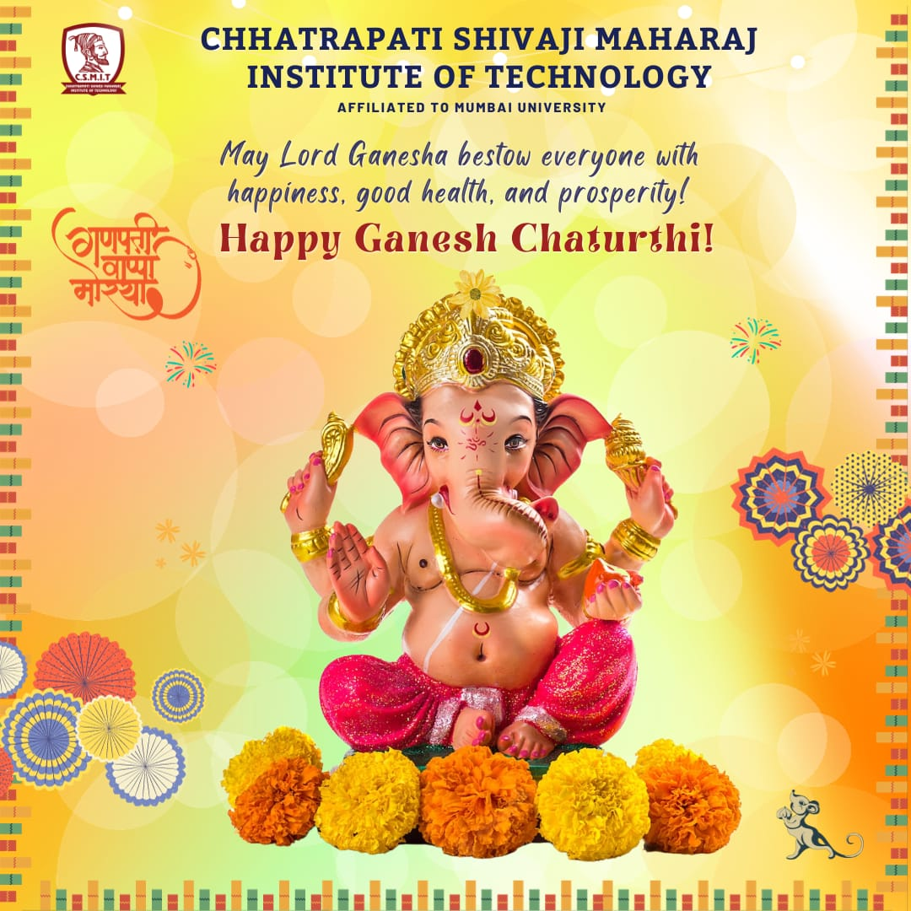

ABOUT THE PROGRAMME

St. Wilfred Education Society, Panvel organised “Eunoia cha Raja” on the occasion of Ganesh Chaturti festival from 19th september, 2023 to 25th september, 2023. The celebration began with a ceremonial puja that was initiated by our respected Cultural head Mr. Mahesh Jadhav. This marked the commencement of a spiritually significant day. The puja was conducted with traditional rituals, including the lighting of the lamp, Vedic chants, and offerings to Lord Ganesha’s idol. Presence of all department faculty and students added a sense of solemnity and reverence to the event. Following the ‘Anjali’ ritual, ‘Prasad’ was distributed to all present. Sweets and fruits were shared among the attendees, symbolising the blessings and benevolence of Lord Ganesha. This act of sharing fostered unity and a sense of community. Stay of Lord Ganesha’s Idol. We extend our heartfelt gratitude to all the students, staff, and organisers whose dedication and participation made this celebration a grand success. May the blessings of Lord Ganesha continue to guide us, and may our university community always remain close-knit and harmonious. The Ganesh pooja and aarti was attended by all the teaching and non – teaching staff of college with everyone looking their best in traditional attire. After the aarti, prasad was distributed among all followed by the cultural program.

GLIMPSES:

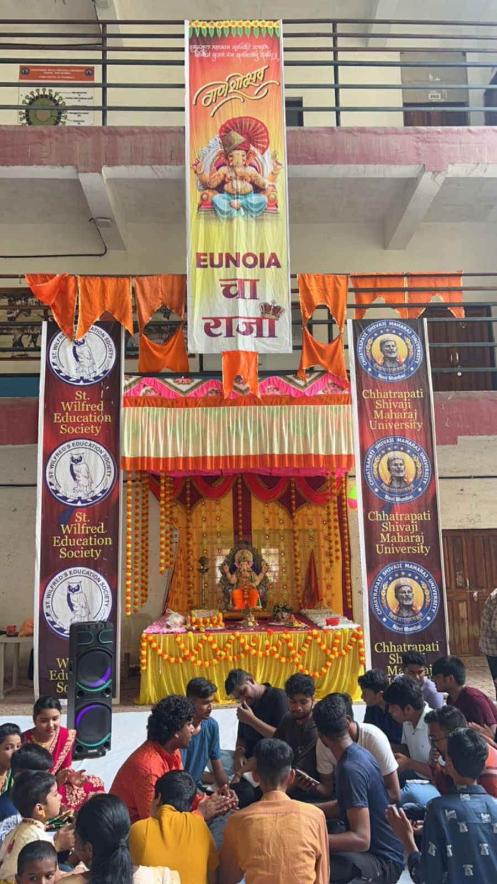

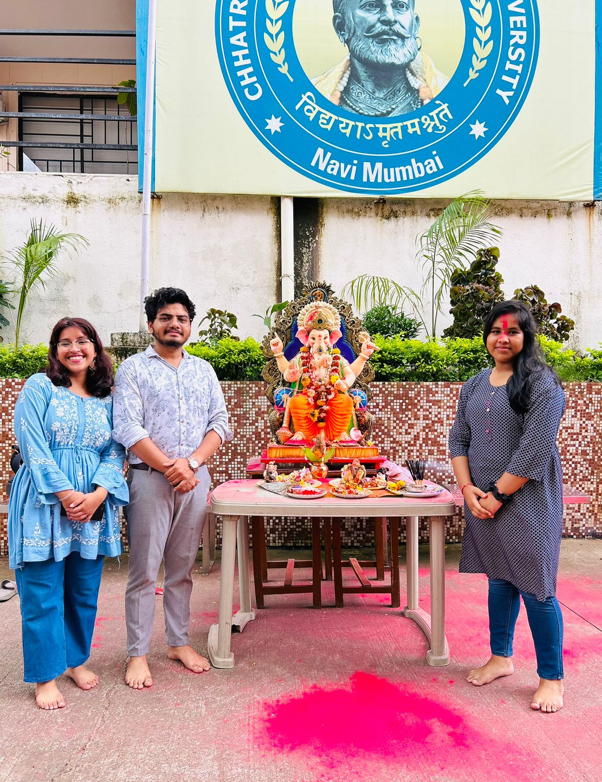

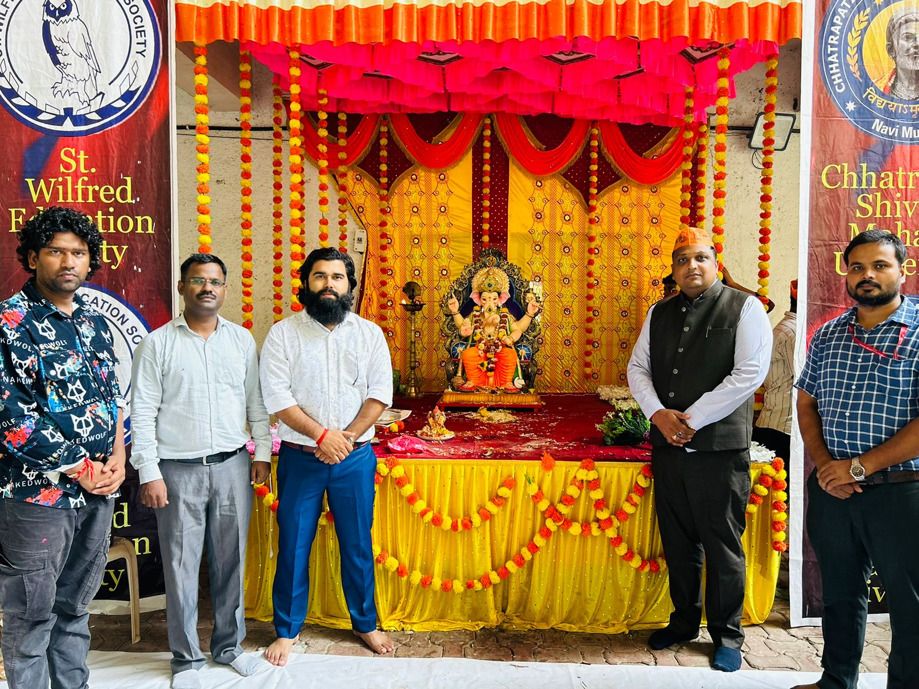

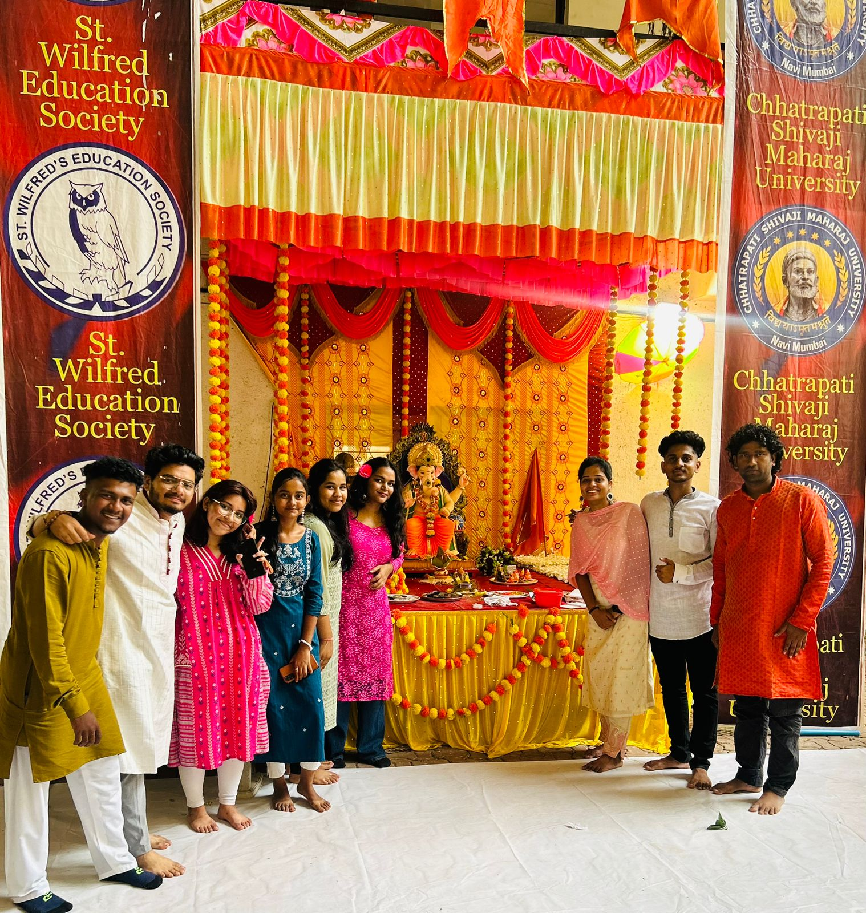

A REPORT ON CLEANING DRIVE

- NAME OF ACTIVITY: CLEANING DRIVE

- DATE & DURATION: 02nd 10, 2023

- TYPE OF ACTIVITY: NSS Activity

- ORGANIZED BY: IQAC, Chhatrapati Shivaji Maharaj Institute of Technology, Panvel.

GLIMPSES:

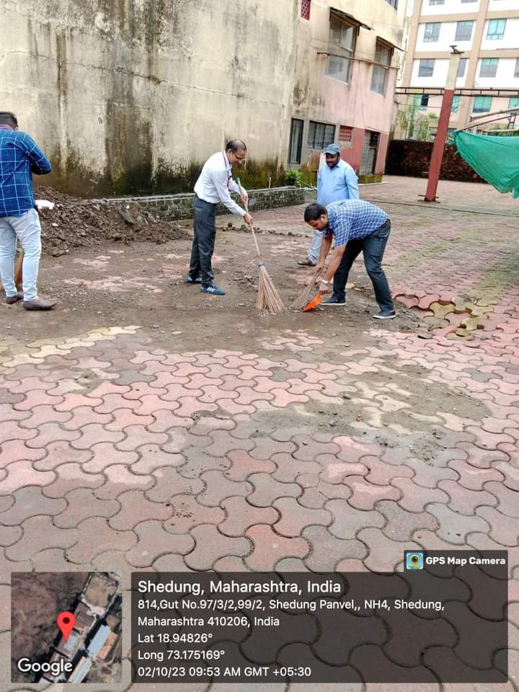
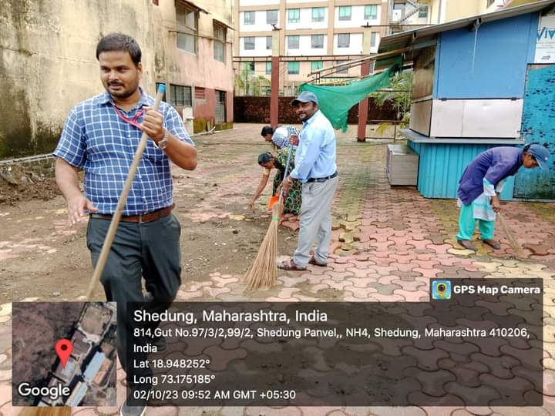

A REPORT ON GANDHI JAYANTI CELEBRATION

- NAME OF ACTIVITY: Gandhi Jayanti

- DATE & DURATION: 02nd 10, 2023

- TYPE OF ACTIVITY: NSS Activity

- ORGANIZED BY: IQAC, Chhatrapati Shivaji Maharaj Institute of Technology, Panvel.

FLYER:

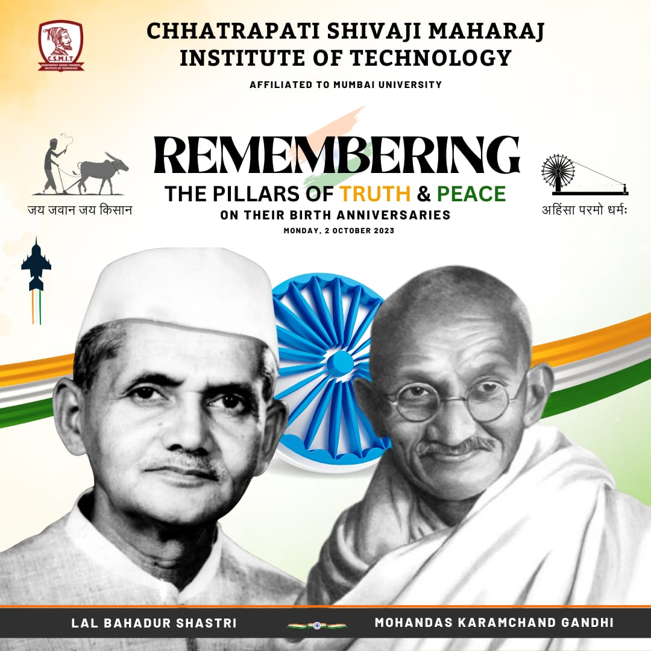

ABOUT THE PROGRAMME
Chhatrapati Shivaji Maharaj Institute of Technology, Panvel celebrated “GANDHI JAYANTI” AND “LAL BAHADUR SHASTRI” Birth anniversary on 2nd October, 2023. On this occasion we organised A Cleanliness Drive in the campus. All faculty taking part in that our principal Dr. Dharmendra Dubey, Dr. Baljit sir, Mr. Nutan Kale, Mr. Harishchandra Mourya, Mr. Abhay sir.etc.

GLIMPSES:

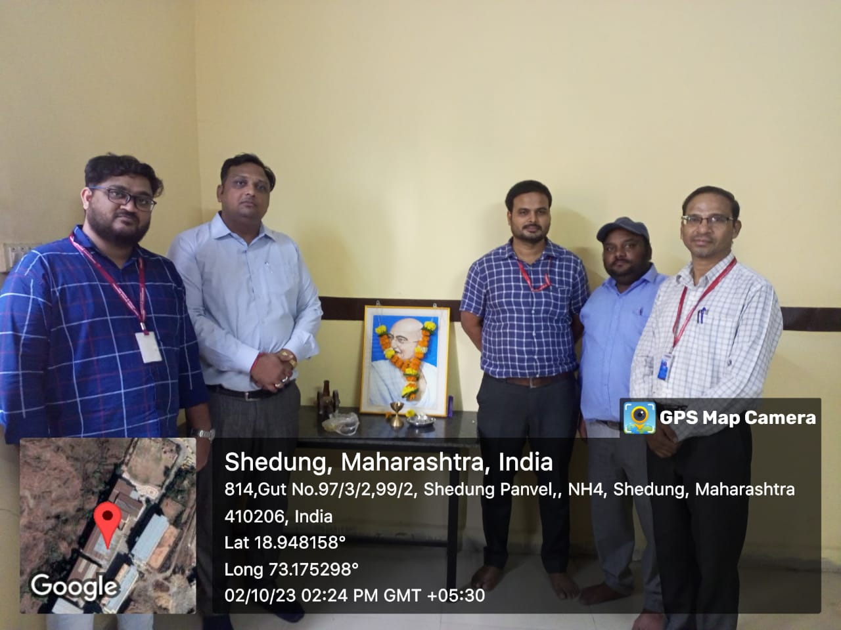

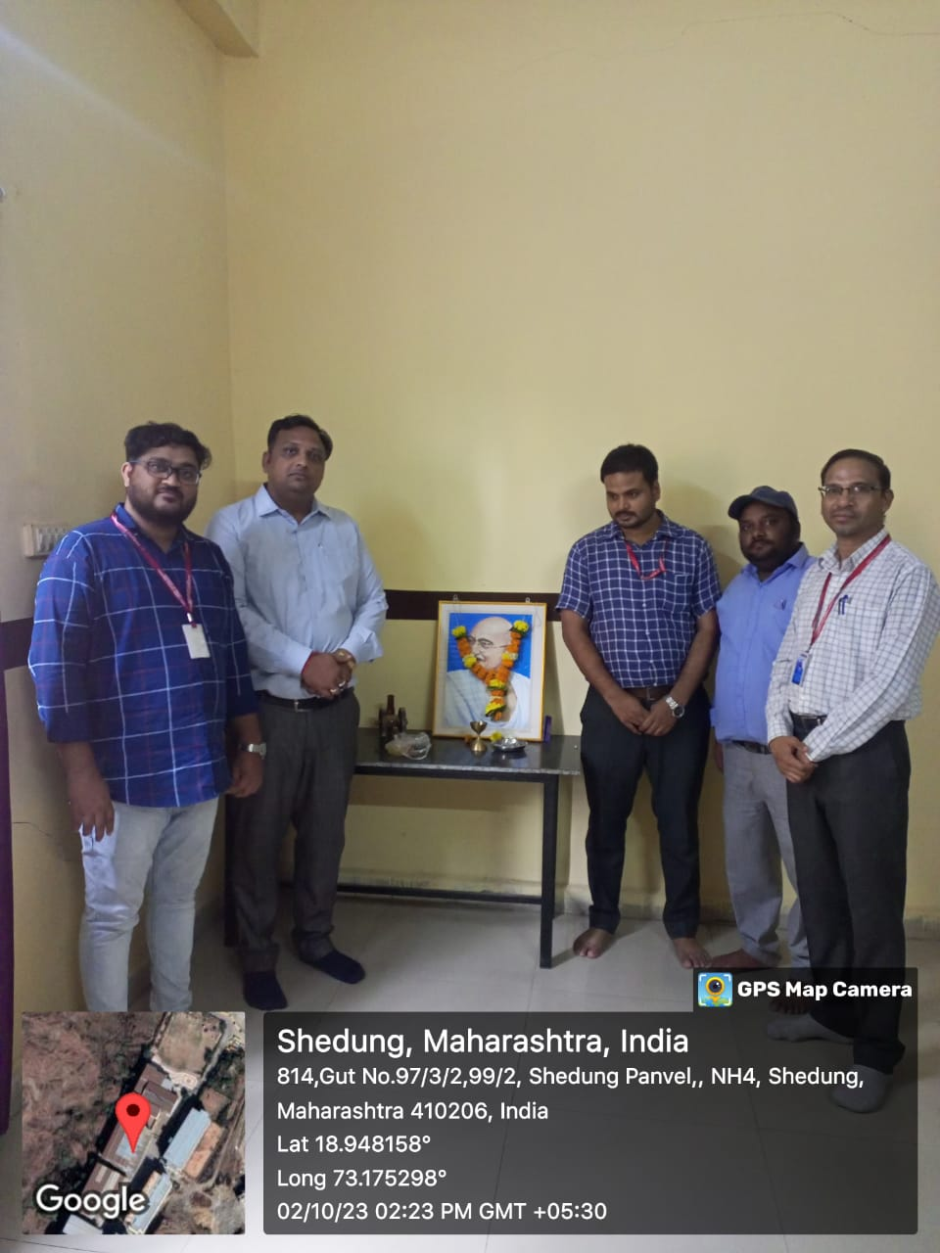

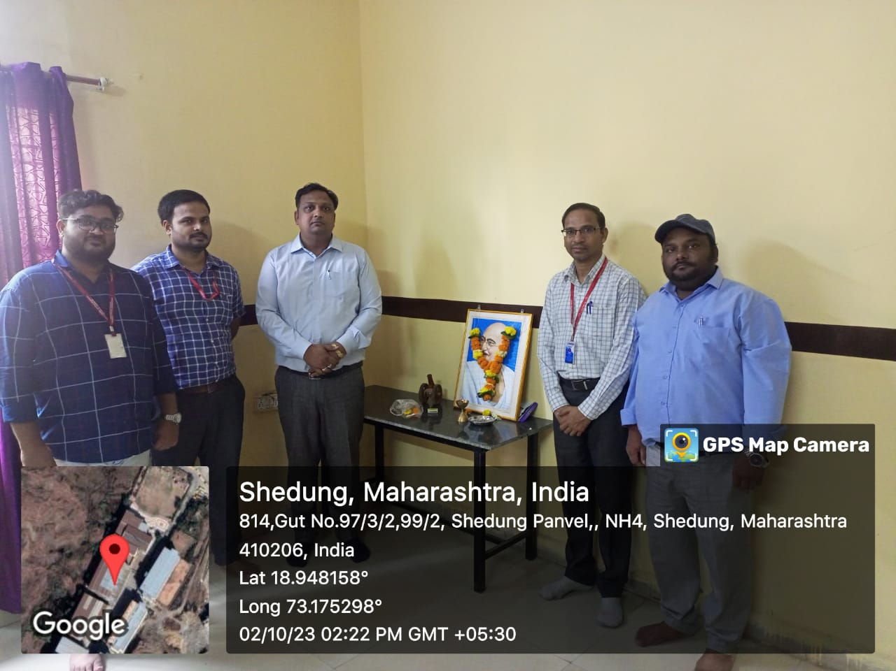

A REPORT ON WORLD ANIMAL DAY

- NAME OF ACTIVITY: World Animal Day

- DATE & DURATION: 04nd 10, 2023

- TYPE OF ACTIVITY: NSS Activity

- ORGANIZED BY: IQAC, Chhatrapati Shivaji Maharaj Institute of Technology, Panvel.

FLYER:

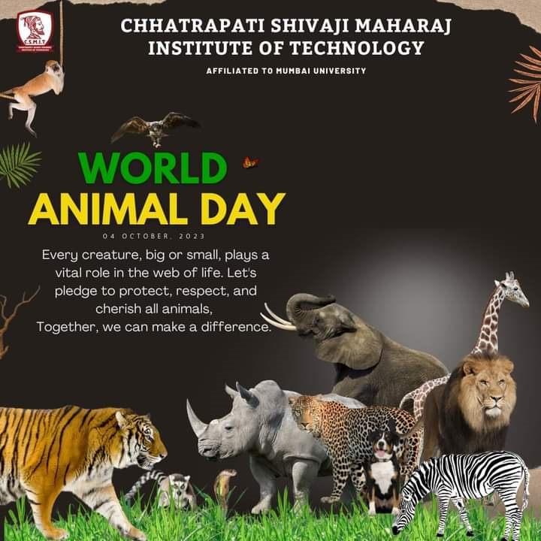

ABOUT THE PROGRAMME
World Animal Day is a global celebration of animals, a day when we come together to recognize and appreciate the incredible diversity of species that share our planet. Each year on October 4th, people from all walks of life unite to raise awareness about animal welfare, advocate for their protection, and celebrate the profound connection between humans and animals. In 2023, the theme for World Animal Day is 'Great or Small, Love Them All,' emphasizing the importance of loving and caring for all creatures, regardless of their size or species.

A REPORT ON WORLD MENTAL HEALTH DAY

- NAME OF ACTIVITY: World Mental Health Day

- DATE & DURATION: 10th 10, 2023

- TYPE OF ACTIVITY: NSS Activity

- ORGANIZED BY: IQAC, Chhatrapati Shivaji Maharaj Institute of Technology, Panvel.

FLYER:

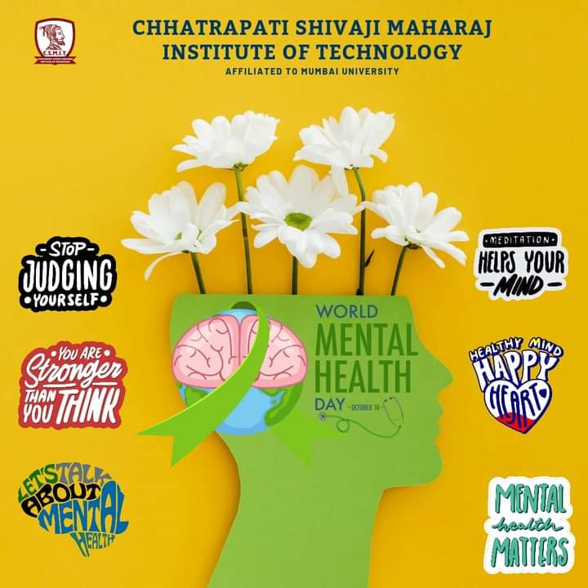

ABOUT THE PROGRAMME
World Mental Health Day is an international day for global mental health education, awareness and advocacy against social stigma. It was first celebrated in 1992 at the initiative of the World Federation for Mental Health, a global mental health organization with members and contacts in more than 150 countries. This day, each October, thousands of supporters come to celebrate this annual awareness program to bring attention to mental illness and its major effects on people's lives worldwide.

A REPORT ON YOUTH CAMAIGN ON QUALITY CONNECT BY BIS

- NAME OF ACTIVITY: BIS Youth

- DATE & DURATION: 12th 10, 2023

- TYPE OF ACTIVITY: NSS Activity

- ORGANIZED BY: IQAC, Chhatrapati Shivaji Maharaj Institute of Technology, Panvel.

FLYER:

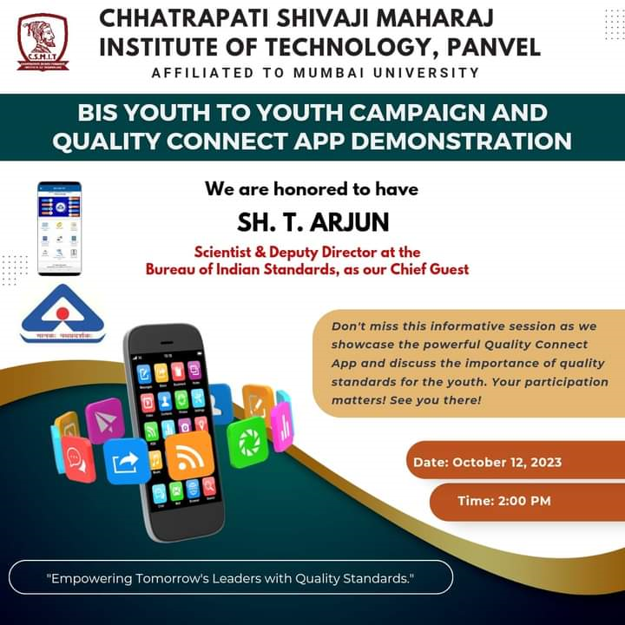
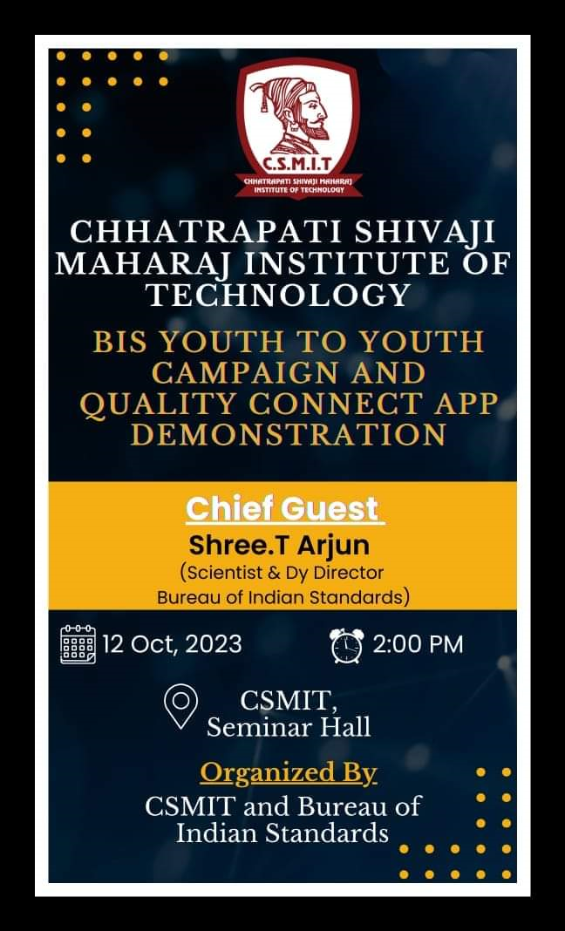

ABOUT THE PROGRAMME
BIS, The National Standards Body of India. We develop & publish Indian Standards, Implement Conformity Assessment Schemes, Recognise & run laboratories for Conformity Assessment, Implement Hallmarking, Work for Consumer empowerment, Conduct capacity building programs on quality assurance and represent the country in ISO & IEC.

GLIMPSES:

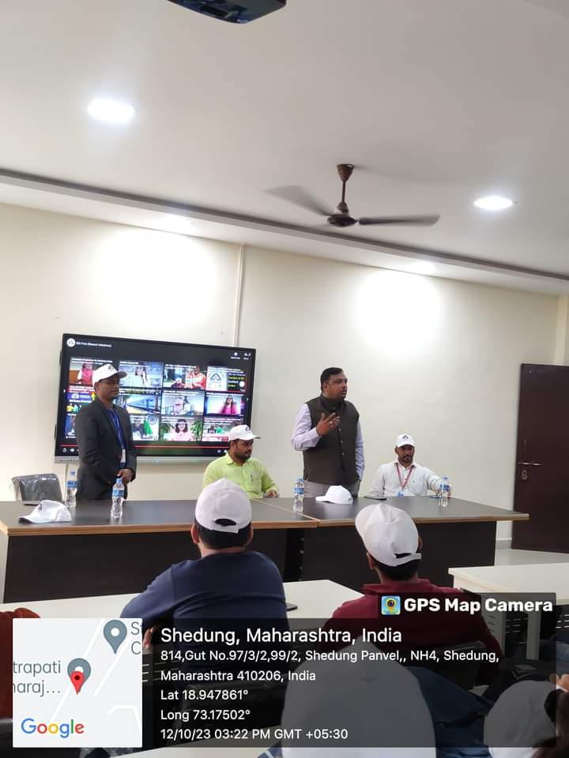

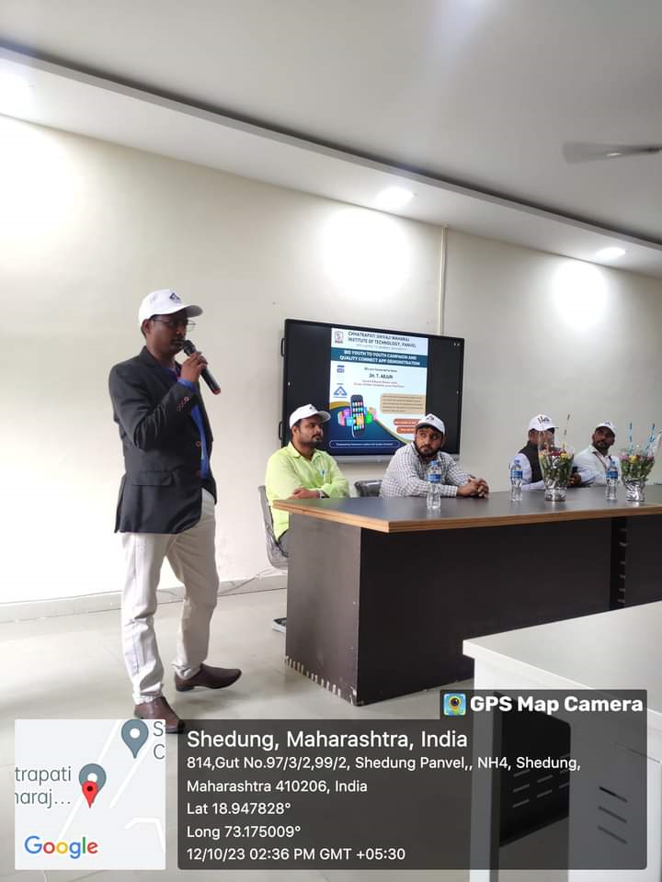

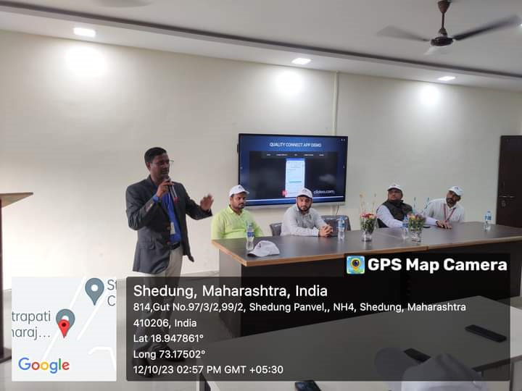

A REPORT ON HEALTH CHECK-UP CAMP

- NAME OF ACTIVITY: Free Health Check-up Camp

- DATE & DURATION: 14th 10, 2023

- TYPE OF ACTIVITY: NSS Activity

- ORGANIZED BY: IQAC, Chhatrapati Shivaji Maharaj Institute of Technology, Panvel.

FLYER:

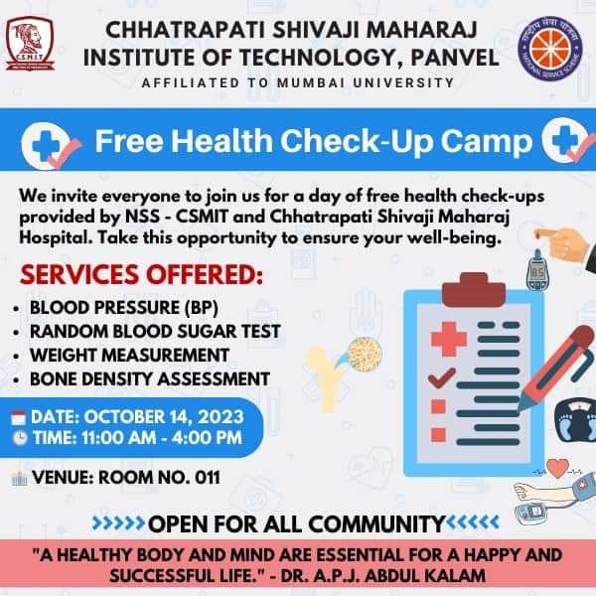

ABOUT THE PROGRAMME

The importance and objectives of the free medical camp are vital, but the main objective is that the free medical camps are set up with the sacred aim to bring awareness amongst the deprived population of the country who have no access to basic healthcare services or knowledge about the diseases they are suffering from. So, Transparent Hands provide the importance and objectives of the medical camp free medical advice, and medicine to unfortunate people, and refer them for specialized treatment or surgery whenever it is required. These camps make sure people are getting the healthcare at the right time, and seeing the doctor early enough before a small health problem turns serious.
A Free Medical Camp can be considered as a life-saving program that aims to provide free medical and surgical services to poor communities living in rural or urban areas by a mobile team with varieties of medical specialized services. Some NGOs, Charitable Medical Trusts, and medical professionals are driven by strong ethics of medicine and believe that it is the moral responsibility and obligation to treat each patient regardless of their income, race, or social status. The main objective of a medical camp is to provide initial care to people in life-threatening conditions which reflects the unique strengths and goals of medical ethics. Other objectives are as stated below:
1. Provide free and high-quality medical services for the poor population.
2. Working as an emergency team in disasters.
3. Raise health awareness among the community and teach them to deal with communicable and non-communicable
4. Register rare and severe cases and refer them to specialized centers.
5. Evaluate the living conditions and determine the obstacles and challenges to work on solving their problems.
6. Refer medical cases towards surgeries if required.

GLIMPSES:

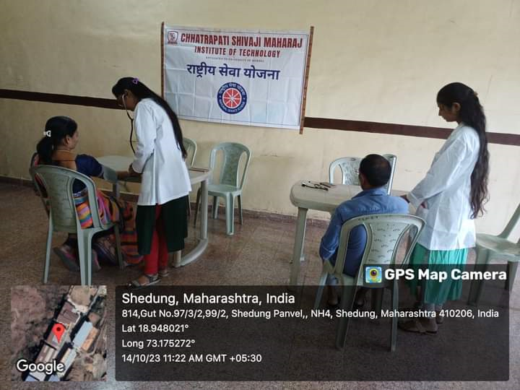

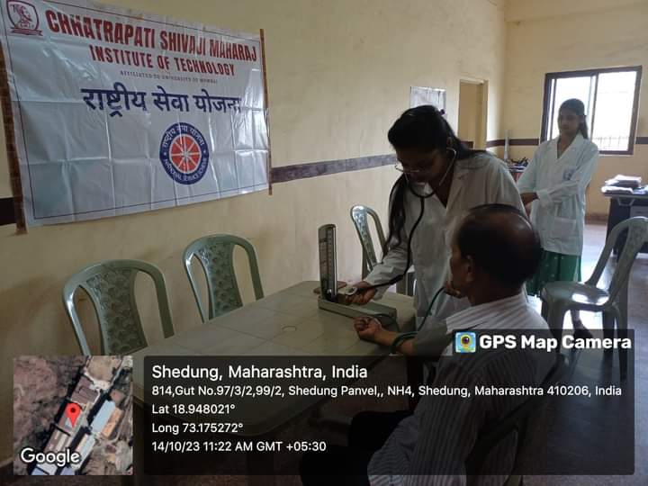

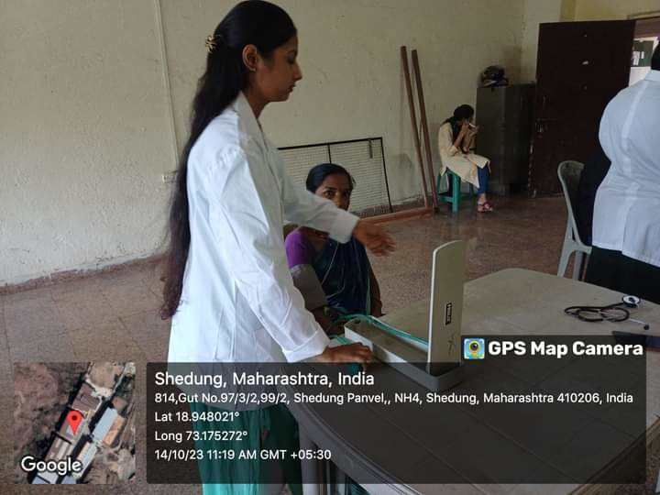

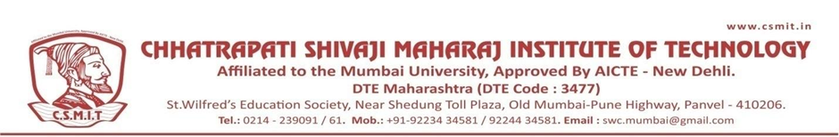

A REPORT ON THE GRAMIN COMPUTER LITERACY PROGRAM

- NAME OF ACTIVITY: Gramin Computer Literacy Program

- DATE & DURATION: 31st Oct, 2023

- TYPE OF ACTIVITY: NSS Activity

- ORGANIZED BY: IQAC, Chhatrapati Shivaji Maharaj Institute of Technology, Panvel.

FLYER

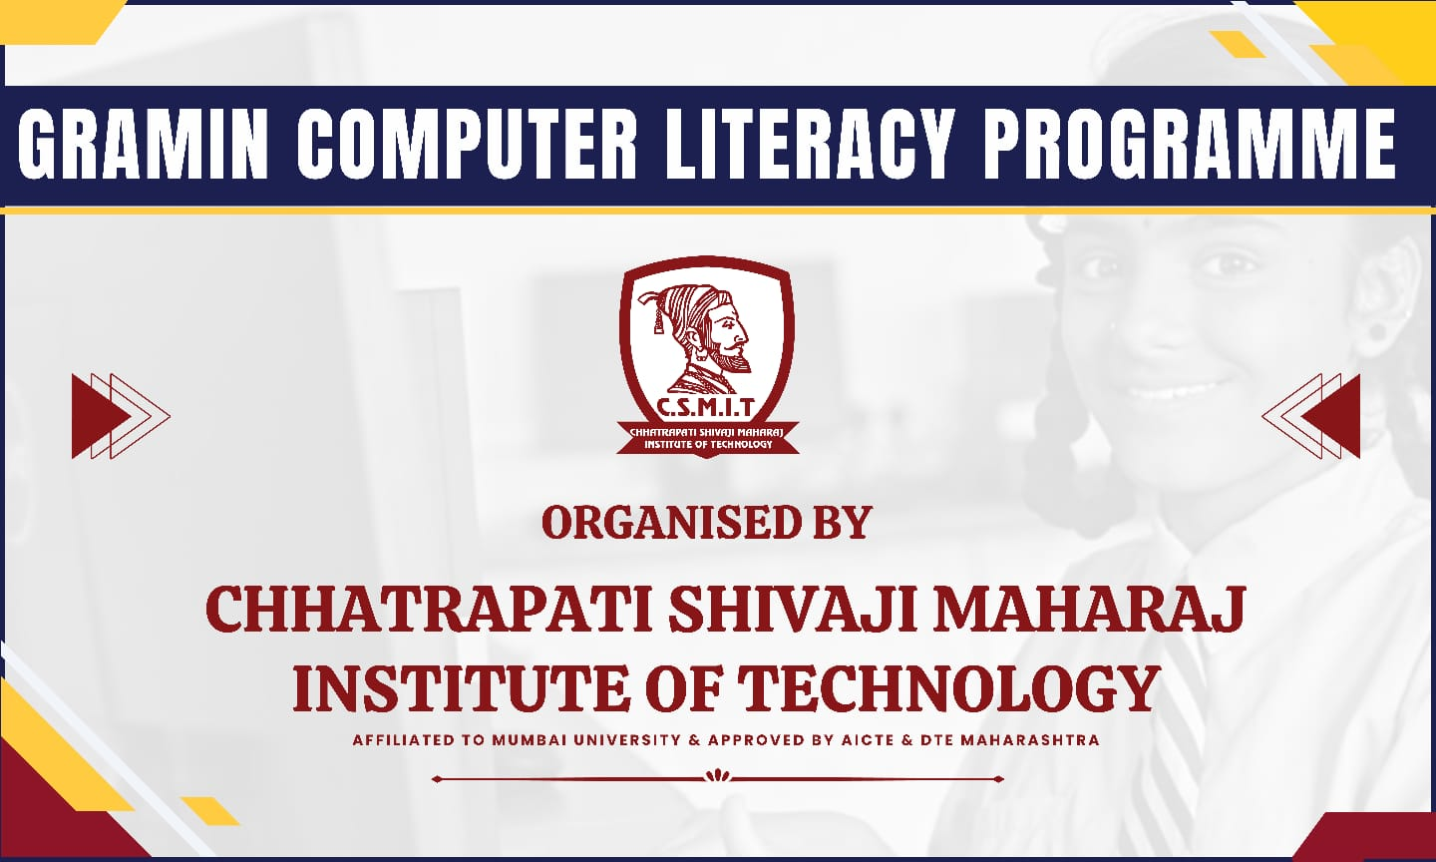

ABOUT THE PROGRAMME
Digital Literacy is the ability of individuals and communities to understand and use digital technologies for meaningful actions within life situations. Digitally literate persons would be able to operate computers/digital access devices (like tablets, smartphones, etc.), send and receive emails, browse the internet, access Government Services, search for information, undertake cashless transactions, etc. and hence use IT to actively participate in the process of nation building.

ATTENDANCE

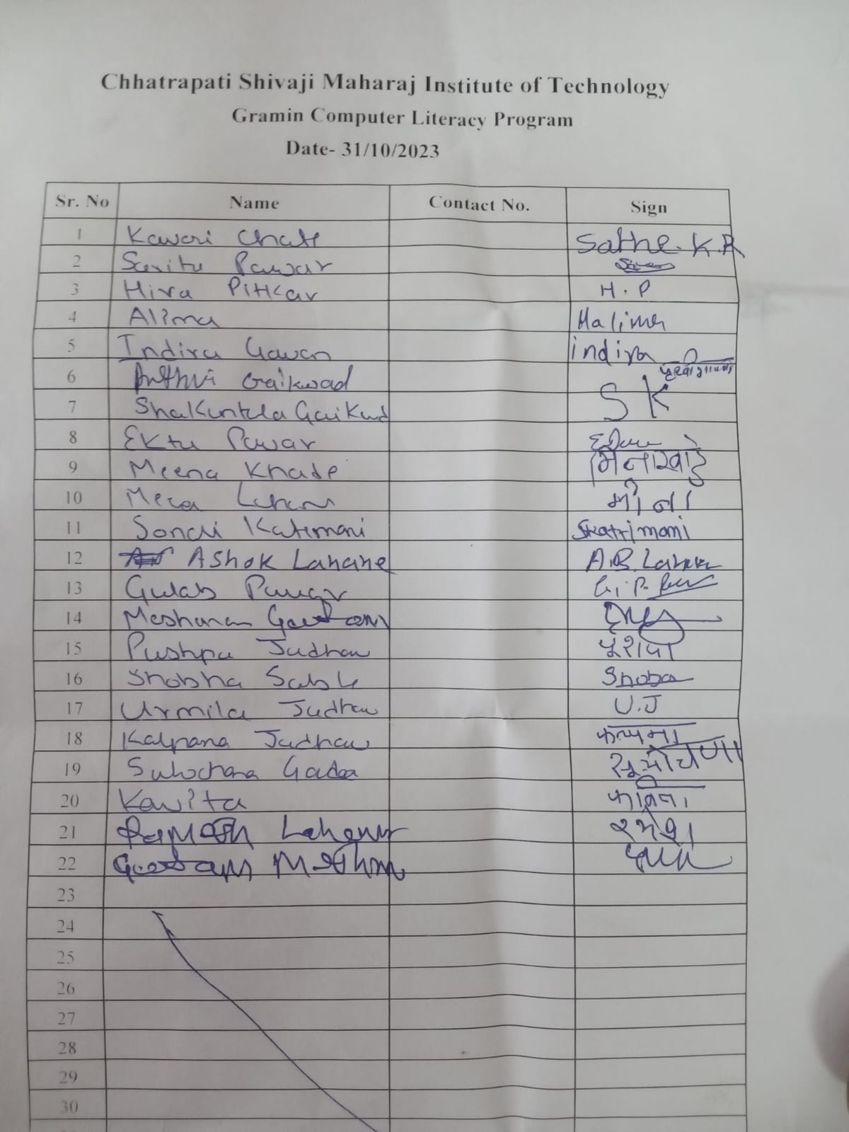

GLIMPSES:

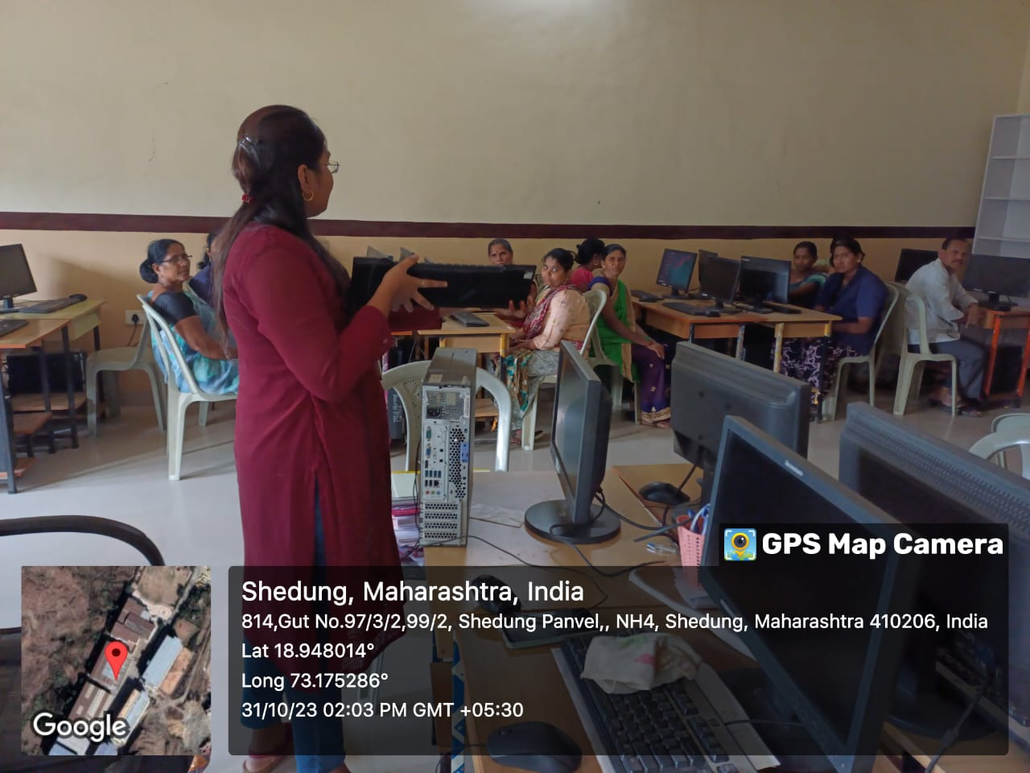

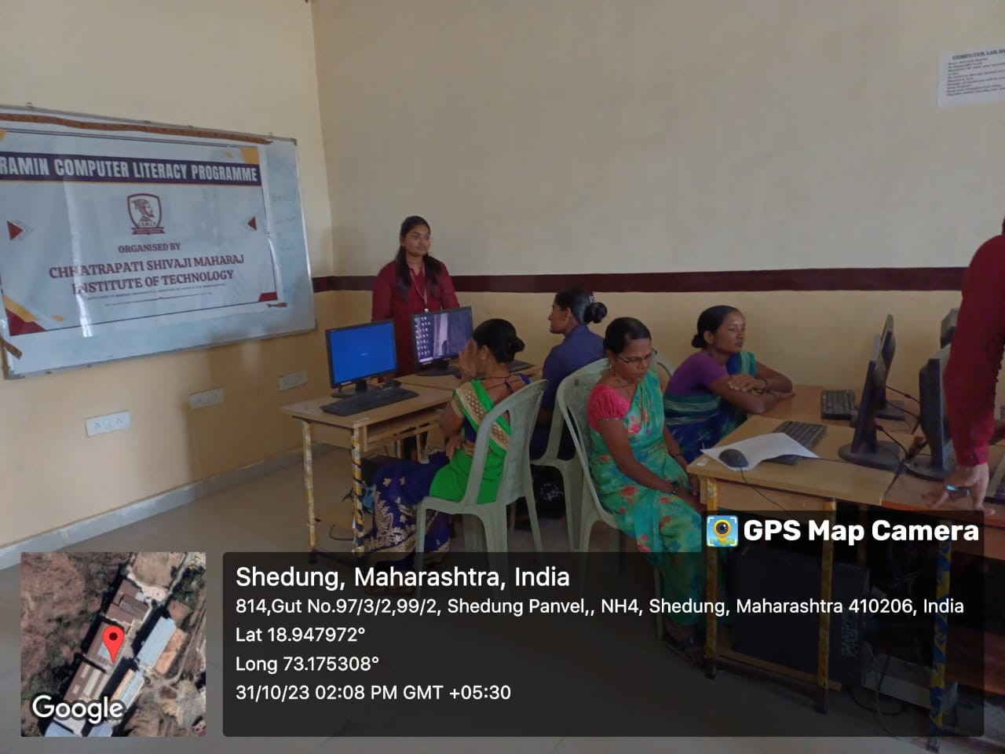

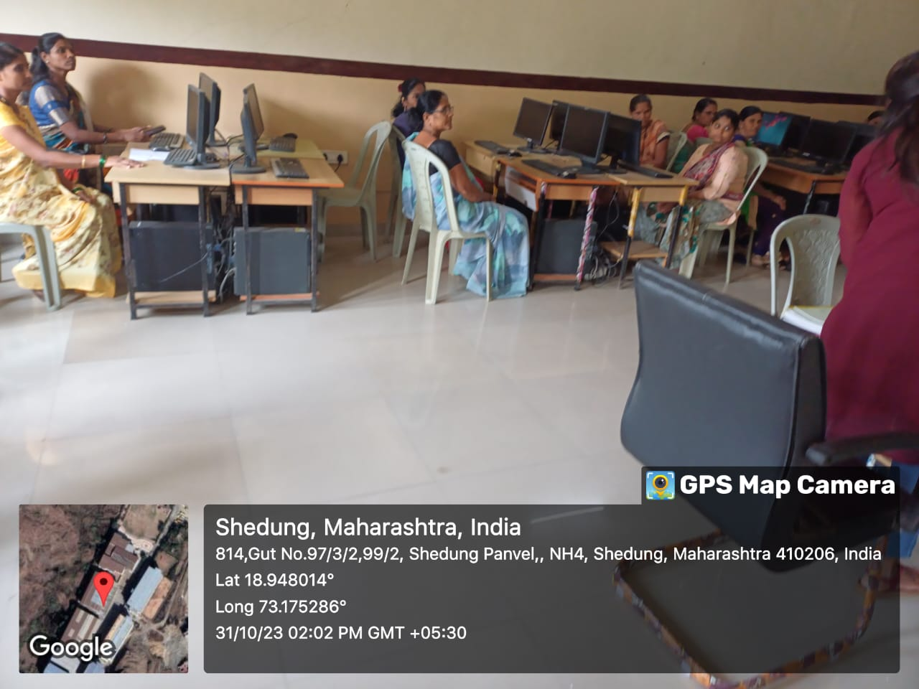

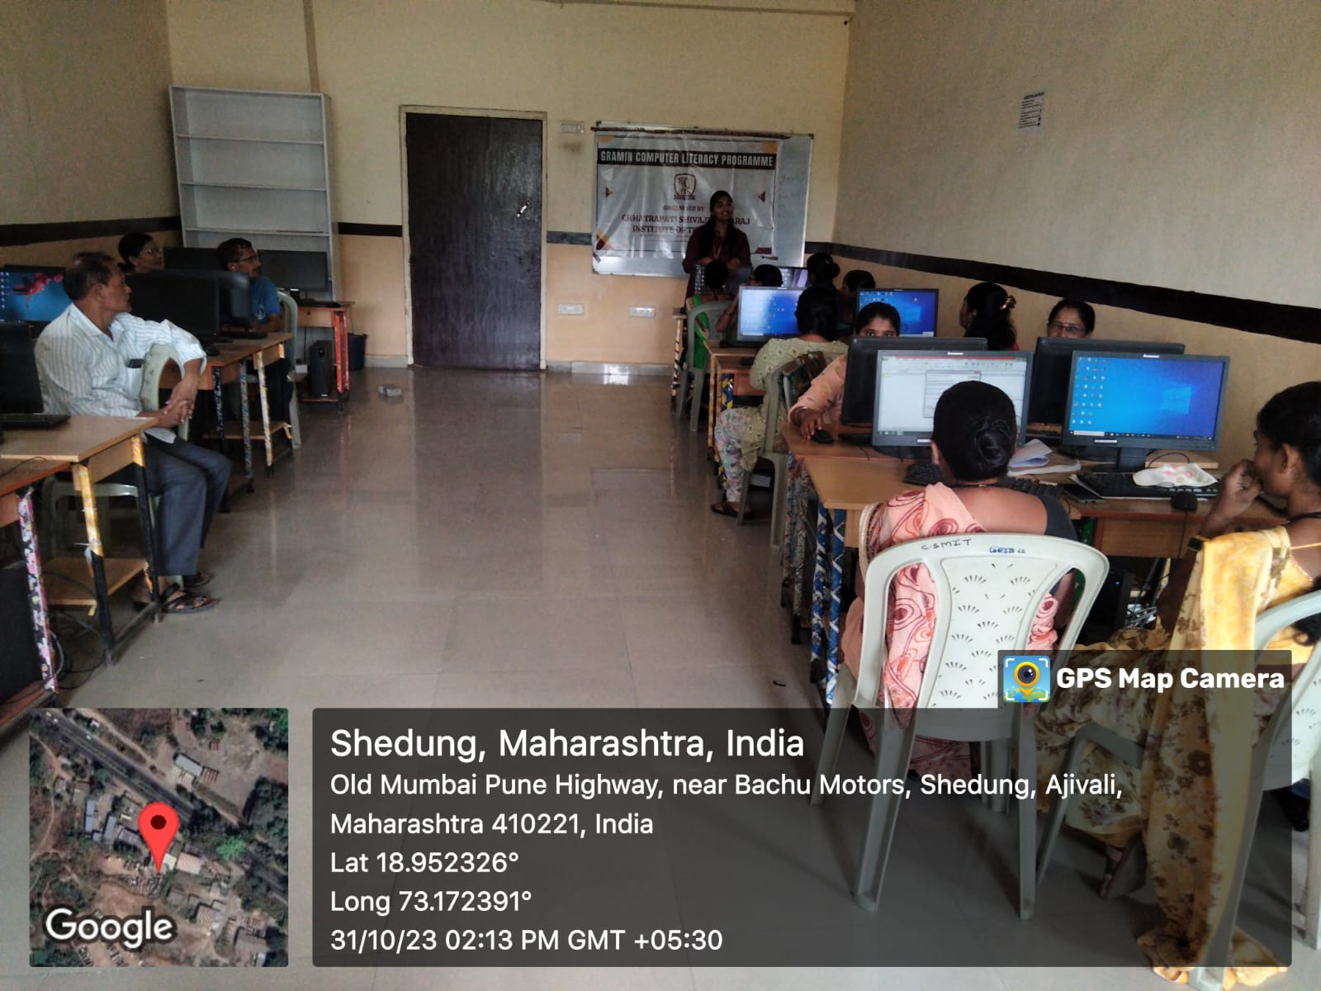
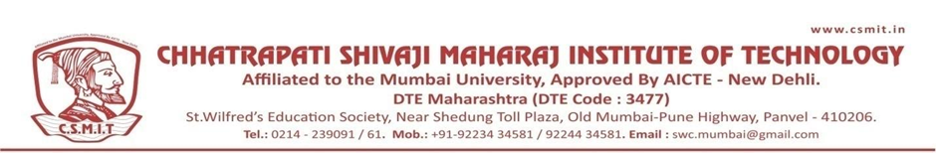

A REPORT ON NATIONAL UNITY DAY

- NAME OF ACTIVITY: National Unity Day

- DATE & DURATION: 31st Oct, 2023

- TYPE OF ACTIVITY: NSS Activity

- ORGANIZED BY: Chhatrapati Shivaji Maharaj Institute of Technology, Panvel.

GLIMPSES:

