3.3.1 Number of research papers published per teacher in the Journals notified on UGC CARE list during the last five years
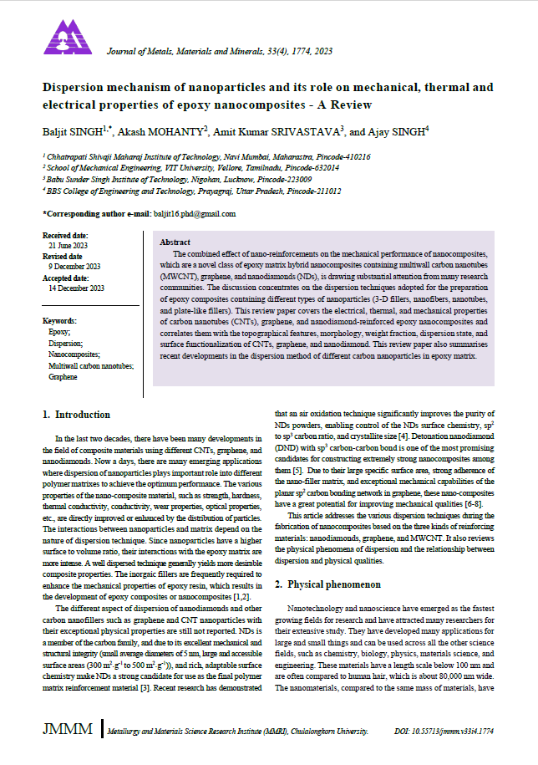
First page of publications
