A REPORT ON JANMASHTAMI CELEBRATION 2023

- NAME OF ACTIVITY: Janmashtami Celebration

- DATE & DURATION: 06th 09, 2023

- TYPE OF ACTIVITY: Festival

- ORGANIZED BY: Chhatrapati Shivaji Maharaj Institute of Technology, Panvel.

FLYER:

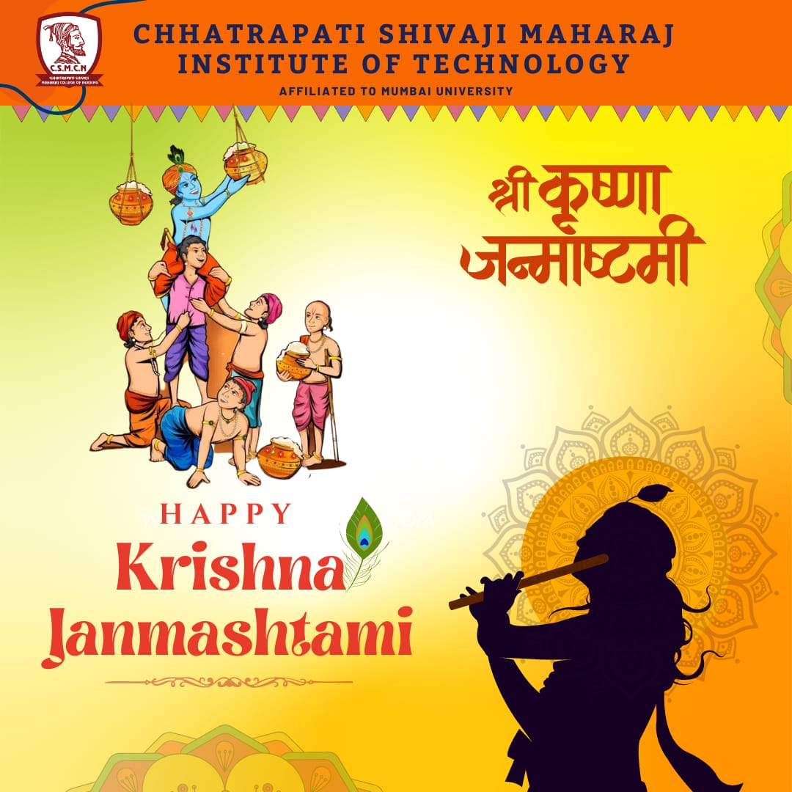

ABOUT THE PROGRAMME
The Krishna Janmashtami festival, popularly known as Janmashtami, is celebrated across India and marks the birth of revered Hindu deity Krishna, the eighth incarnation of Lord Vishnu.
This day is celebrated to commemorated the birth anniversary of the beloved God Krishna. He was born on Ashtami Tithi of Krishna Paksha especially under Rohini Nakshatra in Bharapada month. In the year 2023, Krishna Janmashtami was celebrated on September 6, 2023 and Dahi Handi is going to be celebrated on September 7, 2023.

GLIMPSES:
