A REPORT ON SWACHH BHARAT ABHIYAN AT POYANJE LAKE

- NAME OF ACTIVITY: Swachh Bharat Abhiyan

- DATE & DURATION: 16th 09, 2023

- TYPE OF ACTIVITY: NSS Cell

- ORGANIZED BY: NSS Cell, Chhatrapati Shivaji Maharaj Institute of Technology, Panvel.

FLYER:

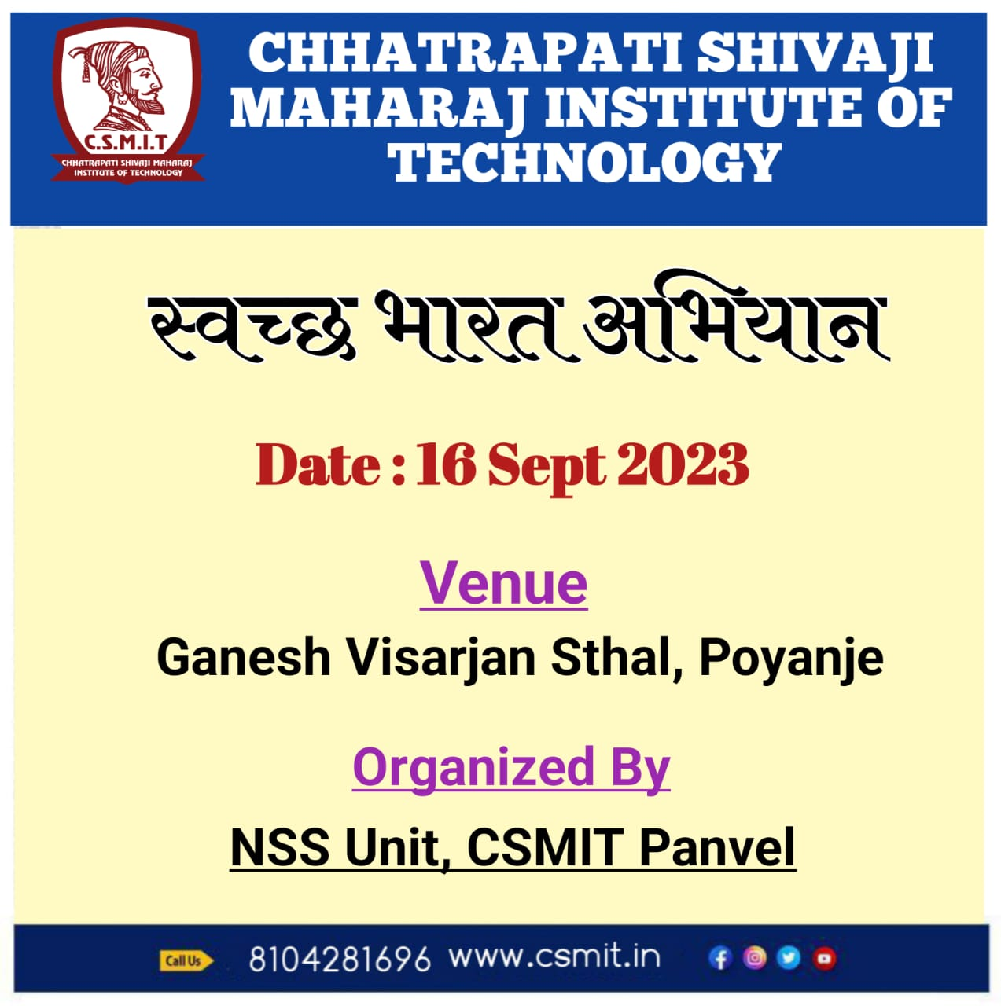
ABOUT THE PROGRAMME
Chhatrapati Shivaji Maharaj Institute of Technology organised a Cleanliness Drive under Swachh Bharat Abhiyan Programme on the occasion of Ganesh Chaturti festival on 16th september, 2023 at 12.00pm. For that we have to visit a lake which is in Poyanje village. The main purpose of this programme was to create awareness among the students regarding Cleanliness and its benefits. Under this programme, all the students from first year engineering had to participate. Even teachers were the essential part of this drive. As a part of this Cleanliness Drive, we had to clean the nearby area of the lake. Some of us picked brooms and started our jobs. Some of the students did the dusting of the area. After collecting them they threw them into the dustbins. After doing this job for two to three hours, we all assembled in the hall. There we were given refreshment in the form of vada pav and tea. Also students enjoy the lake side.

GLIMPSES:

