A REPORT ON GANESH CHATURATI CELEBRATION 2023

- NAME OF ACTIVITY: Ganesh Chaturthi Celebration

- DATE & DURATION: 19th to 25th 09, 2023

- TYPE OF ACTIVITY: NSS Activity, Cultural Committee

- ORGANIZED BY: ST. WILFRED EDUCATION SOCIETY, PANVEL

FLYER:

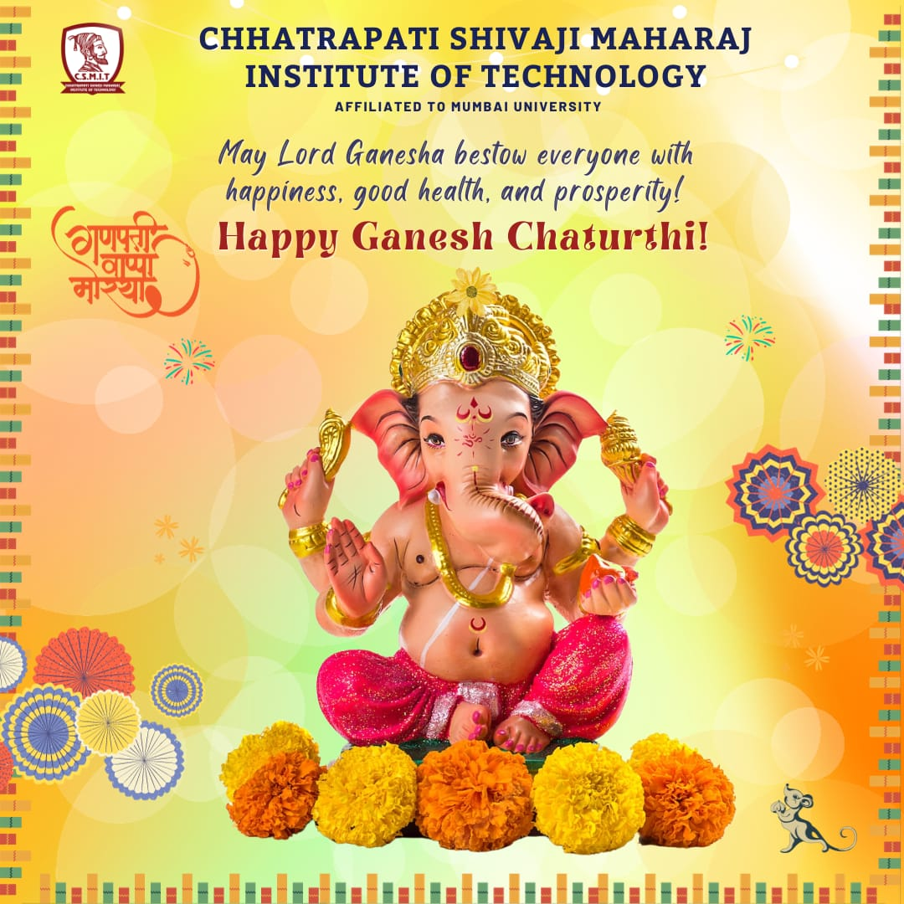

ABOUT THE PROGRAMME

St. Wilfred Education Society, Panvel organised “Eunoia cha Raja” on the occasion of Ganesh Chaturti festival from 19th september, 2023 to 25th september, 2023. The celebration began with a ceremonial puja that was initiated by our respected Cultural head Mr. Mahesh Jadhav. This marked the commencement of a spiritually significant day. The puja was conducted with traditional rituals, including the lighting of the lamp, Vedic chants, and offerings to Lord Ganesha’s idol. Presence of all department faculty and students added a sense of solemnity and reverence to the event. Following the ‘Anjali’ ritual, ‘Prasad’ was distributed to all present. Sweets and fruits were shared among the attendees, symbolising the blessings and benevolence of Lord Ganesha. This act of sharing fostered unity and a sense of community. Stay of Lord Ganesha’s Idol. We extend our heartfelt gratitude to all the students, staff, and organisers whose dedication and participation made this celebration a grand success. May the blessings of Lord Ganesha continue to guide us, and may our university community always remain close-knit and harmonious. The Ganesh pooja and aarti was attended by all the teaching and non – teaching staff of college with everyone looking their best in traditional attire. After the aarti, prasad was distributed among all followed by the cultural program.

GLIMPSES:

