A REPORT ON NSS FOUNDATION DAY

- NAME OF ACTIVITY: NSS FOUNDATION DAY

- DATE & DURATION: 24st Sep, 2023

- TYPE OF ACTIVITY: NSS Activity

- ORGANIZED BY: NSS Cell/Chhatrapati Shivaji Maharaj Institute of Technology, Panvel.

FLYER

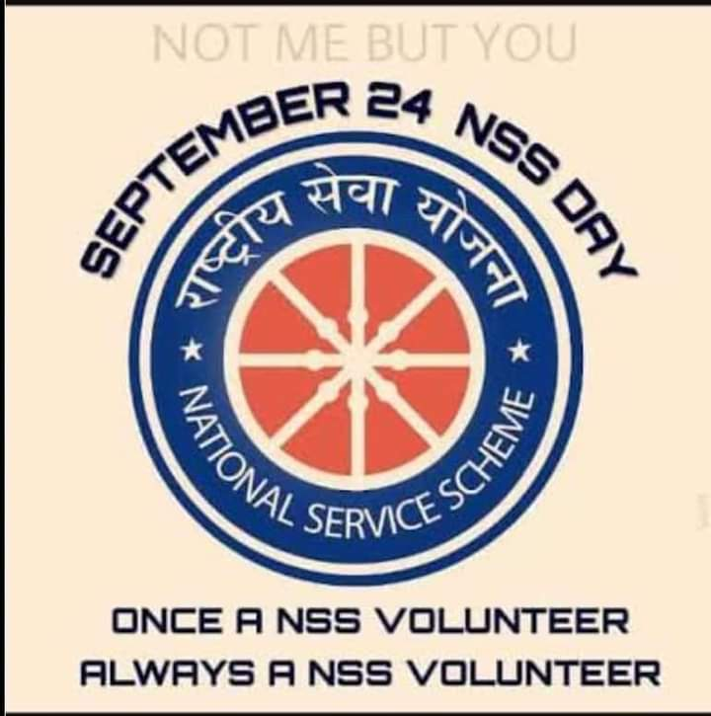

ABOUT THE PROGRAMME

GLIMPSES:

