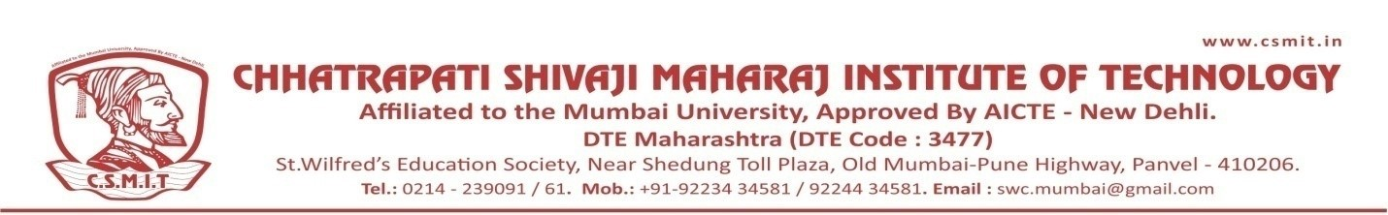

SOCIAL ACTIVITY
HAR GHAR TIRANGA- AN AWARENESS RALLY

12 ^{TH} AUGUST 2022

An awareness rally for HAR GHAR TIRANGA was conducted by Chhatrapati Shivaji Maharaj Institute of Technology, Panvel on 12th August 2022, Friday. The students, teachers and general public joined the foot March taken out for public awareness. Rally was held between Orion mall to Karnala sports Academy.

