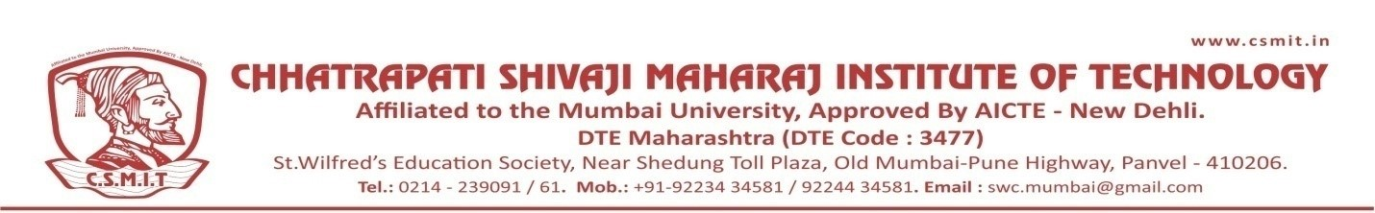

NATIONAL UNITY DAY

31ST OCTOBER 2021

Organized by
CSMIT

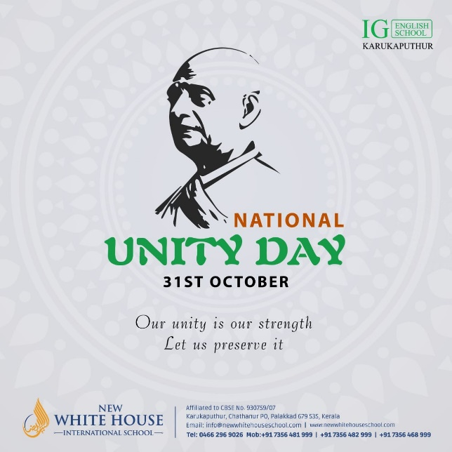

National Unity Day is a commemoration of solidarity, harmony, and diversity. It brings together people from all walks of life, transcending boundaries and fostering a sense of oneness. Through celebration and reflection, it reminds us of the strength and importance of unity in building a prosperous and inclusive nation.
On National Unity Day, we honor the sacrifices of our ancestors who fought for freedom and unity. It is a day to embrace our shared values, bridge differences, and work towards a common goal. Through dialogue, understanding, and respect, we strive to create a society where diversity is celebrated and every voice is heard. Together, we build a stronger, more cohesive nation for future generations.

