ONLINE INDUCTION PROGRAM AND WELCOME TO DSE

07RD DECEMBER 2021

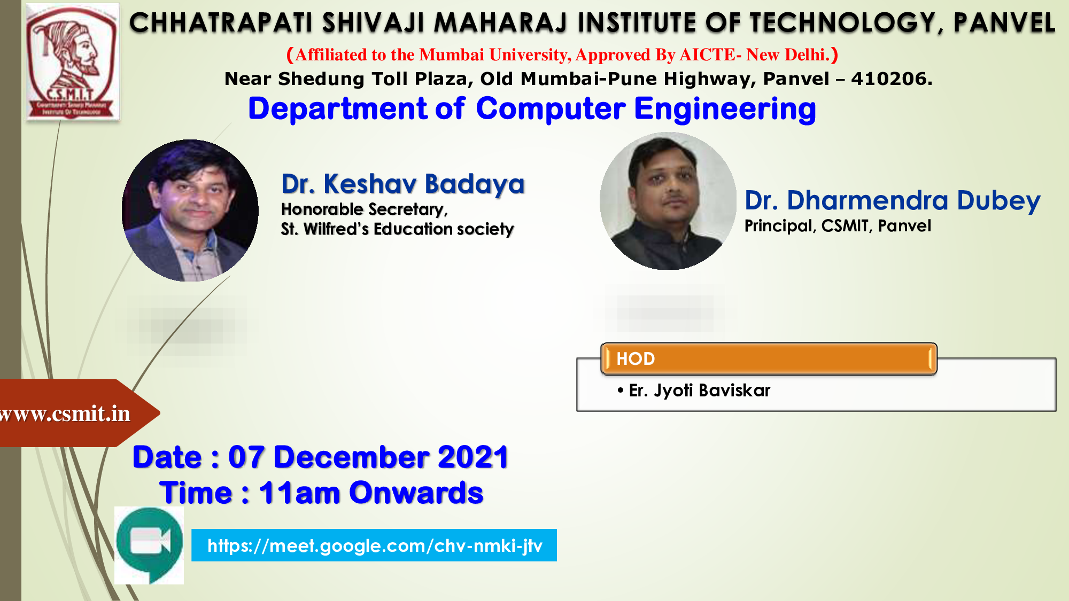
ONLINE INDUCTION PROGRAM AND WELCOME TO DSE DSEDSETUDENTS

