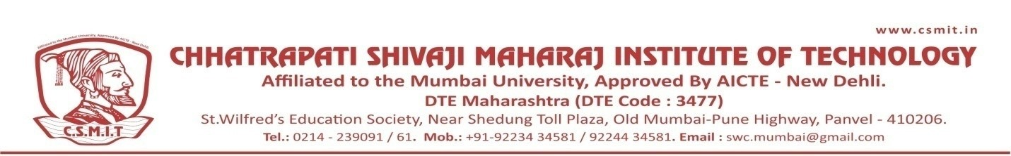

WEBINAR
ON

EMERGING TRENDS IN CIVIL ENGINEERING

11TH OCTOBER 2021

Organized by
DEPARTMENT OF CIVIL ENGINEERING

ABOUT THE PROGRAM:
The session was conducted for the students to introduce about the topic Emerging Trends in Civil Engineering. Maximum number of students joined the session.

SPEAKER NAME:
MR. AMITAVA HAIDER
SENIOR MANAGER-BUSINESS SUPPORT,CADD CENTRE

