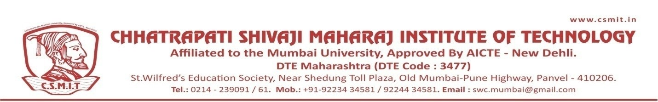

WEBINAR ON
FUTURE SCOPE AND CARRER OPPORTUNITIES IN MECHANICAL INDUSTRY
20TH JANUARY 2022
Organized by
Department of Mechanical Engineering

ABOUT THE PROGRAMME

Revolutionary industry changes along with the severe decline in available opportunities during covid period have caused major impacts on graduates worldwide.
This webinar emphasizes the recent carrer opportunities in mechanical industries. It will bring about awareness among participants on current trends and their applications in industry and research area. Innovation has the capability of saving the world without stopping So, we must take advantage of this seminar for creating a better world.

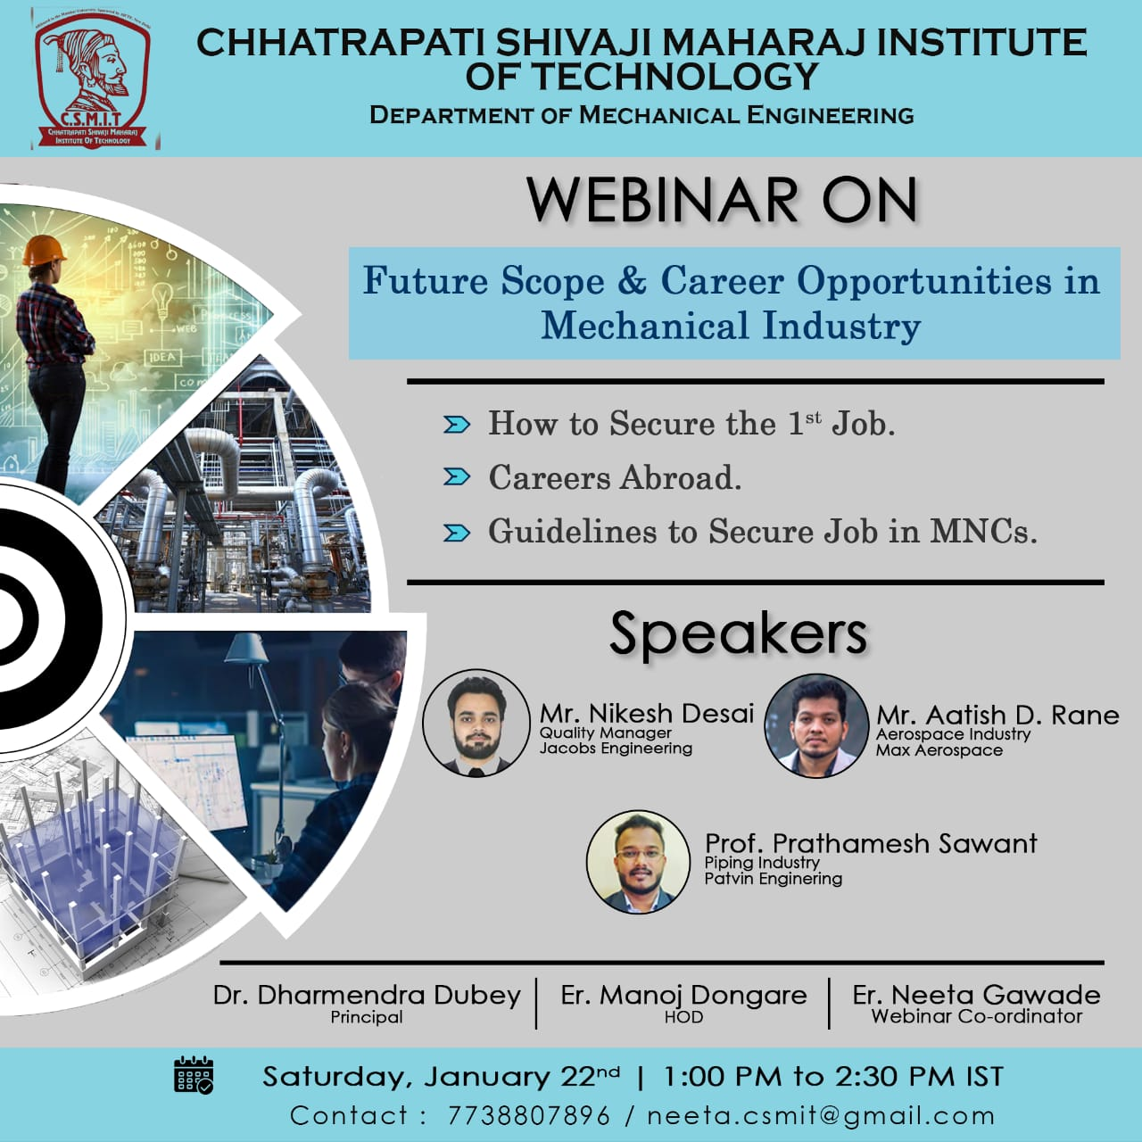

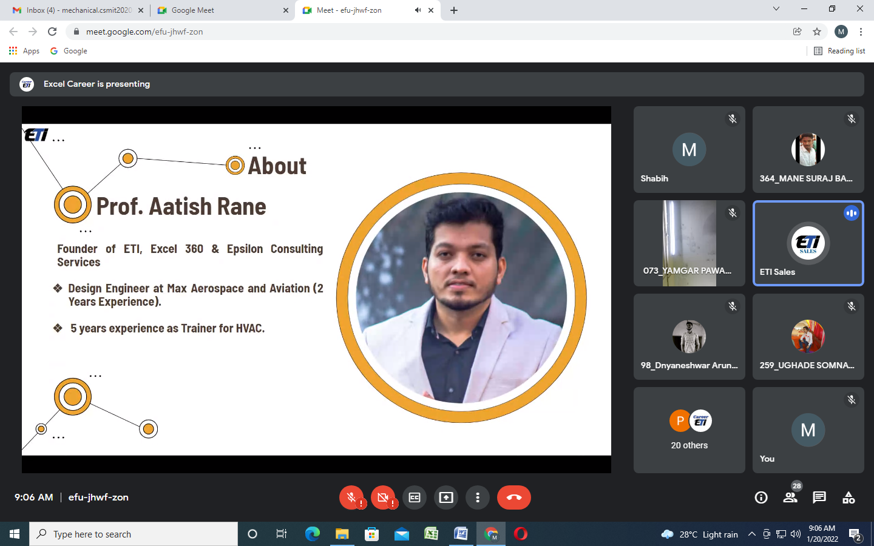
PROF. ATISH RANE, presenting during the conference
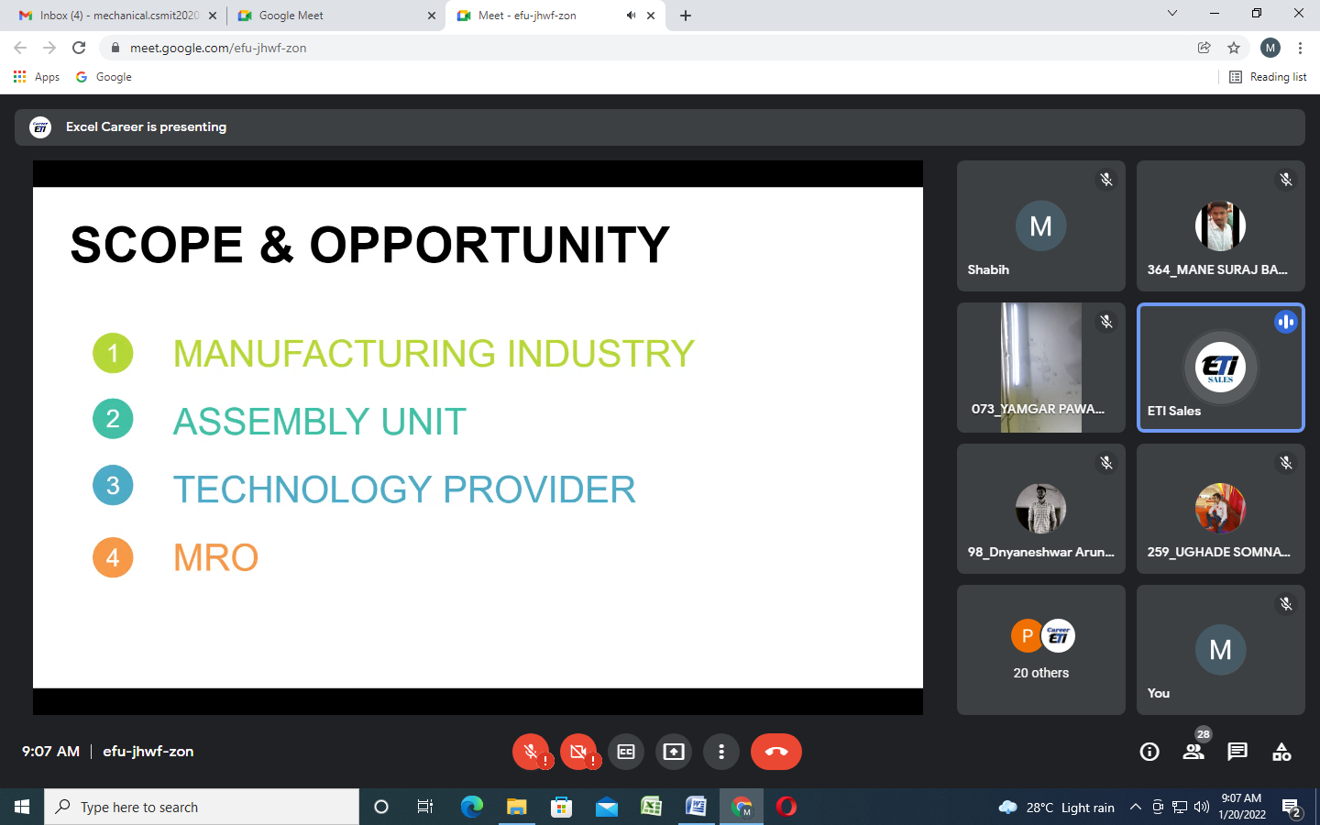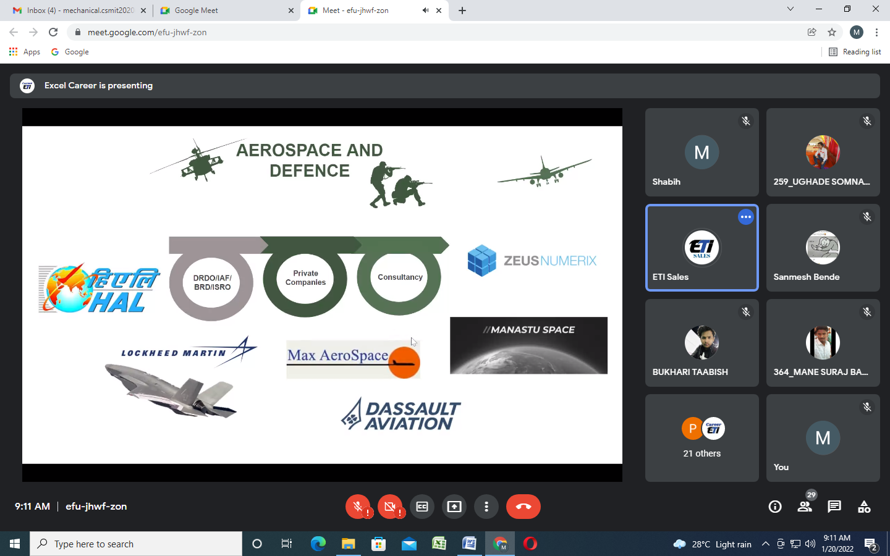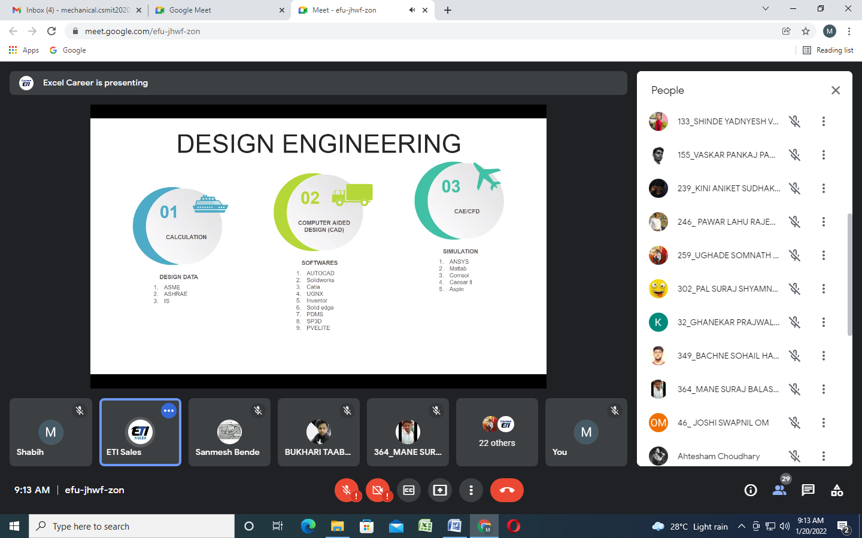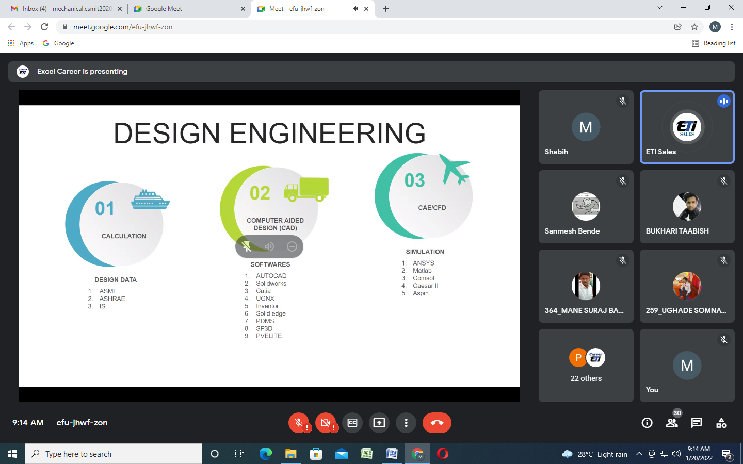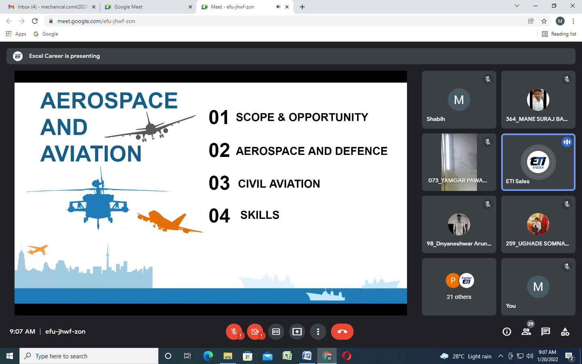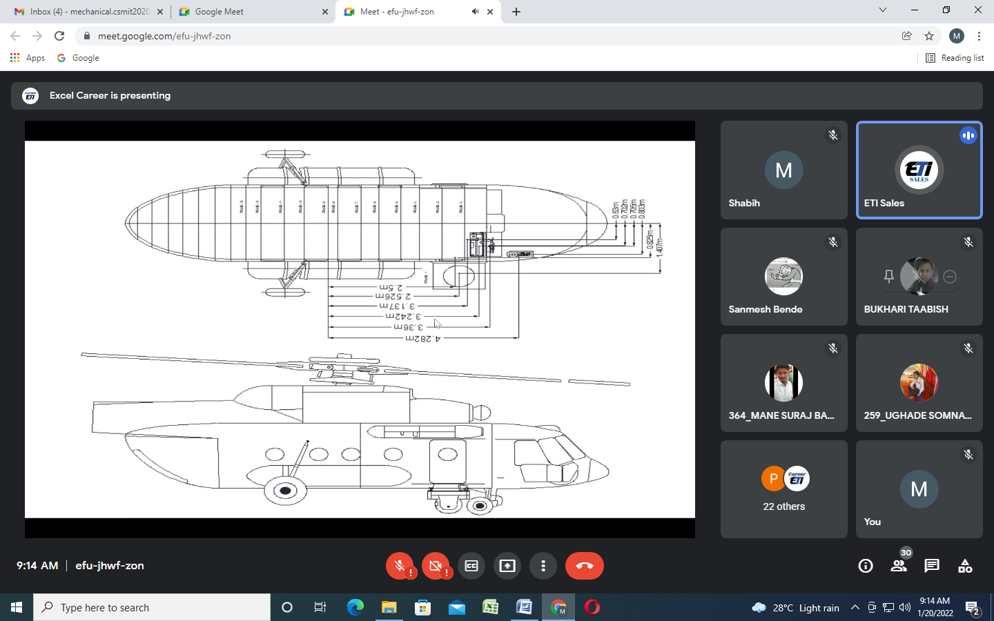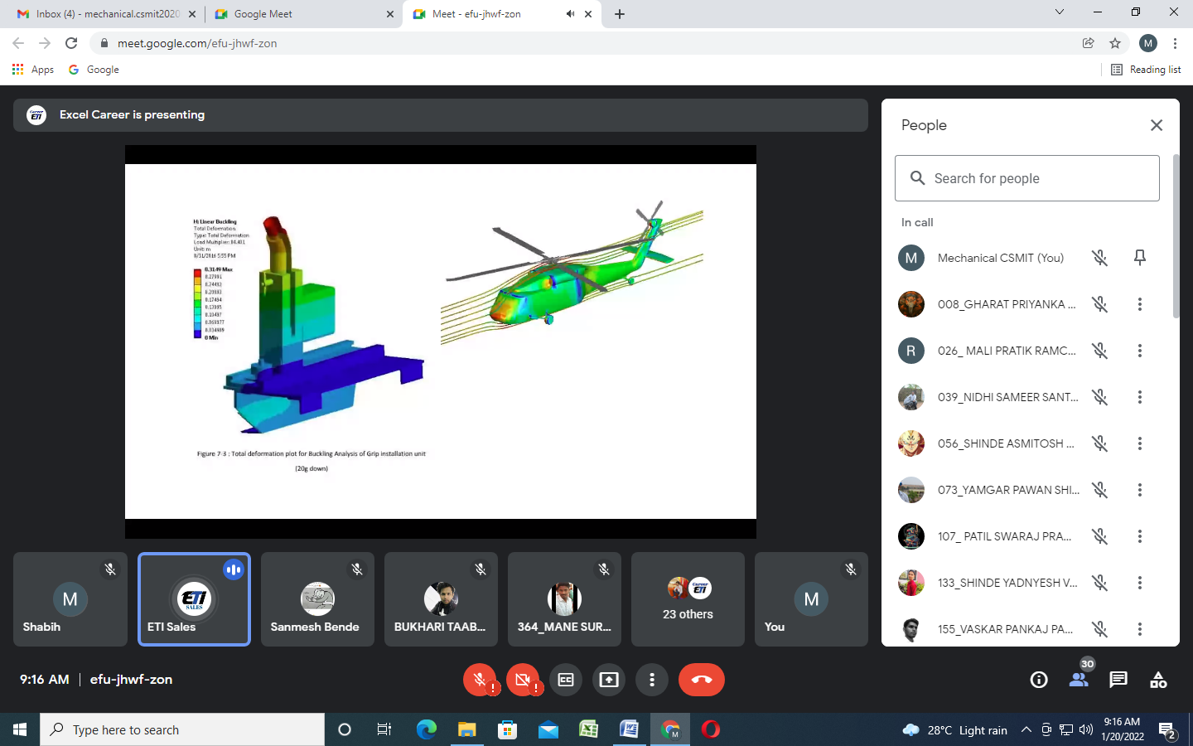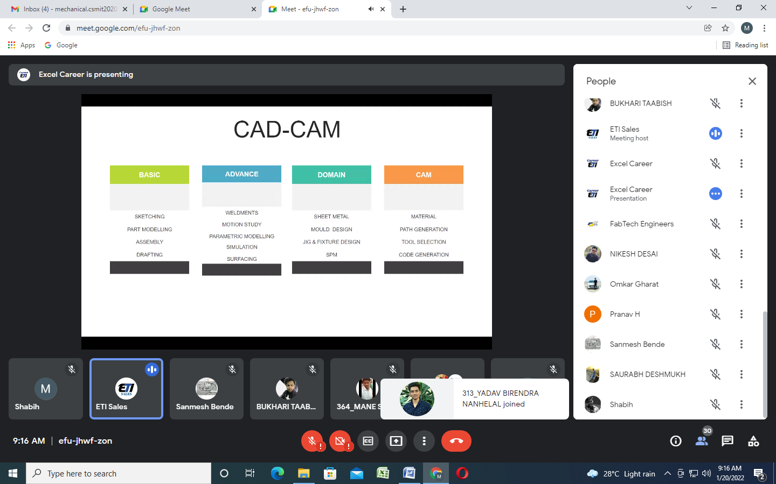

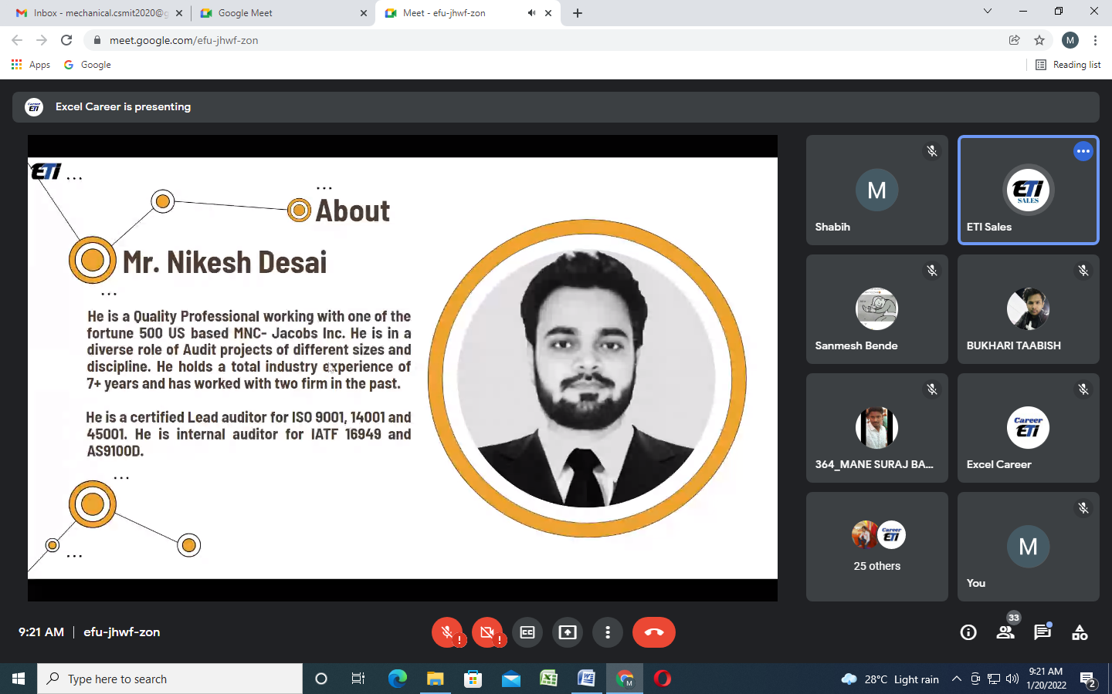
MR. NIKESH DESAI, presenting during the conference
