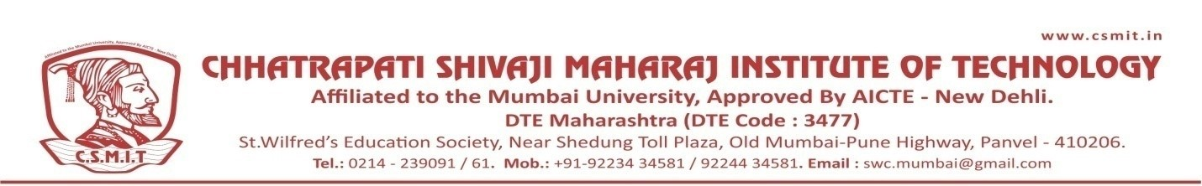

WEBINAR
ON

Focus- Meri Life Mera Lakshya

22ND OCTOBER 2021

Organized by
DEPARTMENT OF SCIENCE AND HUMANITIES

ABOUT THE PROGRAM:
Dr. sanjay Prem who is the great motivationsl speaker has conducted the session very effectively. The session was very effective for the students. around 200 students joined the session. Dr. sanjay sir mainly focused on topis how to remain positive

SPEAKER NAME:
Dr.Sanjay Prem
Motivational Speaker
Founder, Safalta Ki Pathshala

