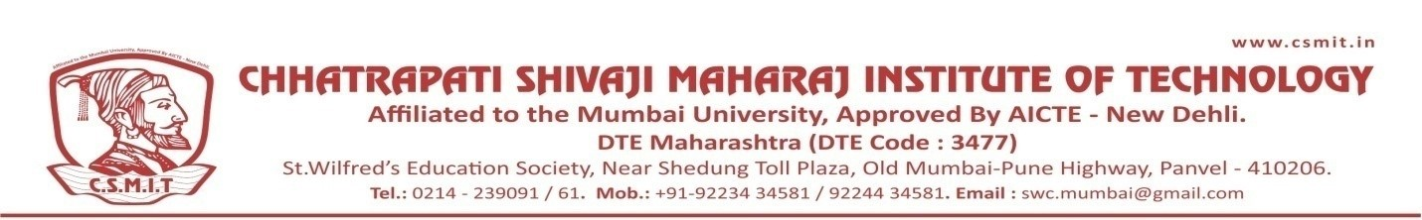

WEBINAR
ON

JOB OPPORTUNITIES IN PLANT DESIGN IN CIVIL ENGINEERING

18TH AUGUST 2021

Organized by
DEPARTMENT OF CIVIL ENGINEERING

ABOUT THE PROGRAM:
The webinar was conducted for the students to get overview about the opportunities in welding and NDT. ER. NIRMALYA BANERJEE is India’s 1st PCN level -II. He has excellent knowledge of his field.

SPEAKER NAME:
MR. DAYANAND WASATE
BUSINESS DEVELOPMENT HEAD PIPETECH ENGINEERING SOLUTION PVT LTD MUMBAI

