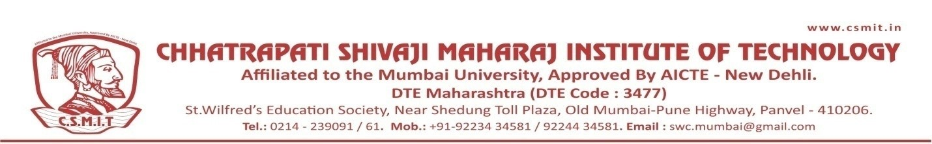

WEBINAR
ON

METROLOGY IS DAILY USE

15TH SEPTEMBER 2021

Organized by
DEPARTMENT OF MECHANICAL ENGINEERING

ABOUT THE PROGRAM:
The seminar was conducted on the occasion of WORLD ENGINEER'S DAY. DR. HARISH KUMAR. enlightened on the topic of Metrology. Metrology is basic to the economic and social development of a country. It is concerned with providing accurate measurements which impact our economy, health, safety and general well-being.

SPEAKER NAME:
DR. HARISH KUMAR
DEPARTMENT OF MECHANICAL ENGINEERING, NIT, NEW DELHI

