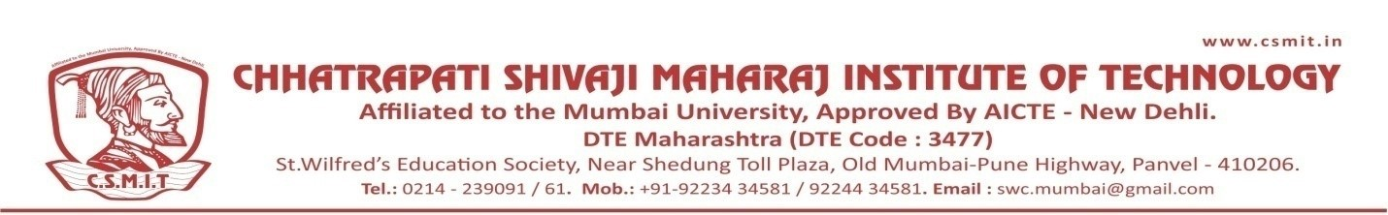

WEBINAR
ON
OCCUPATIONAL SAFETY AND HEALTH CAREER OPTION IN INDIA AND ABROAD

06TH AUGUST 2021

ABOUT THE PROGRAM:
The session was conducted for the students to get knowledge about the opportunities in Safety and Health career. DR. RAM KUMAR BARATHAN has complete knowledge of safety standard in India as well as in abroad. The session has motivated students for look into this field as a career.

SPEAKER NAME:
DR. RAM KUMAR BARATHAN
SAFETY OFFICER , QHSE DEPARTMENT ,
TRAFFIC TECH(GULF) W.L.L.,DOHA , QATAR.

