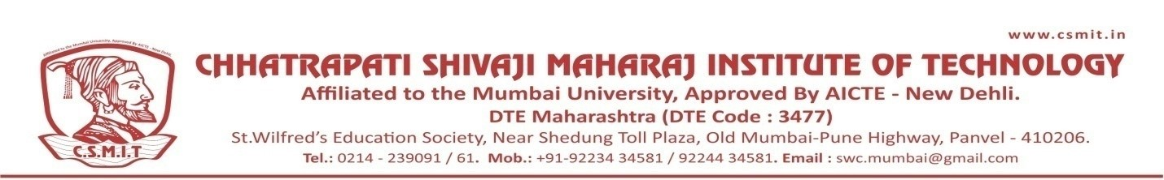

WEBINAR
ON

Profile Building for High Profile Jobs

07TH AUGUST 2021

Organized by
DEPARTMENT OF COMPUTER ENGINEERING

ABOUT THE PROGRAM:
The Session was about Career Development of students. She guided on career opportunities after Computer Engineering.
She had also guided about corporate culture in companies. For this interactive session more than 100 students form computer branch participated.

SPEAKER NAME:
Nidisha Sree M
Career Coach | L&D | 7+ yrs, Hyderabad, Telangana.

