Ref.No:- CSMIT/ 2024-25/ ARC-01 Date-24/06/2024

**Office Order**

**Subject:Anti-Ragging Committee for Academic Year: 2024-25**

a

|  |  |  |  |
| --- | --- | --- | --- |
| **Sr. No.** | **Name of Faculty** | **Designation** | **Position** |
| 1 | Dr. Manish Sharma | Principal | Chairman |
| 2 | Er. Shreyas Pandey | Assistant Professor | Convener |
| 3 | Er. Anup Maurya | Assistant Professor | Member |
| 4 | Dr.Baljit Singh | Assistant Professor | Member |
| 5 | Er. Tejashree Wavekar | Assistant Professor | Member |
| 6 | Er. Sachin Bhosale | Assistant Professor | Member |

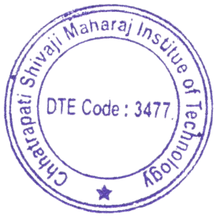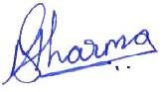

(Dr.Manish Sharma)

Principal, CSMIT

Copy to,

1. All Department
2. Principal
3. All Committee Members