**Date-25/06/2024**

**Office Order**

**Subject: Grievance Redressal Committee for Academic Year: 2024-2025**

a

|  |  |  |  |
| --- | --- | --- | --- |
| **Sr. No.** | **Name of Faculty** | **Designation** | **Position** |
| 1 | Dr. Manish Sharma | Principal | Chairman |
| 2 | Dr. Baljit singh | Assistant Professor | Convener |
| 3 | Er. Manoj Udaygiri | Assistant Professor | Member |
| 4 | Er. Jyoti Nimje | Assistant Professor | Member |
| 5 | Er. Mansi Thakur | Assistant Professor | Member |
| 6 | Er. Rahul Patil | Assistant Professor | Member |
| 7 | Ms, Shreya Sawant | Student | Student Representative |

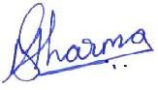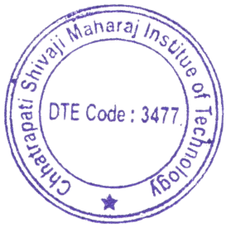

(Dr. Manish Sharma)

Principal, CSMIT

Copy to,

1. All Department
2. Principal
3. All Committee Members