**Date-18/07/2022**

**Office Order**

**Subject: SC/ST Committee for Academic Year: 2024-2025**

a

|  |  |  |  |
| --- | --- | --- | --- |
| **Sr. No.** | **Name of Faculty** | **Designation** | **Position** |
| 1 | Er. Nutankumar Kale | Assistant Professor | Convener |
| 2 | Er. Rakesh Junnarkar | Assistant Professor | Member |
| 3 | Prashant Kashid | Assistant Professor | Member |
| 4 | Er. Mansi Thakur | Assistant Professro | Member |
| 5 | Er. Rahul Shingare | Assistant Professor | Member |
| 6 | Sihan Mahale | Student | Student representative |

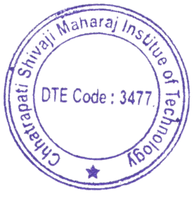

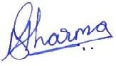

(Dr. Manish Sharma)

Principal, CSMIT

Copy to,

1. All Department
2. Principal
3. All Committee Members