MALLA REDDY ENGINEERING COLLEGE
DEPARTMENT OF MECHANICAL ENGINEERING
Name of the Faculty | Prof .Deepika S.Sonawane | 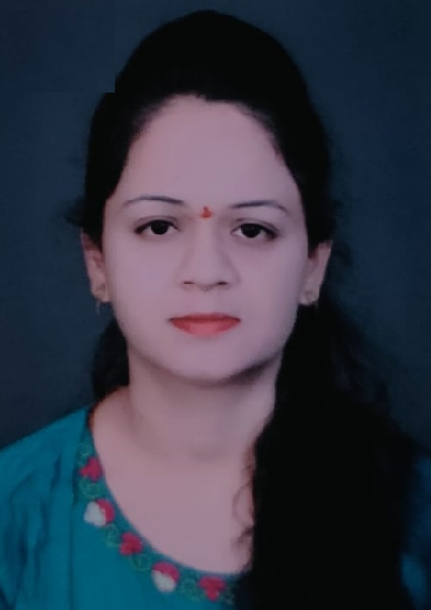
Designation | Assist..Professor
Aadhar ID | 4706-4506-4381
No.of B.Tech Project Guided | no
No.of M.Tech Project Guided | no
Area of Specialization | Computer Science Engineering
UG Degree | BE (Computer Technology) from Sinhagad Institute Of Technology, Pune
PG Degree | M Tech ( Computer Science Engineering) from Bhabha University,Bhopal
Ph.D | no
Total Experience | Teaching:5 | Industry: NIL
No. of Journals (National & International) | 2
No .of Patents Published | no
Roles and Responsibilities
Guest Lecture Delivered | no
FDP’s Conducted | no
NPTEL
Area of Interest:
About My Research work

