CHHATRAPATI SHIVAJI MAHARAJ INSTITUTE OF TECHNOLOGY, RAIGAD
DEPARTMENT OF MECHANICAL ENGINEERING
Name of the Faculty | Dr. Shyam B Kaushal
  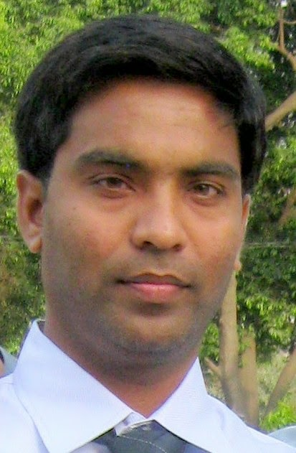
Designation | Asst. Professor
Aadhar ID | 273358736509
No.of B.Tech Project Guided | 08
No.of M.Tech Project Guided | 01
Area of Specialization | Advanced Manufacturing Processes
UG Degree | B. Tech. In Industrial Production Engineering
PG Degree | M.Tech. in CAD-CAM (Mechanical Engineering Department)
Ph.D. | Ph. D. in Mechanical Engineering.
Total Experience | Teaching:05 | Industry: 01
No. of Journals (National & International) | 05
GATE Score | 4 times GATE Qualified with good score and upto 95 percentile scored in 2015.
Area of Interest:
Conventional and Non Conventional Machining Processes, Thermal Engineering, Power Plant, Solar Desalination.
About My Research work
My research work on new machining processes for aerospace superalloys which can increase material removal rate (MRR), surface finish and dimensional accuracy. To achieve this, efforts have been made in the development of tool materials as well as the improvement of machining processes. Due to frequent failure of the tool, advanced machining processes (AMPs) are found as the most suitable processing technique for shaping of aerospace superalloys. Advanced machining processes such as Electric Discharge Machining (EDM), Laser Beam Machining (LBM) and Electrochemical Machining (ECM) are the most suitable processes for shaping advanced materials because there is no physical contact between workpiece and tool. But AMPs also have certain limitations such as low MRR, poor surface finish, type of workpiece material to be processed and large heat affected zone particularly in case of EDM and LBM.
In the present work, Electrochemical Face Grinding (ECFG) and Electrochemical Diamond Face Grinding (ECDFG) process were performed for machining of Ni-based and Ti-based superalloys. The work reported in this research comprises of development of ECDFG setup on die sinking ECM. In addition to the development of ECDFG setup, modeling and optimization of process were done for better understanding the exact behavior of ECDFG process under different operating conditions.

