Chhatrapati Shivaji Maharaj Institute of Technology, Panvel
Name of the Faculty | Dr. Rossi D’Souza | 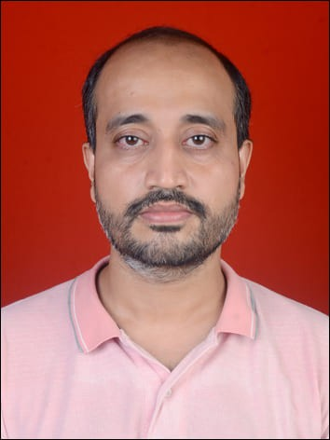
Designation | Assistant Professor
Aadhar ID | 9890-9028-5286
No.of B.Tech Project Guided | 0
No.of M.Tech Project Guided | 0
Area of Specialization | Modeling & Simulation, Computational Genomics, Science Education, Political Economy of Mathematics Education
UG Degree | B.Sc (Physics) St. Xavier’s College, Mumbai University
PG Degree | M. Sc (Instrumentation Science) Pune University  M.Tech (Modeling & Simulation), Pune University
Ph.D | Mathematics Education from Homi Bhabha Centre for Science Education (HBCSE), TIFR
Total Experience | Teaching:7 | Industry: 1.5
No. of Journals (National & International) | 5
No .of Patents Published | 0
Roles and Responsibilities | Teaching & Exam Controller
Guest Lecture Delivered
FDP’s Conducted
NPTEL
Area of Interest:
Physics Education, Mathematics Education, Political Economy of STEM Education
About My Research work
Understanding the History and Political Economy of the Energy Crisis and its implications for teaching about energy to undergraduate students of engineering.

