CHHATRAPATI SHIVAJI MAHARAJ INSTITUTE OF TECHNOLOGY
DEPARTMENT OF SCIENCE & HUMANITY
Name of the Faculty | Revatee Bagade | 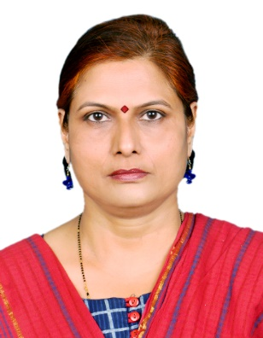
Designation | Assistant Professor
Aadhar ID | 6812 9201 7005
No. of B. Tech Project Guided | 0
No. of M. Tech Project Guided | 0
Area of Specialization | Image processing
Diploma | Diploma in Electrical engineering
UG Degree | B.E. (Electronics & Telecommunication Engineering) from Pune University
PG Degree | M. E. (Electronics & Telecommunication Engineering) from Mumbai University
Total Experience | Teaching:12 yrs. | Industry: 1 yr.
No. of Journals (National & International) | 2
No. of Patents Published | 0
Roles and Responsibilities | Examination Understudy
Guest Lecture Delivered | Guest Lecture Delivered on Career Guidance in Barns Junior College, Panvel.
FDP’s Conducted
NPTEL | - Digital Image Processing  - Machine Learning  - Control Systems  - Data Mining
Area of Interest:
Electrical Engineering, Digital Electronics, Image processing, microprocessor, Control systems, AI
About My Project work
Classification of Texture with Feature extraction using Wavelet approach:

Texture classification is important in pattern recognition. Wavelets are used to analyze the textured images. Wavelet Transform provides the time-frequency representation of a signal. Features are derived from approximation and detail sub band images uniquely. Discrete wavelet transform are used to decompose the textured images into detail and approximation regions. If selected features are suitable and contain enough information about the given samples, the classifier classify them successfully.

